Lesson 9: Add Three-digit Numbers

Standards Alignments
Addressing | 2.NBT.B.7, 2.NBT.B.9

Teacher-facing Learning Goals
- Add 2 three-digit numbers using place value strategies that include composing 2 units.

Student-facing Learning Goals
- Let’s practice adding within 1,000.

Lesson Purpose
The purpose of this lesson is for students to add 2 three-digit numbers.
In previous lessons, students added a two-digit number and a three-digit number. They shared and compared methods and representations that showed adding by place and composing units.
In this lesson, students practice adding within 1,000. They add two three-digit numbers using methods based on place value and the properties of operations. Students also compare diagrams and drawings to written methods that use equations and expressions. They analyze work to identify why a method worked and identify any errors if the method did not work (MP3).

Access for:

Students with Disabilities
- Engagement (Activity 1)

Instructional Routines
MLR8 Discussion Supports (Activity 1), Number Talk (Warm-up)

Materials to Gather
- Base-ten blocks: Activity 1, Activity 2

Lesson Timeline
Warm-up | 10 min
Activity 1 | 20 min
Activity 2 | 15 min
Lesson Synthesis | 10 min
Cool-down | 5 min

Teacher Reflection Question
Reflect on who participated in math class today. What assumptions are you making about those who did not participate? How can you leverage each of your students’ ideas to support them in being seen and heard in tomorrow’s math class?

Cool-down
(to be completed at the end of the lesson) 5min
Find the Sum

Standards Alignments
Addressing | 2.NBT.B.7

Student-facing Task Statement
Priya used a diagram to find the value of $565+247$.
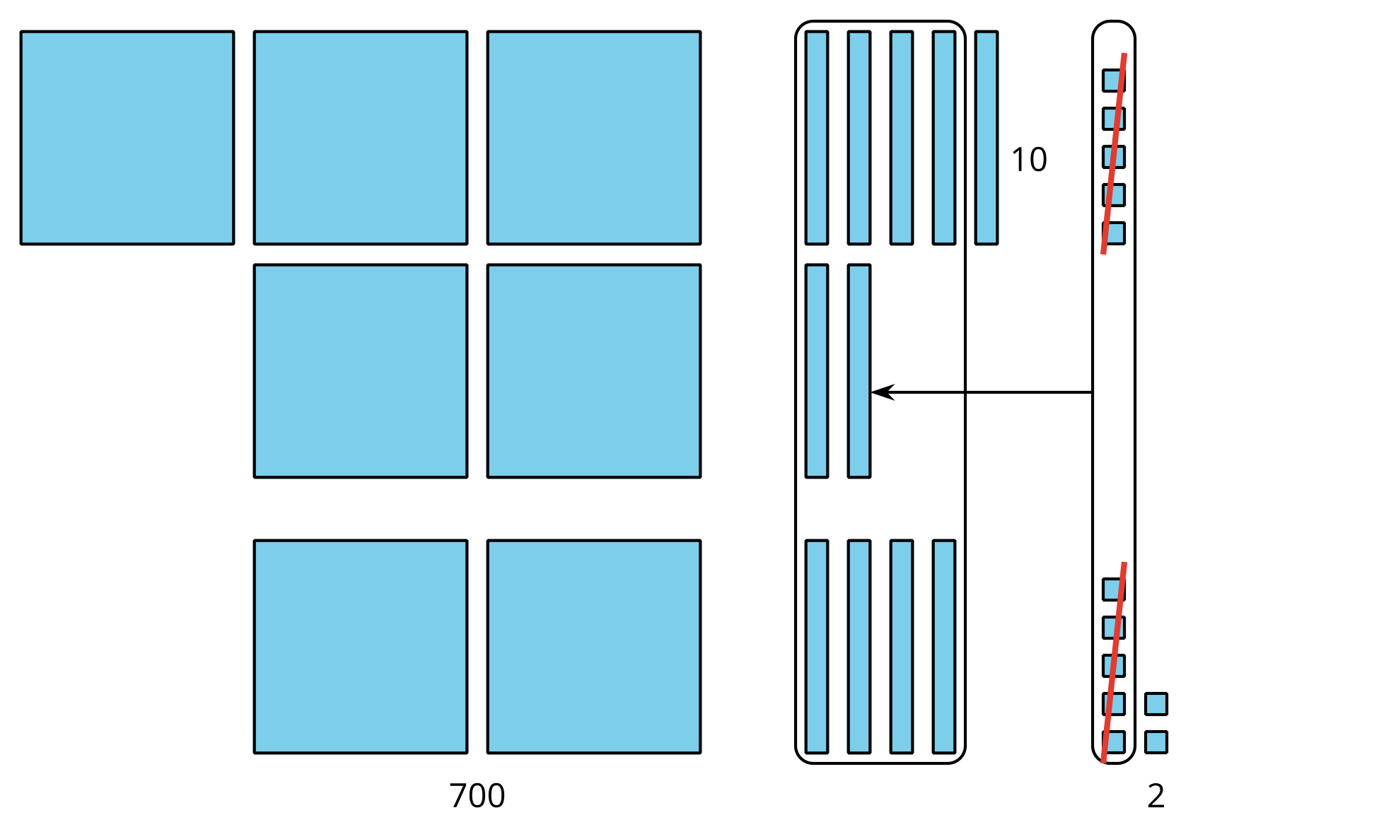
$700+10+2=712$
Did she find the correct value? Explain or show your thinking.

Student Responses
No. Sample response: Priya showed 565 and 247 and grouped 10 tens by circling them. She did not add the hundred she composed into the sum, so her answer is 100 less than it should be.

