Lesson 22: Solve Problems Involving Large Numbers
- Let’s solve problems by adding and subtracting.

Warm-up: True or False: Sums and Differences
Decide if each statement is true or false. Be prepared to explain your reasoning.
- $7,​000+3,​000=10,​000$
- $7,​180+3,​920=10,​100$
- $423,​450−42,​345=105$
- $400,​000−99,​999=311,​111$

22.1: The Fundraiser
A school’s track teams raised $41,560 from fundraisers and concession sales.
In the fall, the teams paid $3,180 for uniforms, $1,425 in entry fees for track meets, and $18,790 in travel costs.
In the spring, the teams paid $10,475 in equipment replacement, $1,160 for competition expenses, and $912 for awards and trophies.
- Was the amount collected enough to cover all the payments? Explain or show how you know.
- If the amount collected was enough, how much money did the track teams have left after paying all the expenses? If it was not enough, how much did the track teams overspend? Explain or show how you know.

22.2: The Least and the Greatest of Them All
Your teacher will give you and your partner a set of 10 cards, each with a number between 0 and 9. Shuffle the cards and put them face down.
- Draw 3 cards. Use all 3 cards to form two different numbers that would give:
  - the greatest possible sum
  - 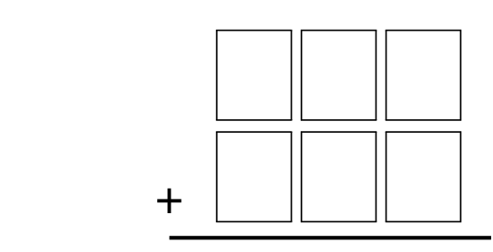
  - the least possible sum
  - the greatest possible difference
  - 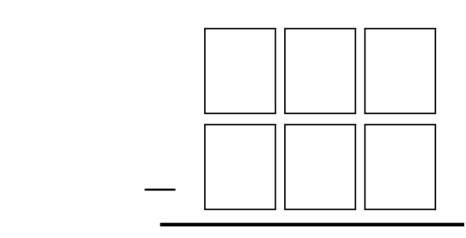
  - the least possible difference
- Shuffle the cards and draw 4 cards. Use them to form two different numbers that would give:
  - the greatest possible sum
  - 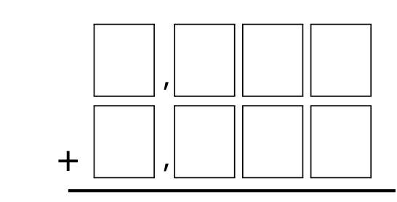
  - the least possible sum
  - the greatest possible difference
  - 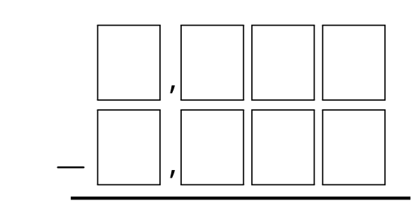
  - the least possible difference

Section Summary
Section Summary
In this section, we used our understanding of place value and expanded form to add and subtract large numbers using the standard algorithm.
We learned how to use the algorithm to keep track of addition of digits that results in a number greater than 9.
Whenever we have 10 in a unit, we make a new unit and record the new unit at the top of the column of numbers in the next place to the left.
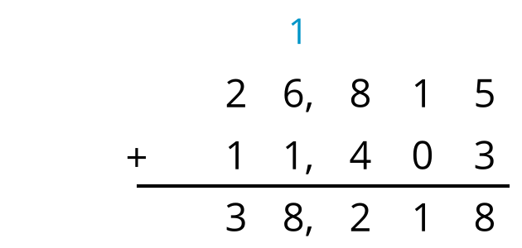
When we subtract numbers it may be necessary to decompose tens, hundreds, thousands or ten-thousands before subtracting.
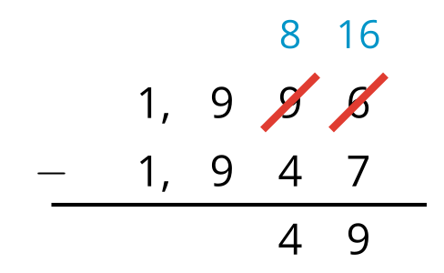
Finally, we learned that if the digit we are subtracting is a zero, we may need to decompose one unit of the digit in the next place to the left.
Sometimes, it is necessary to look two or more places to the left to find a unit to decompose. For example, here is one way to decompose a ten and a thousand to find $2,​050−1,​436$.
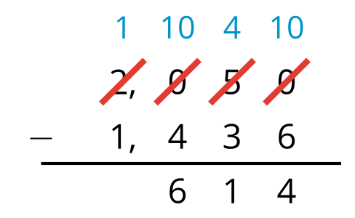
© CC BY 2021 Illustrative Mathematics®

