Unit 6 Lesson 25: Cylinders, Cones, and Spheres

1 Sphere Arguments (Warm up)

Student Task Statement
Four students each calculated the volume of a sphere with a radius of 9 centimeters and they got four different answers.
- Han thinks it is 108 cubic centimeters.
- Jada got $108π$ cubic centimeters.
- Tyler calculated 972 cubic centimeters.
- Mai says it is $972π$ cubic centimeters.
Do you agree with any of them? Explain your reasoning.

2 Sphere’s Radius (Optional)

Student Task Statement
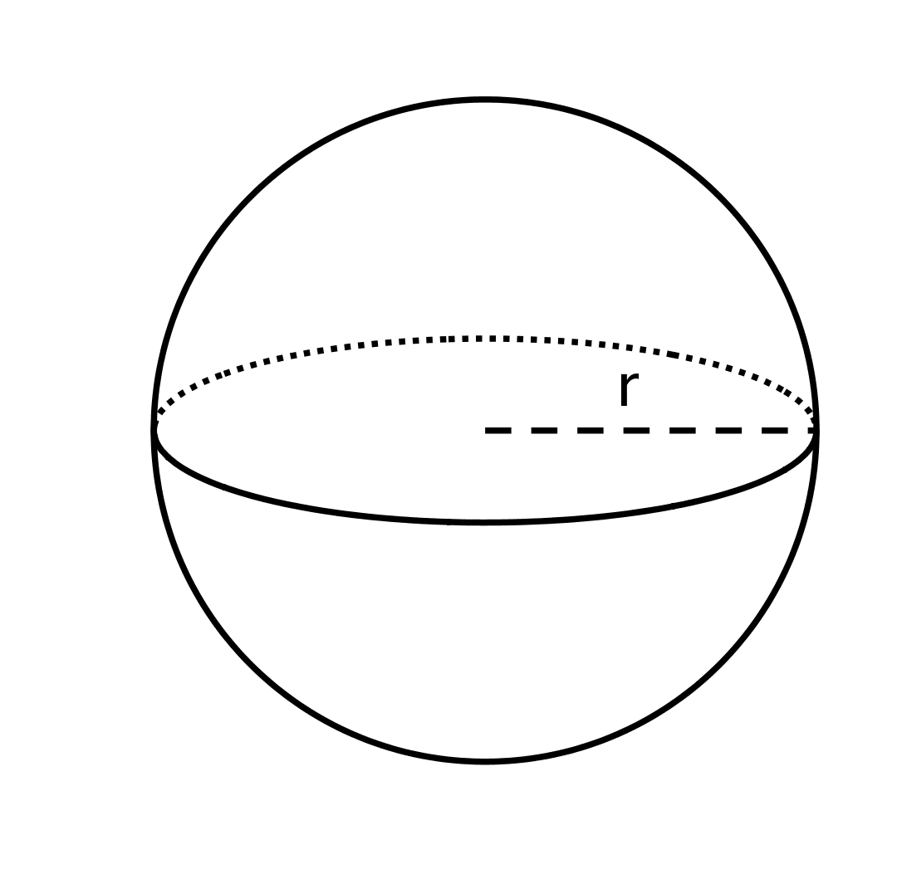
The volume of this sphere with radius $r$ is $V=288π$. This statement is true:
$288π=\frac{4}{3}r^{3}π.$ What is the value of $r$ for this sphere? Explain how you know.

3 Info Gap: Unknown Dimensions

Student Task Statement
Your teacher will give you either a problem card or a data card. Do not show or read your card to your partner.
If your teacher gives you the problem card:
- Silently read your card and think about what information you need to be able to answer the question.
- Ask your partner for the specific information that you need.
- Explain how you are using the information to solve the problem.
- Continue to ask questions until you have enough information to solve the problem.
- Share the problem card and solve the problem independently.
- Read the data card and discuss your reasoning.
If your teacher gives you the data card:
- Silently read your card.
- Ask your partner “What specific information do you need?” and wait for them to ask for information.
- If your partner asks for information that is not on the card, do not do the calculations for them. Tell them you don’t have that information.
- Before sharing the information, ask “Why do you need that information?” Listen to your partner’s reasoning and ask clarifying questions.
- Read the problem card and solve the problem independently.
- Share the data card and discuss your reasoning.
Pause here so your teacher can review your work. Ask your teacher for a new set of cards and repeat the activity, trading roles with your partner.

4 The Right Fit

Student Task Statement
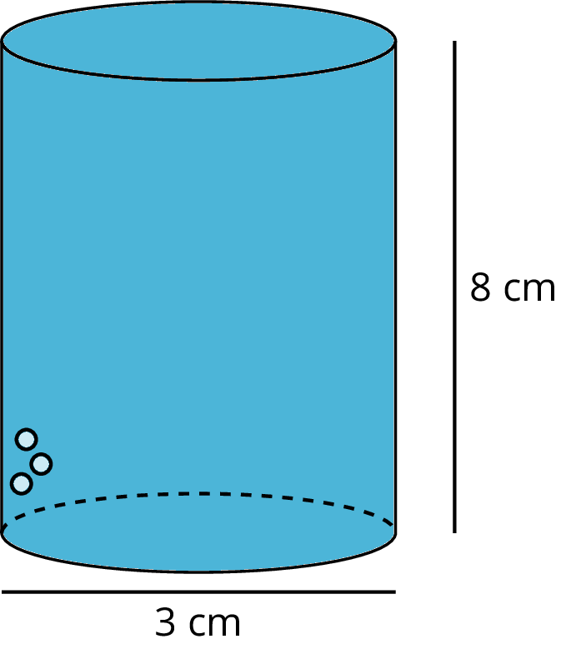
A cylinder with diameter 3 centimeters and height 8 centimeters is filled with water. Decide which figures described here, if any, could hold all of the water from the cylinder. Explain your reasoning.
- Cone with a height of 8 centimeters and a radius of 3 centimeters.
- Cylinder with a diameter of 6 centimeters and height of 2 centimeters.
- Rectangular prism with a length of 3 centimeters, width of 4 centimeters, and height of 8 centimeters.
- Sphere with a radius of 2 centimeters.
© CC BY Open Up Resources. Adaptations CC BY IM.

