Unit 6 Lesson 8: Analyzing Bivariate Data

1 Speed vs. Step Length (Warm up)

Student Task Statement
A researcher found an association between a dog’s stride length and its speed: the longer a dog’s steps, the faster it goes. The predicted speed in meters per second, $s$, as a function of step length in meters, $l$, is
$s=4l−1.6$
What does the rate of change of the function tell you about the association between stride length and speed?

2 Animal Brains

Student Task Statement
Is there an association between the weight of an animal’s body and the weight of the animal’s brain?
Use the data in the table to make a scatter plot. Are there any outliers?
animal | body weight (kg) | brain weight (g)
cow | 465 | 423
grey wolf | 36 | 120
goat | 28 | 115
donkey | 187 | 419
horse | 521 | 655
potar monkey | 10 | 115
cat | 3 | 26
giraffe | 529 | 680
gorilla | 207 | 406
human | 62 | 1,320
rhesus monkey | 7 | 179
kangaroo | 35 | 56
sheep | 56 | 175
jaguar | 100 | 157
chimpanzee | 52 | 440
pig | 192 | 180
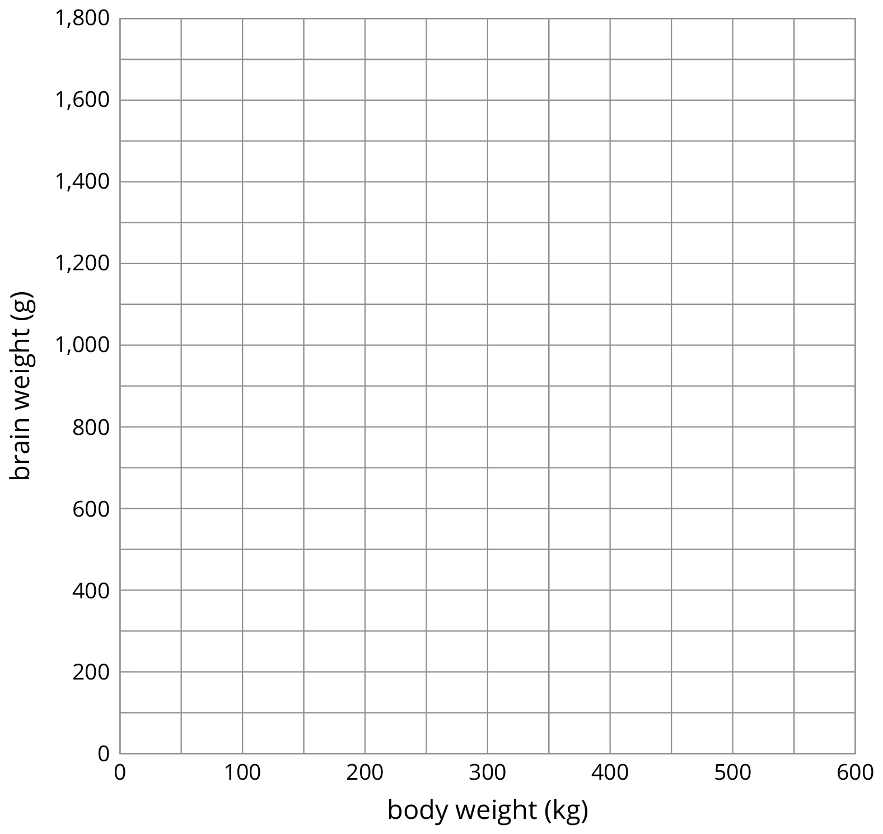
- After removing the outliers, does there appear to be an association between body weight and brain weight? Describe the association in a sentence.
- Using a piece of pasta and a straightedge, fit a line to your scatter plot, and estimate its slope. What does this slope mean in the context of brain and body weight?
- Does the fitted line help you identify more outliers?

3 Equal Body Dimensions

Images for Launch
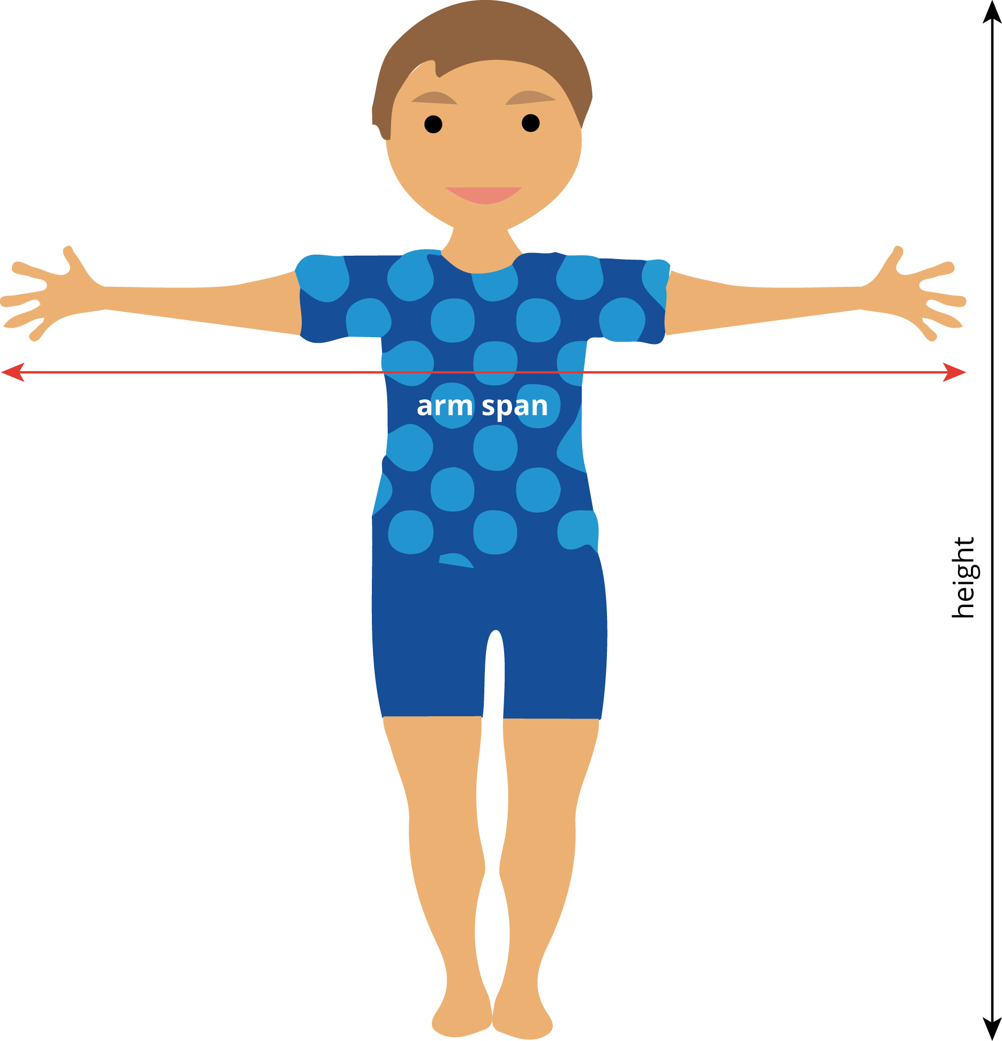

Student Task Statement
Earlier, your class gathered data on height and arm span.
- Sometimes a person’s arm span is the same as their height. Is this true for anyone in the class?
- Make a scatter plot for the arm span and height data, and describe any association.

- Is the line $y=x$ a good fit for the data? If so, explain why. If not, find the equation of a line that fits the data better.
- Examine the scatter plot. Which person in your class has the largest ratio between their arm span and their height? Explain or show your reasoning.
© CC BY Open Up Resources. Adaptations CC BY IM.

