Unit 2 Lesson 2: Writing Equations to Model Relationships (Part 1)

1 Math Talk: Percent of 200 (Warm up)

Student Task Statement
Evaluate mentally.
25% of 200
12% of 200
8% of 200
$p$% of 200

2 A Platonic Relationship

Student Task Statement
These three figures are called Platonic solids.

Tetrahedron
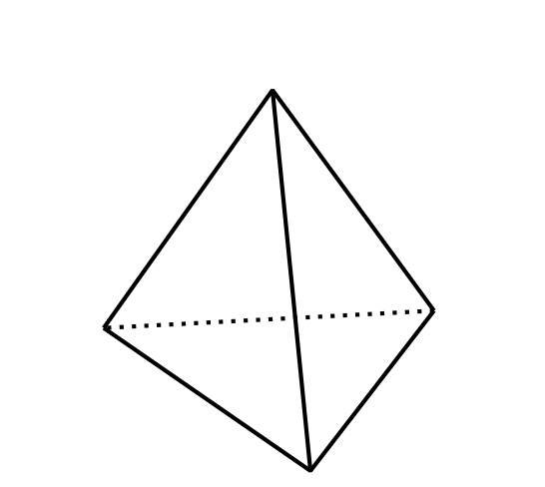

Cube
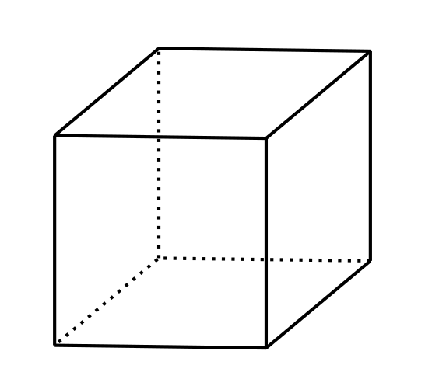

Dodecahedron
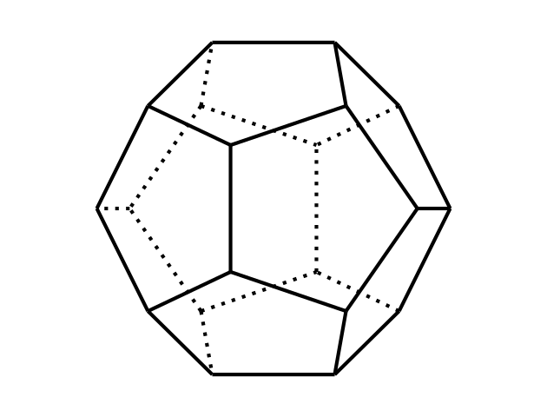
The table shows the number of vertices, edges, and faces for the tetrahedron and dodecahedron.
 | faces | vertices | edges
tetrahedron | 4 | 4 | 6
cube
dodecahedron | 12 | 20 | 30
- Complete the missing values for the cube. Then, make at least two observations about the number of faces, edges, and vertices in a Platonic solid.
- There are some interesting relationships between the number of faces ($F$), edges ($E$), and vertices ($V$) in all Platonic solids. For example, the number of edges is always greater than the number of faces, or $E>F$. Another example: The number of edges is always less than the sum of the number of faces and the number of vertices, or $E<F+V$.
- There is a relationship that can be expressed with an equation. Can you find it? If so, write an equation to represent it.

3 Blueberries and Earnings

Student Task Statement
- Write an equation to represent each situation.
  - Blueberries are $4.99 a pound. Diego buys $b$ pounds of blueberries and pays $14.95.
  - Blueberries are $4.99 a pound. Jada buys $p$ pounds of blueberries and pays $c$ dollars.
  - Blueberries are $d$ dollars a pound. Lin buys $q$ pounds of blueberries and pays $t$ dollars.
  - Noah earned $n$ dollars over the summer. Mai earned $275, which is $45 more than Noah did.
  - Noah earned $v$ dollars over the summer. Mai earned $m$ dollars, which is 45 dollars more than Noah did.
  - Noah earned $w$ dollars over the summer. Mai earned $x$ dollars, which is $y$ dollars more than Noah did.
- How are the equations you wrote for the blueberry purchases like the equations you wrote for Mai and Noah’s summer earnings? How are they different?

4 Car Prices

Student Task Statement
The tax on the sale of a car in Michigan is 6%. At a dealership in Ann Arbor, a car purchase also involves $120 in miscellaneous charges.
- There are several quantities in this situation: the original car price, sales tax, miscellaneous charges, and total price. Write an equation to describe the relationship between all the quantities when:
  - The original car price is $9,500.
  - The original car price is $14,699.
  - The total price is $22,480.
  - The original price is $p$.
- How would each equation you wrote change if the tax on car sales is $r$% and the miscellaneous charges are $m$ dollars?
© CC BY 2019 by Illustrative Mathematics®

