Unit 8 Lesson 3: Sample Spaces

1 Rolling Cubes (Warm up)

Student Task Statement
When rolling two standard number cubes, one of the possible outcomes is 1 and 1.
- What are the other possible outcomes?
- How many outcomes are in the sample space?

2 Spinner Sample Space

Student Task Statement
Each of the spinners is spun once.
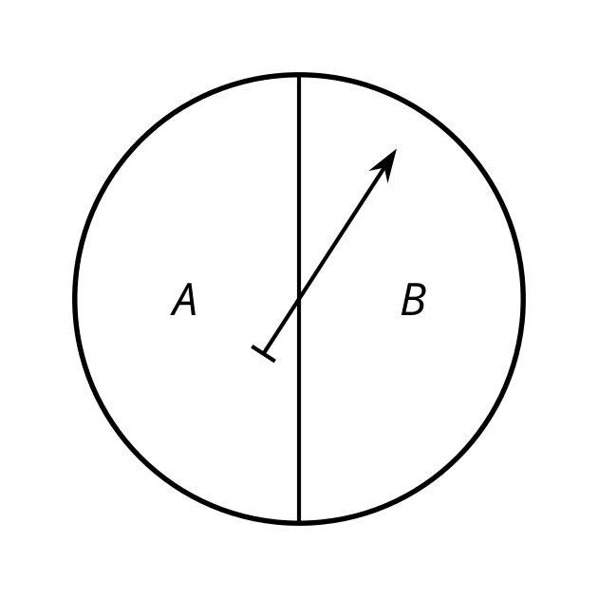
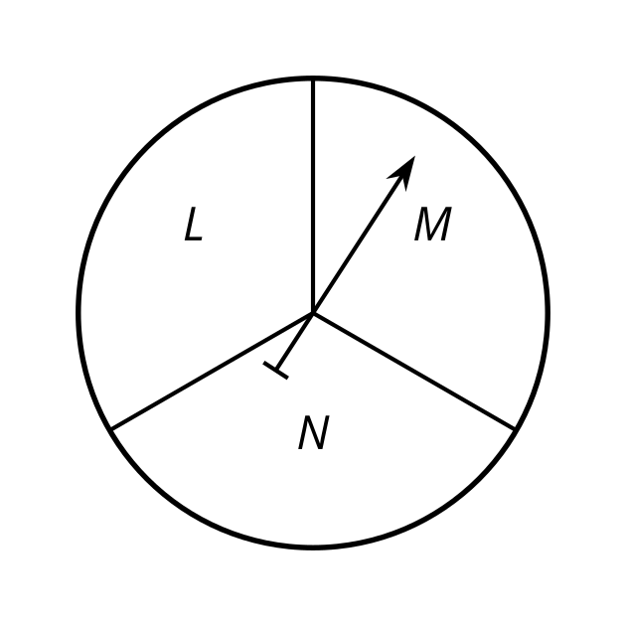
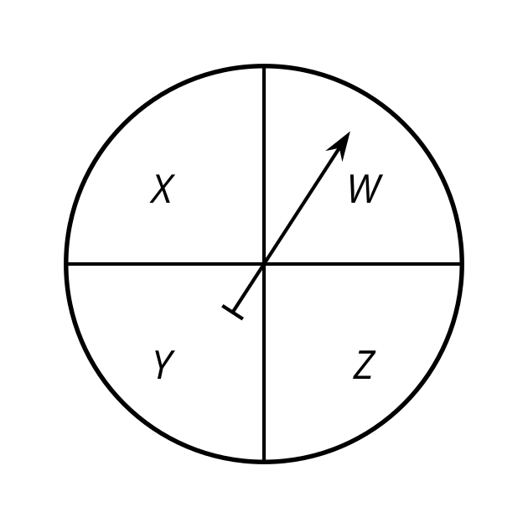
- Diego makes a list of the possible outcomes: ALW, ALX, ALY, ALZ, AMW, AMX, AMY, AMZ, ANW, ANX, ANY, ANZ, BLW, BLX, BLY, BLZ, BMW, BMX, BMY, BMZ, BNW, BNX, BNY, BNZ
- Tyler makes a table for the first two spinners.
 | - L | - M | - N
- A | - AL | - AM | - AN
- B | - BL | - BM | - BN
- Then he uses the outcomes from the table to include the third spinner.
 | - W | - X | - Y | - Z
- AL | - ALW | - ALX | - ALY | - ALZ
- AM | - AMW | - AMX | - AMY | - AMZ
- AN | - ANW | - ANX | - ANY | - ANZ
- BL | - BLW | - BLX | - BLY | - BLZ
- BM | - BMW | - BMX | - BMY | - BMX
- BN | - BNW | - BNX | - BNY | - BNZ
- Lin creates a tree to keep track of the outcomes.
- 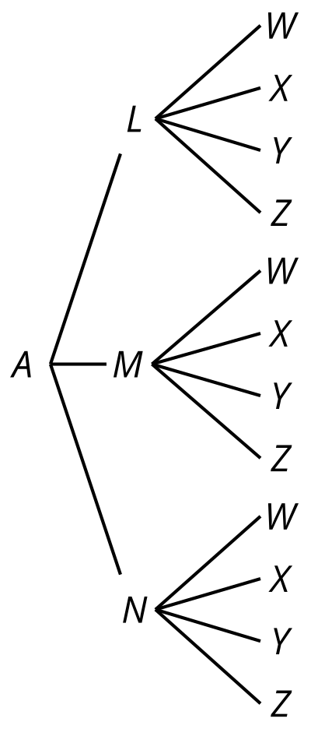
- 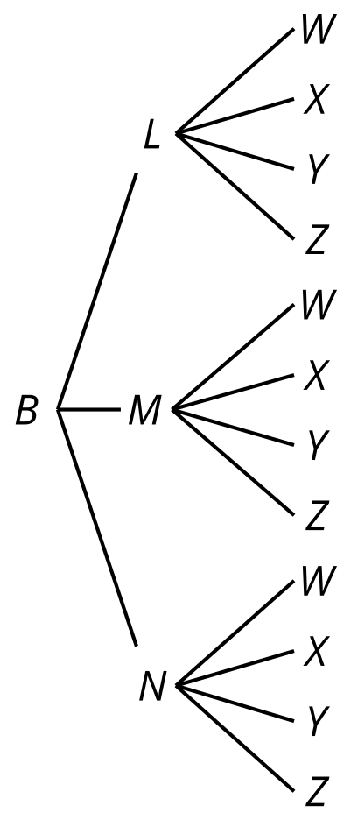
- How many outcomes are in the sample space for this experiment?
- One of the outcomes from Diego’s list is BLX. Where does this show up in Tyler's method? Where is it in Lin’s method?
- When spinning all three spinners, what is the probability that:
  - they point to the letters ANY? Explain your reasoning.
  - they point to the letters AMW, ANZ, or BNW? Explain your reasoning.
- If a fourth spinner that has 2 equal sections labeled S and T is added, how would each of the methods need to adjust?

Activity Synthesis
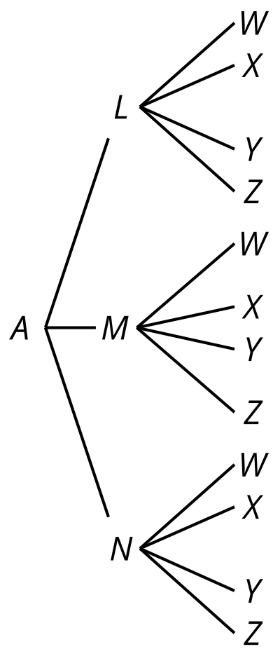
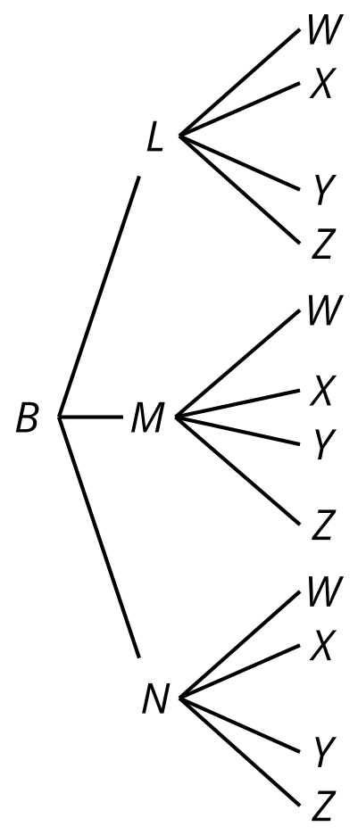

3 Sample Space Practice

Student Task Statement
List all the possible outcomes for each experiment.
- A standard number cube is rolled, then a coin is flipped.
- Four coins are flipped.
- The two spinners are spun.
- 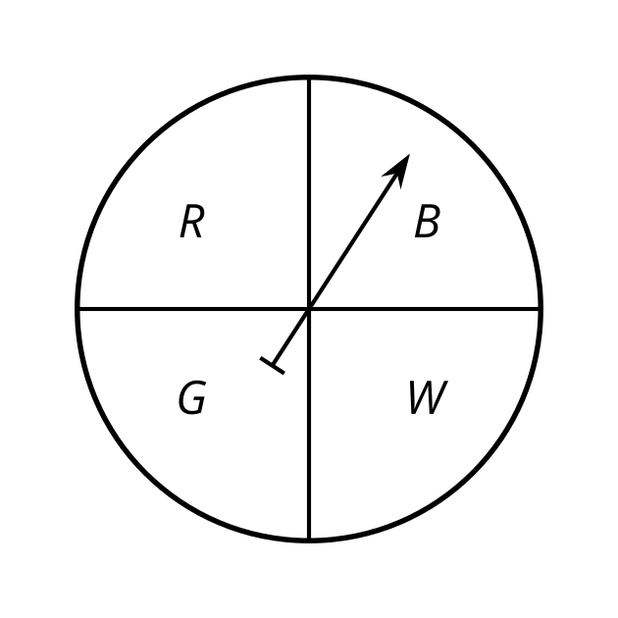
- 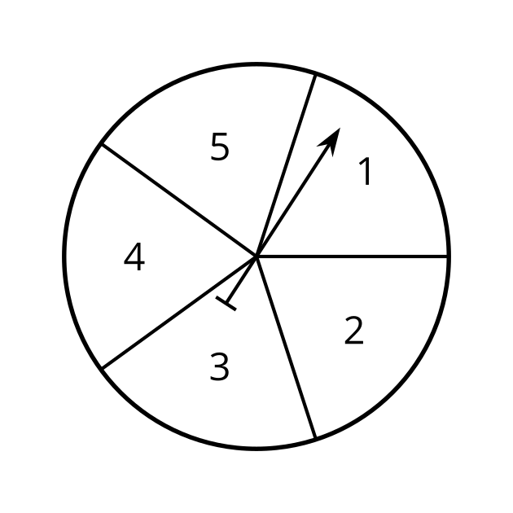
- A class block is chosen from 1, 2, 3, 4, or 5, then a subject is chosen from English or math.
© CC BY 2019 by Illustrative Mathematics®

