Lesson 3: Thousandths in Expanded Form
- Let's represent thousandths.

Warm-up: Which One Doesn't Belong: Different Ways to Express a Decimal Number
Which one doesn't belong?
- $26÷100$
- $0.26$
- $26×0.001$
- $\left(2×0.1\right)+\left(6×0.01\right)$

3.1: Expanded Form

  - Explain or show why the shaded region represents $\left(4×0.1\right)+\left(1×0.01\right)+\left(9×0.001\right)$.
  - 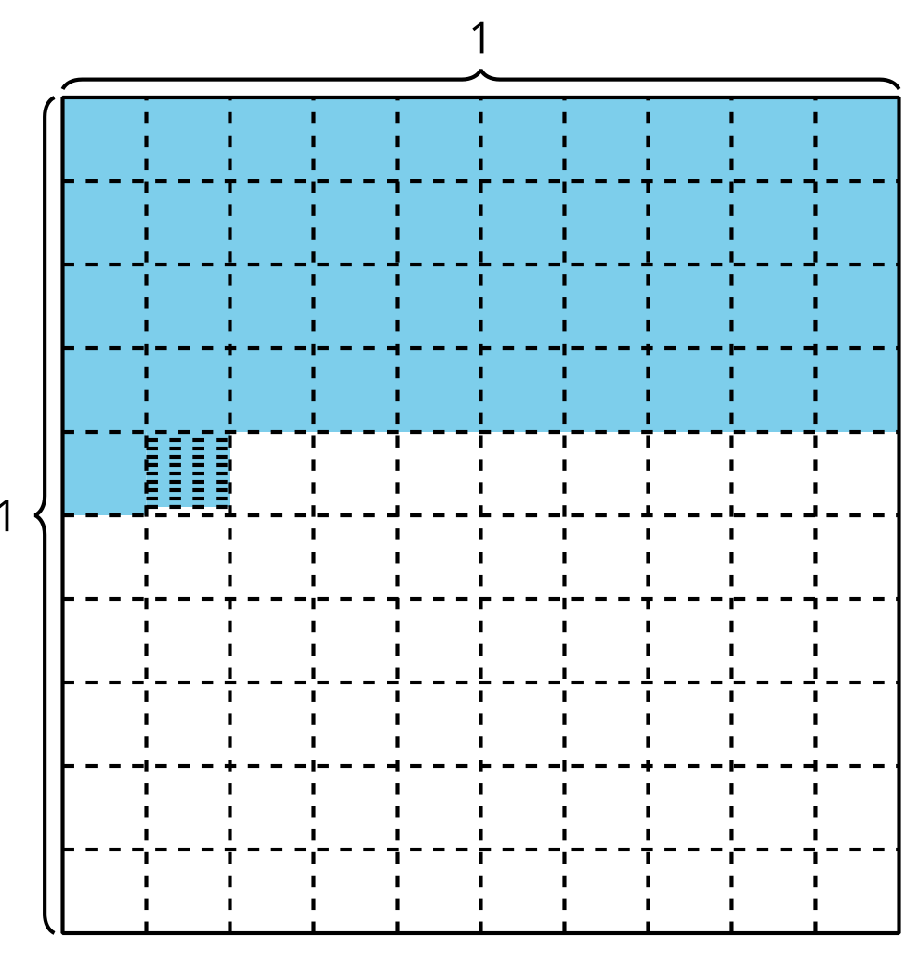
  - What decimal number represents the shaded region?

  - Shade the grid to represent $\left(8×0.1\right)+\left(3×0.01\right)+\left(5×0.001\right)$.
  - Write the number $\left(8×0.1\right)+\left(3×0.01\right)+\left(5×0.001\right)$ in decimal form.
- 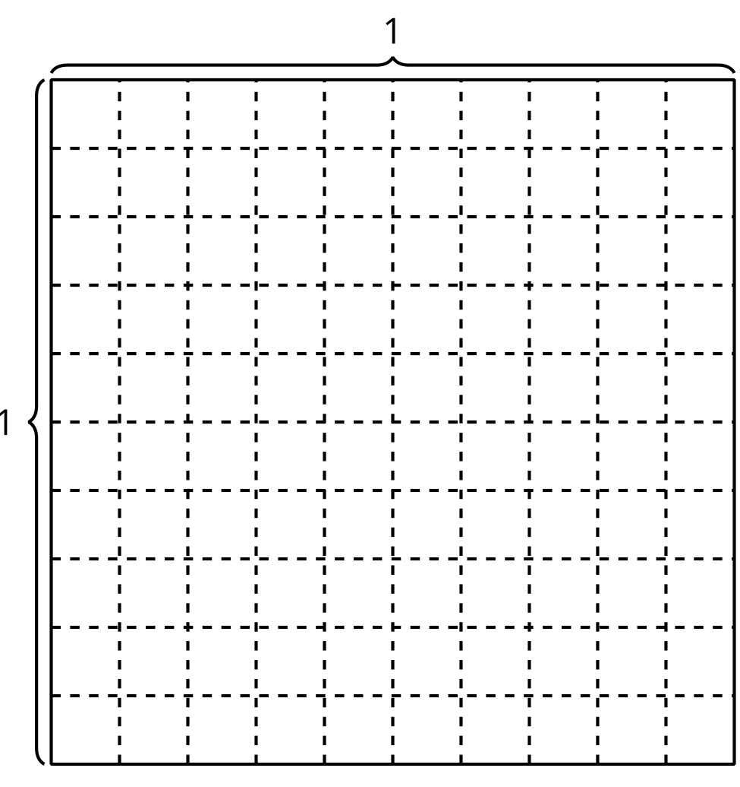
- Mai says that the decimal 0.105 represents $\left(1×0.1\right)+\left(5×0.01\right)$. Do you agree with Mai? Explain or show your reasoning.

3.2: Decimal Numbers in Numerous Ways
Represent each number in as many ways as you can.

- 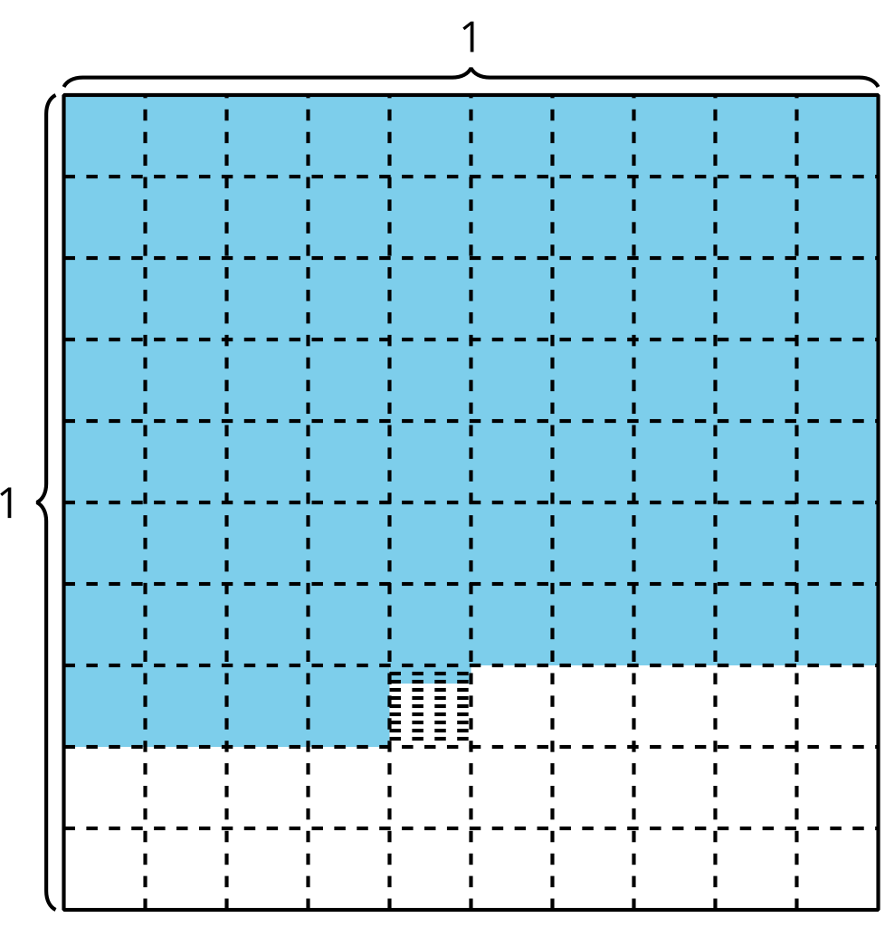
- $\frac{477}{1,000}$
- 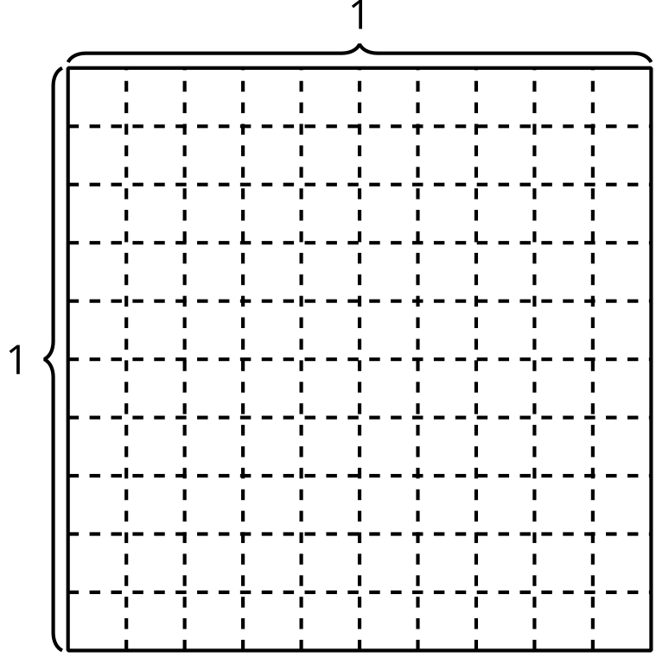
- one hundred thirty-six thousandths
- $\left(3×0.1\right)+\left(6×0.01\right)+\left(8×0.001\right)$
© CC BY 2021 Illustrative Mathematics®

