Unit 3 Lesson 10: Concepts of Division

WU Number Talk: Same Dividend, Different Divisor (Warm up)

Student Task Statement
Find the value of each expression mentally.
- $120÷12$
- $120÷6$
- $120÷3$
- $120÷2$

1 Share Pretzels

Images for Launch
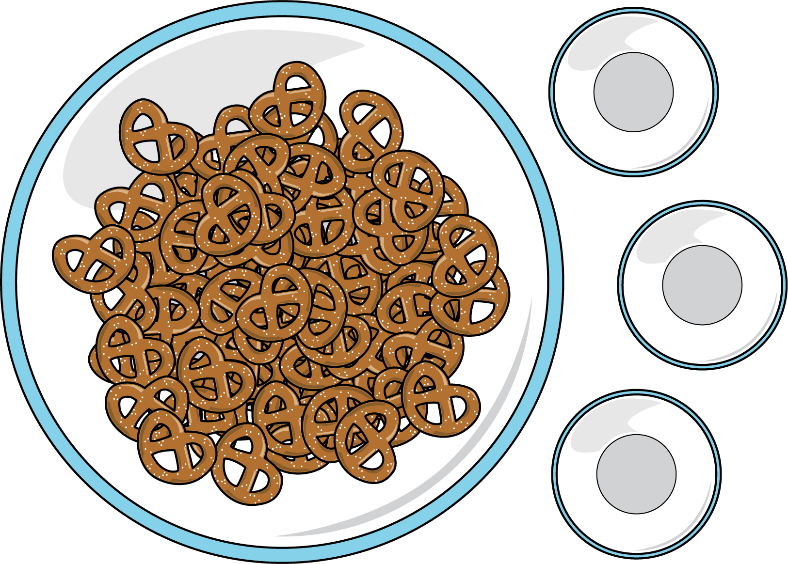

Student Task Statement
Order the situations from greatest to least based on the number of pretzels each student will get. Be prepared to explain your reasoning.
3 students equally share 42 pretzels.
14 students equally share 42 pretzels.
3 students equally share 24 pretzels.
3 students equally share 45 pretzels.
7 students equally share 42 pretzels.
3 students equally share 6 pretzels.
6 students equally share 42 pretzels.

2 Division Patterns

Student Task Statement
- Find the value of each expression.
  - $36÷3$
  - $12÷3$
  - $9÷3$
  - $6÷3$
  - $3÷3$
  - $1÷3$
- What patterns do you notice?
- Why is the quotient getting smaller?
- What do you know about this expression: $\frac{1}{3}÷3$?
- Draw a diagram to represent $\frac{1}{3}÷3$.
© CC BY 2021 Illustrative Mathematics®

