Unit 1 Lesson 17: Center Day 3

WU Number Talk: Add Ten More (Warm up)

Student Task Statement
Find the value of each sum mentally.
- $27+10$
- $27+10+10$
- $27+30$
- $37+30$

1 Revisit Counting Collections

Student Task Statement

2 Centers Choice Time

Student Task Statement
Choose a center.
What's Behind My Back?
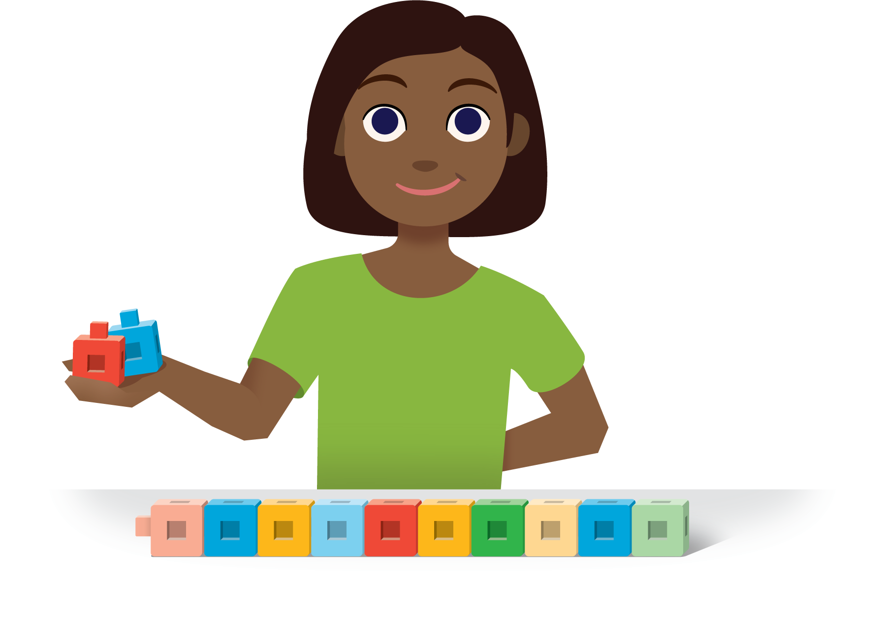
How Close?
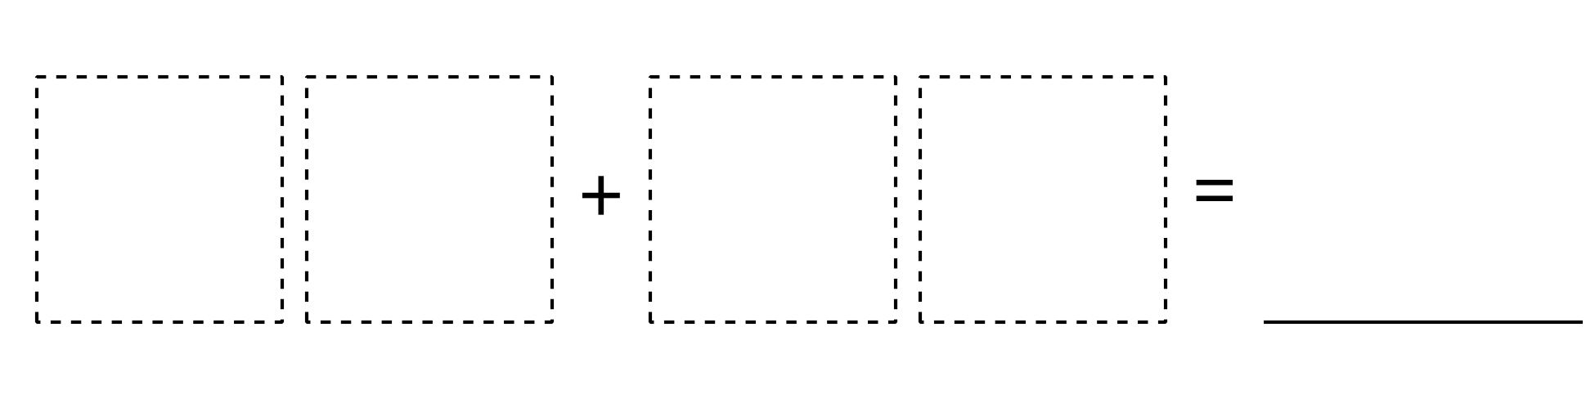
Number Puzzles
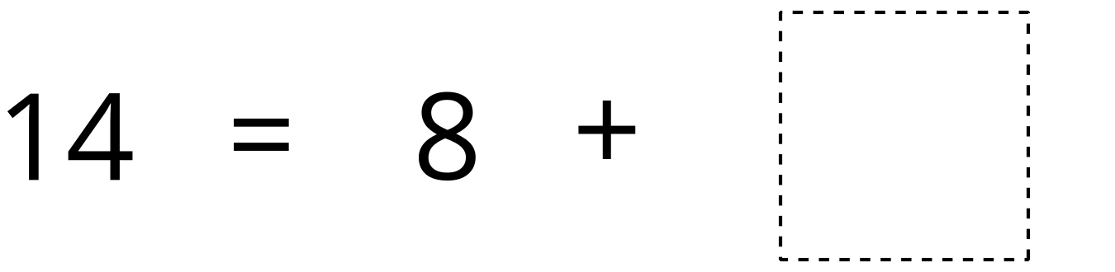
Sort and Display
© CC BY 2021 Illustrative Mathematics®

