Lesson 1: Make Sense of Data
- Let’s read and ask questions about data.

Warm-up: Notice and Wonder: Graphs
What do you notice? What do you wonder?
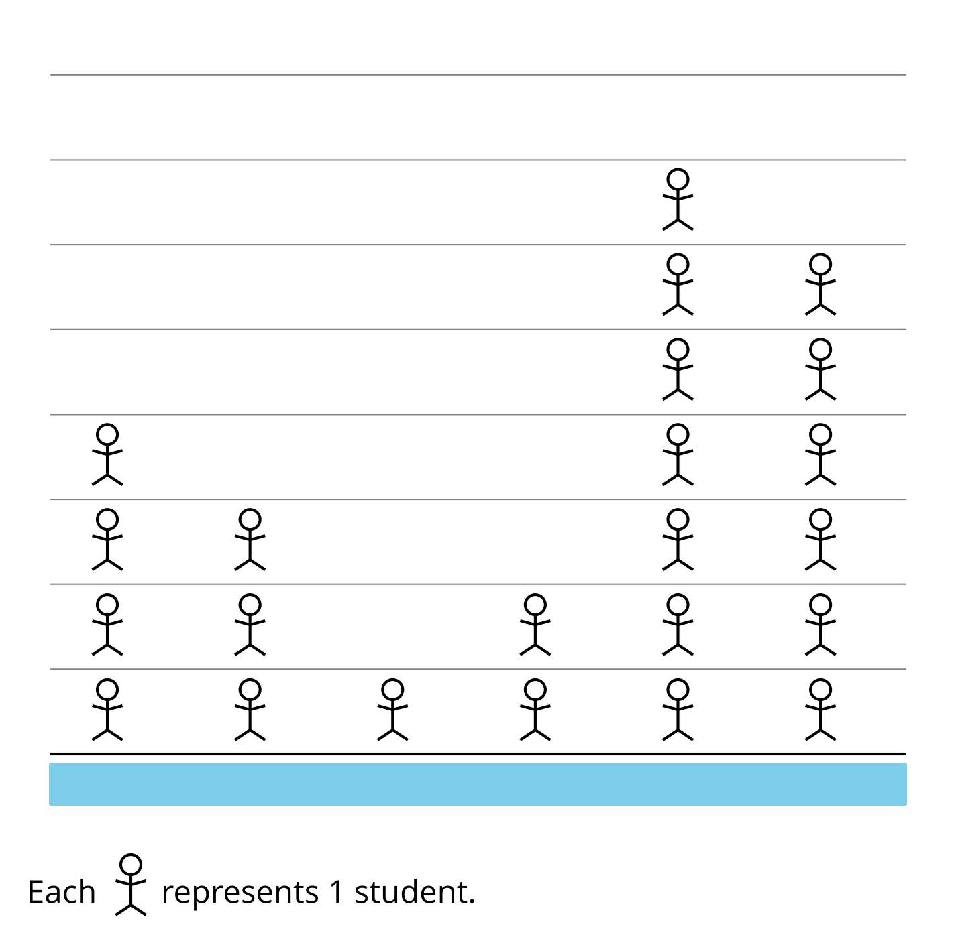

1.1: Picture Time
What could the categories be for this picture graph?
Be prepared to explain your reasoning.
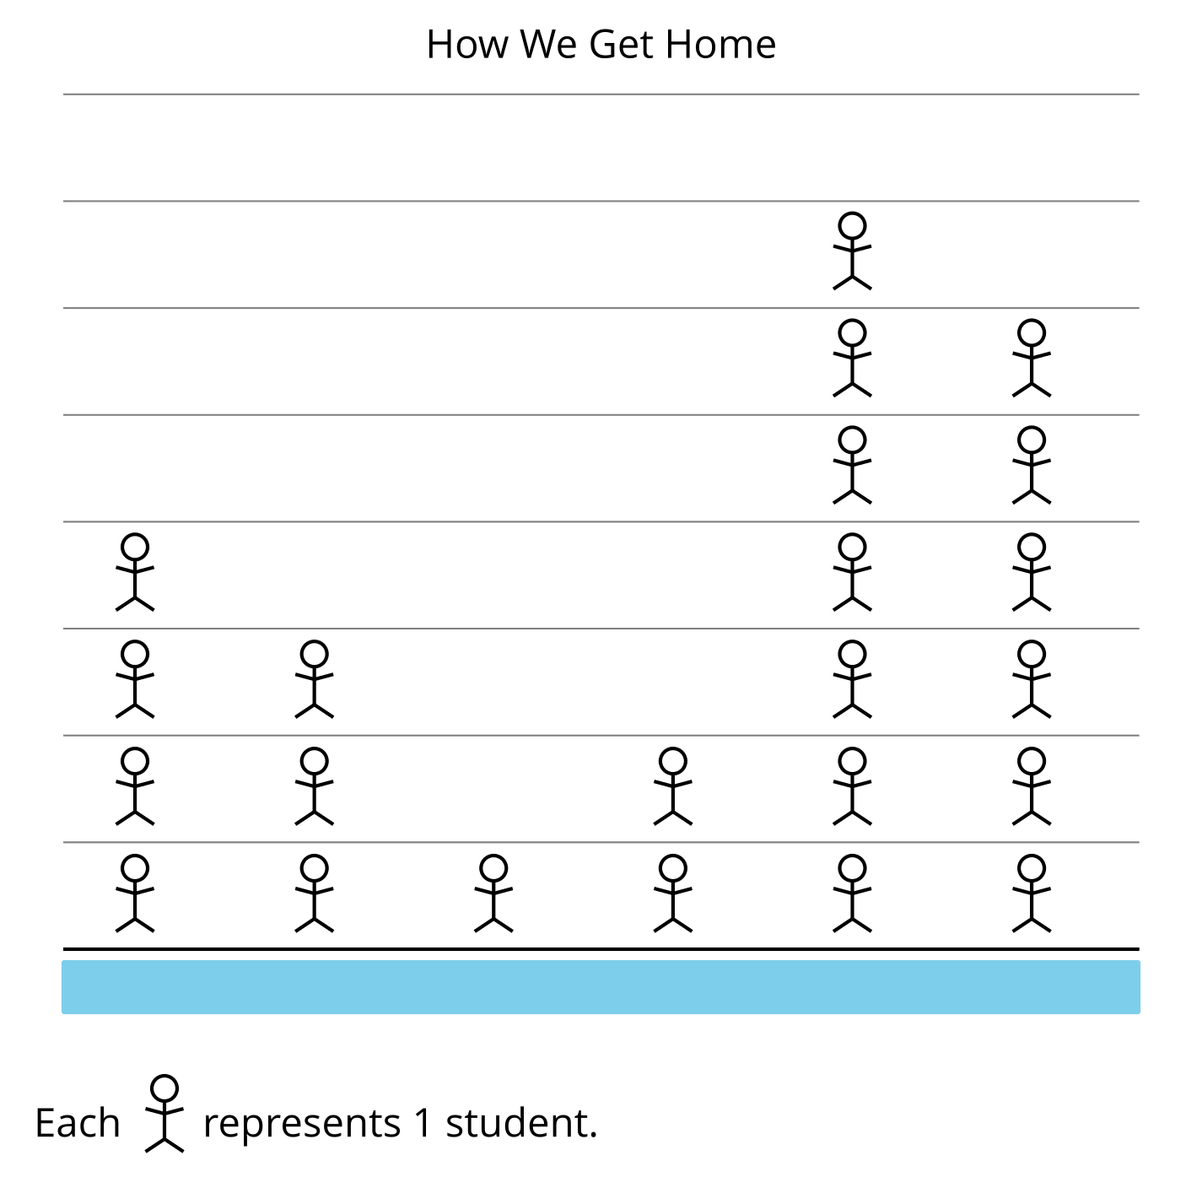

1.2: Picture Graphs and Bar Graphs
A group of students were asked, “How do you get home?” Their responses are shown in a picture graph and a bar graph.
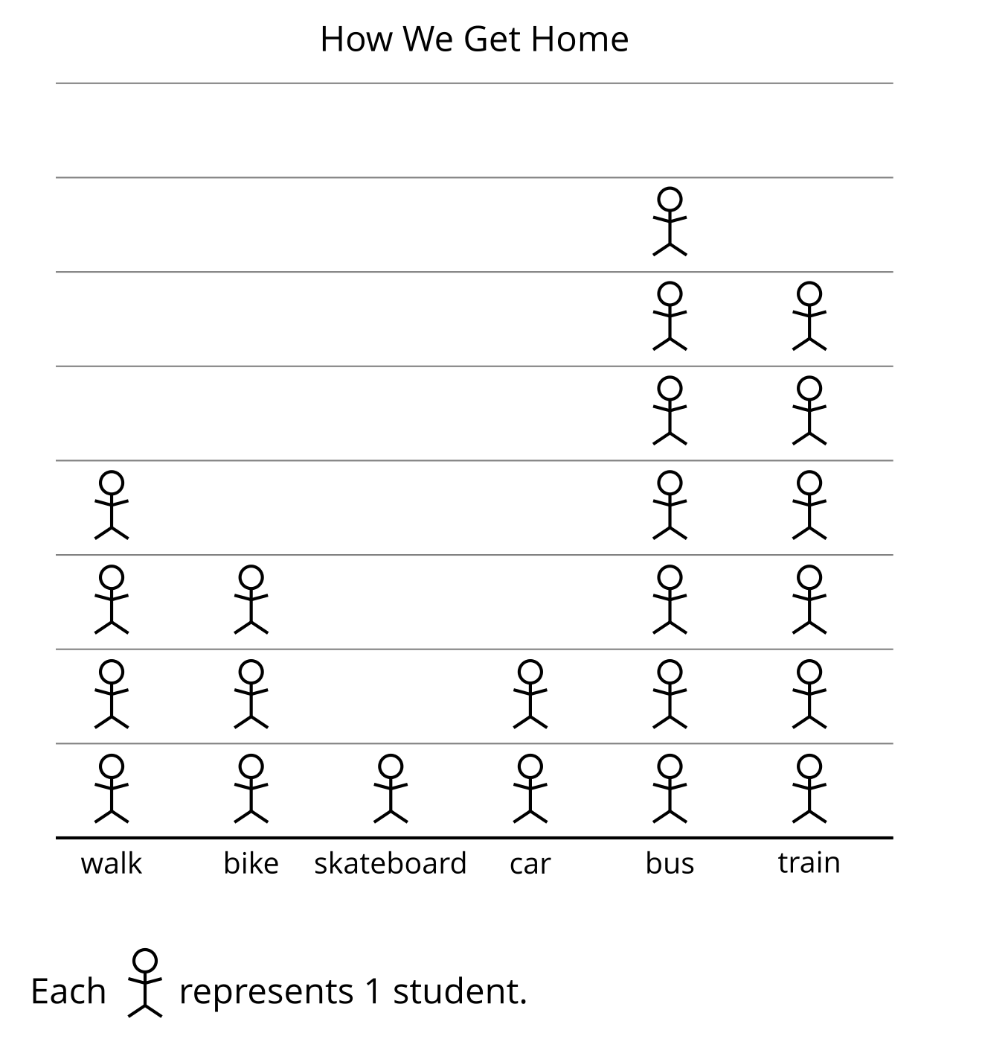
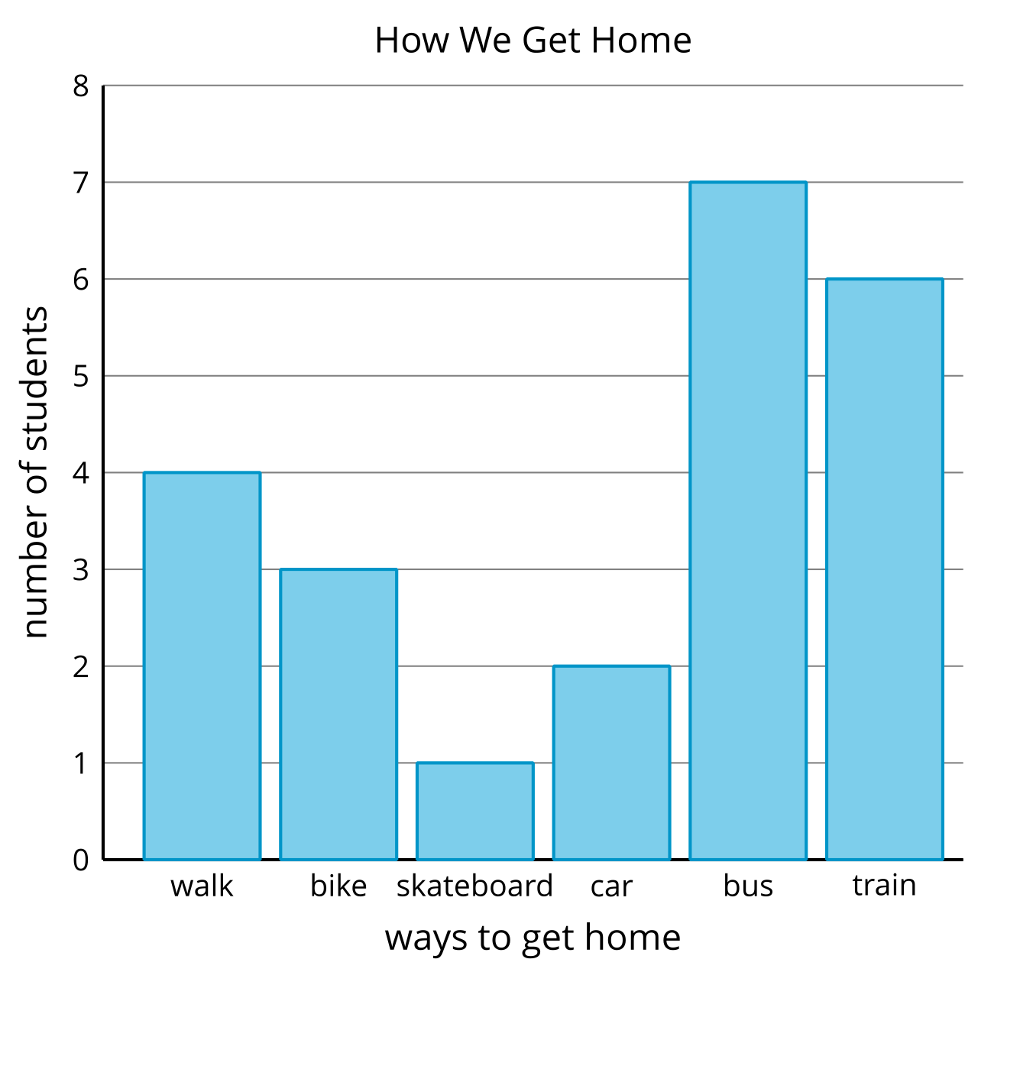
- How are the graphs the same? How are they different?
- What can we learn about how students get home based on the graphs?
- Write two questions you could ask about how students get home based on the graphs.
© CC BY 2021 Illustrative Mathematics®

