Unit 2 Lesson 16: Compare and Order Fractions

WU Number Talk: Multiples of 6 and 12 (Warm up)

Student Task Statement
Find the value of each expression mentally.
- $5×6$
- $5×12$
- $6×12$
- $11×12$

1 Compare Fractions Game

Student Task Statement
Play Compare Fractions with 2 players:
- Split the deck between the players.
- Each player turns over a card.
- Compare the fractions. The player with the greater fraction keeps both cards.
- If the fractions are equivalent, each player turns over one more card. The player with the greater fraction keeps all four cards.
- Play until you run out of cards. The player with the most cards at the end of the game wins.
fraction cards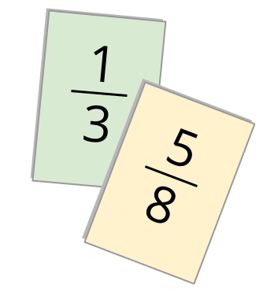
Play Compare Fractions with 3 or 4 players:
- The player with the greatest fraction wins the round.
- If 2 or more players have the greatest fraction, those players turn one more card over. The player with the greatest fraction keeps all the cards.
Record any sets of fractions that are challenging to compare here.
_________ and _________
_________ and _________
_________ and _________
_________ and _________

2 Fractions in Order

Student Task Statement
Put each set of fractions in order, from least to greatest. Be prepared to explain your reasoning.
- $\frac{3}{12} \frac{2}{4} \frac{2}{3} \frac{1}{8}$
- $\frac{8}{5} \frac{5}{6} \frac{11}{12} \frac{11}{10}$
- $\frac{21}{20} \frac{9}{10} \frac{6}{5} \frac{101}{100}$
- $\frac{5}{8} \frac{2}{5} \frac{3}{7} \frac{3}{6}$
© CC BY 2021 Illustrative Mathematics®

