Lesson 23: Bees are Buzzing
- Let’s investigate insect populations.

Warm-up: Estimation Exploration: Bees
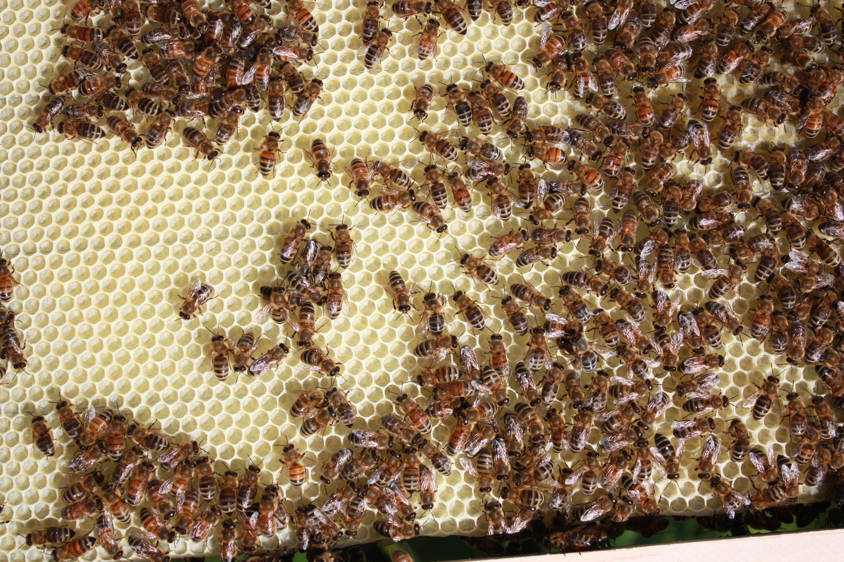
Record an estimate that is:
too low | about right | too high

23.1: Termites, Ants, and Bees
Here is some information about insects:
Termites
- Size of a colony: 100–1,000,000
- A queen lives for 30–50 years.
- There are 3,000–3,500 species of termites.
- The length of a termite is 4 to 15 millimeters.
- In some species, the mature queen may produce around 40,000 eggs a day.
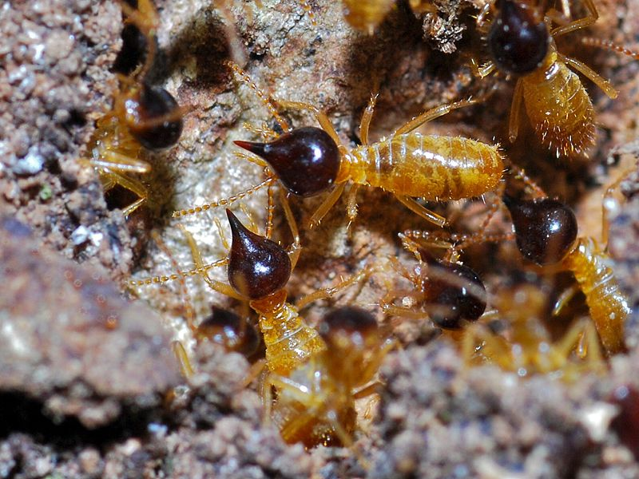
Odorous House Ants
- Size of colony: up to 100,000
- A queen lives for 300–1,800 days.
- The length of an ant is 1.5–3.2 millimeters.
- Foraging ants travel up to 700 feet from their nests.
- There are 12,000–22,000 possible species.
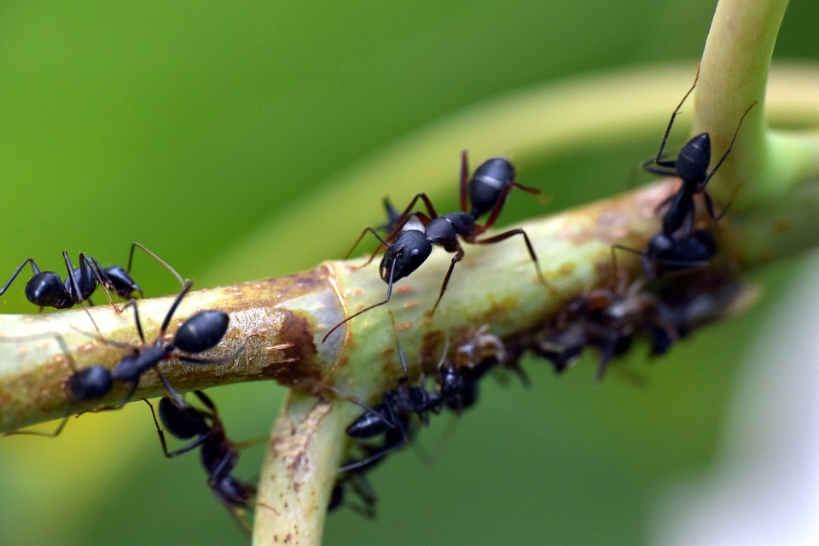
Honey Bees
- Size of a hive: 10,000–60,000
- There are around 500 drones in a hive.
- A queen can lay about 1,500–2,000 eggs each day.
- A hive produces 7–40 liters of honey in a season.
- The length of a bee is 10–20 millimeters.
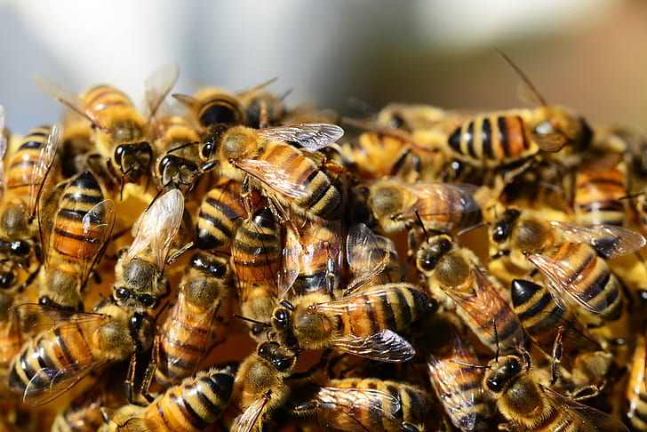
- Here are some numbers that could represent facts about termites, house ants, and honey bees. What might each number represent?
- number | - what it might represent
- 2.4
- 8
- 487
- 1,794
- 6,905
- 20,799
- 530,097
- Add another number to the list. What about the insects might this number represent?
- Discuss your answers with your partner. Be prepared to show or explain your reasoning.

23.2: Bee Population
An entomologist records the number of bees in their beehive over the course of several months. They record:
- the number of bees at the beginning of the month
- how many bees left (and didn’t return) during the month
- how many new bees were added to the hive during the month
Unfortunately, some of the entries in the table are missing.
- Complete the missing information in the table.
- month | - bees in the hive at the beginning of the month | - new bees | - bees that left the hive
- May | - 20,000 | - 9,378 | - 342
- June |  | - 15,870 | - 970
- July |  | - 14,965
- August | - 58,107 |  | - 28,980
- September | - 30,017 | - No data | - No data
- Discuss your responses with your partner. Be prepared to show or explain your reasoning.
© CC BY 2021 Illustrative Mathematics®

