Unit 7 Lesson 2: Inscribed Angles

1 Notice and Wonder: A New Angle (Warm up)

Student Task Statement
What do you notice? What do you wonder?

2 A Central Relationship

Student Task Statement
Here is a circle with central angle $QAC$.
- Use a protractor to find the approximate degree measure of angle $QAC$.
- Mark a point $B$ on the circle that is not on the highlighted arc from $C$ to $Q$. Each member of your group should choose a different location for point $B$. Draw chords $BC$ and $BQ$. Use a protractor to find the approximate degree measure of angle $QBC$.
- Share your results with your group. What do you notice about your answers?
- Make a conjecture about the relationship between an inscribed angle and the central angle that defines the same arc.

Activity Synthesis

$m∠BCA=\frac{1}{2}m∠BOA$

3 Similarity Returns

Student Task Statement
The image shows a circle with chords $CD,CB,ED,$ and $EB$. The highlighted arc from point $C$ to point $E$ measures 100 degrees. The highlighted arc from point $D$ to point $B$ measures 140 degrees.
Prove that triangles $CFD$ and $EFB$ are similar.

Images for Activity Synthesis
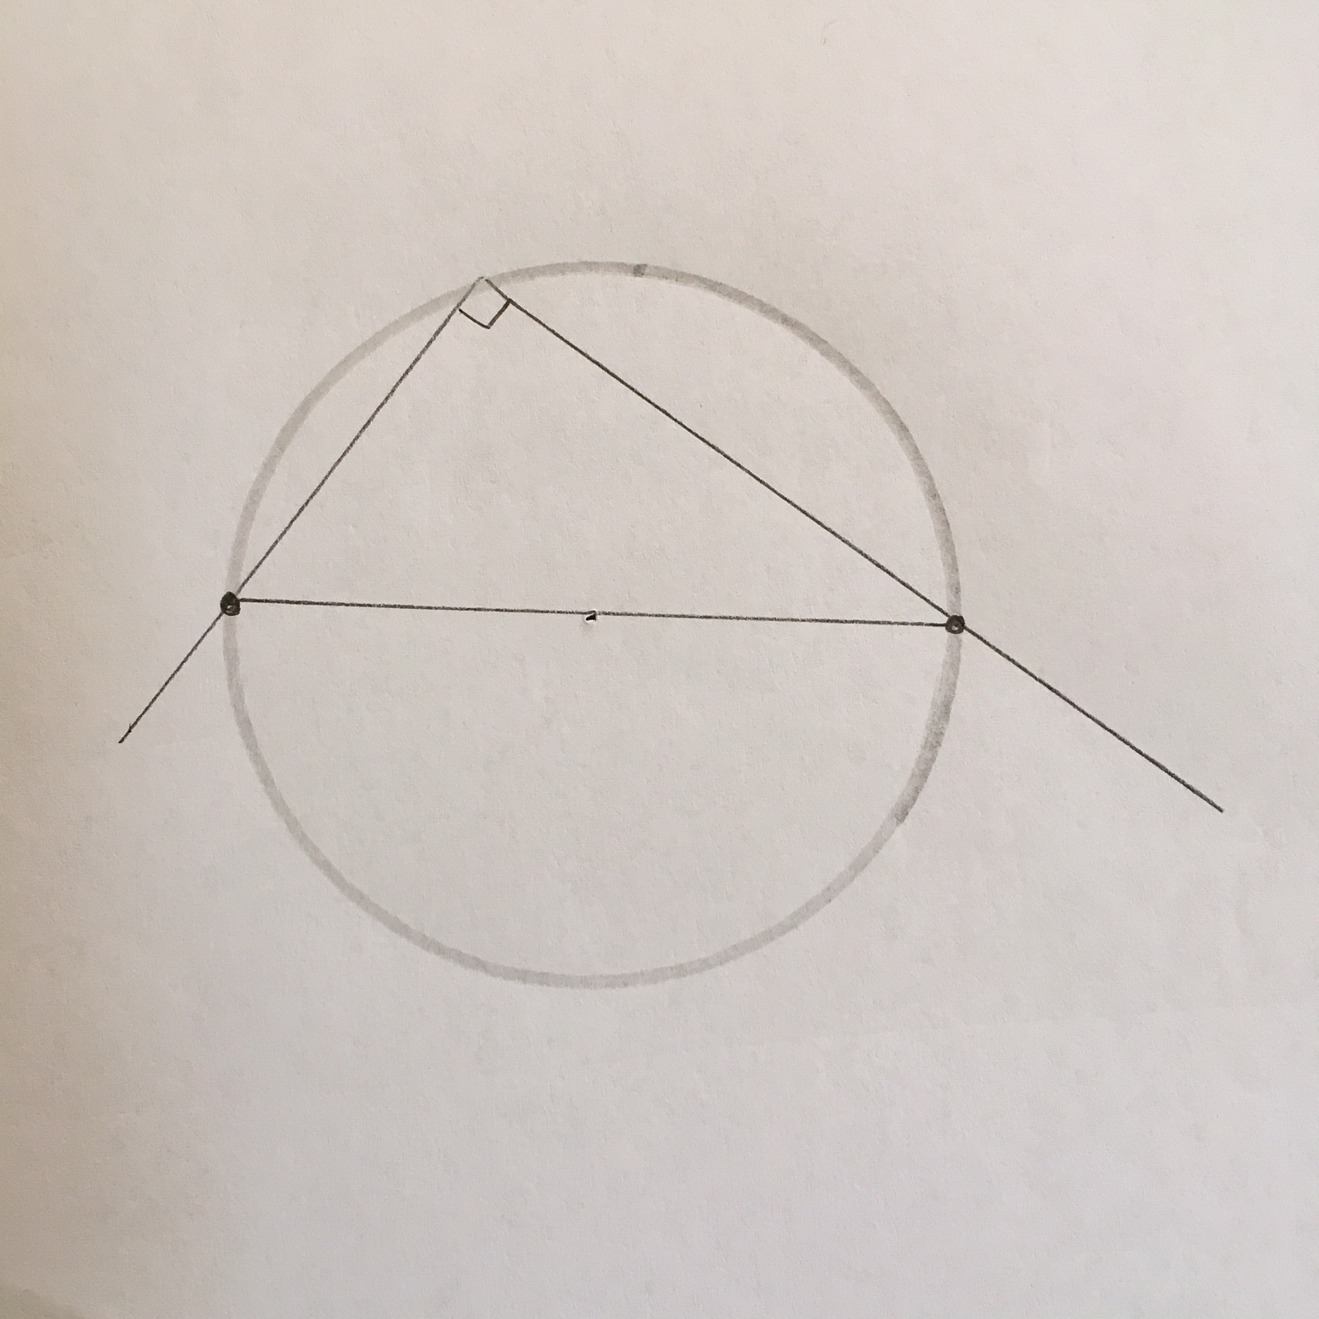
© CC BY 2019 by Illustrative Mathematics®

