Unit 8 Lesson 5: Combining Events

1 Notice and Wonder: Birds and Bats (Warm up)

Student Task Statement
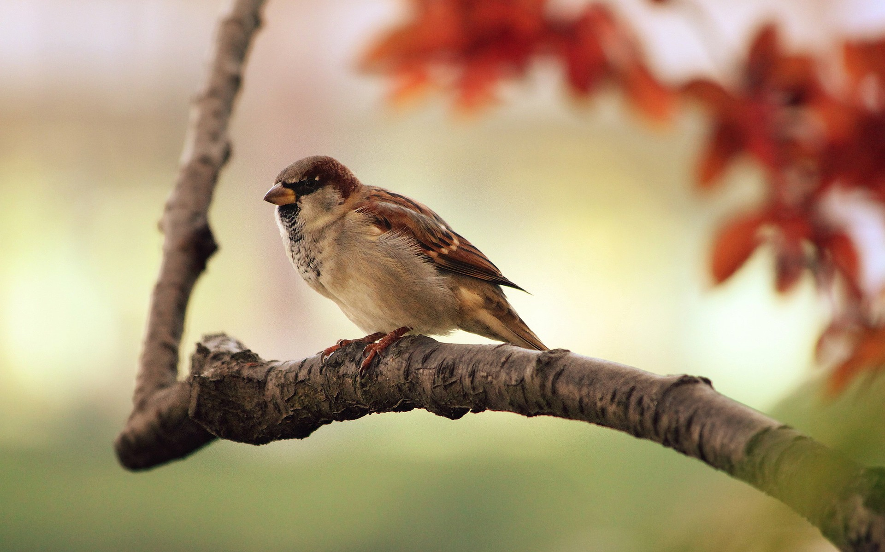
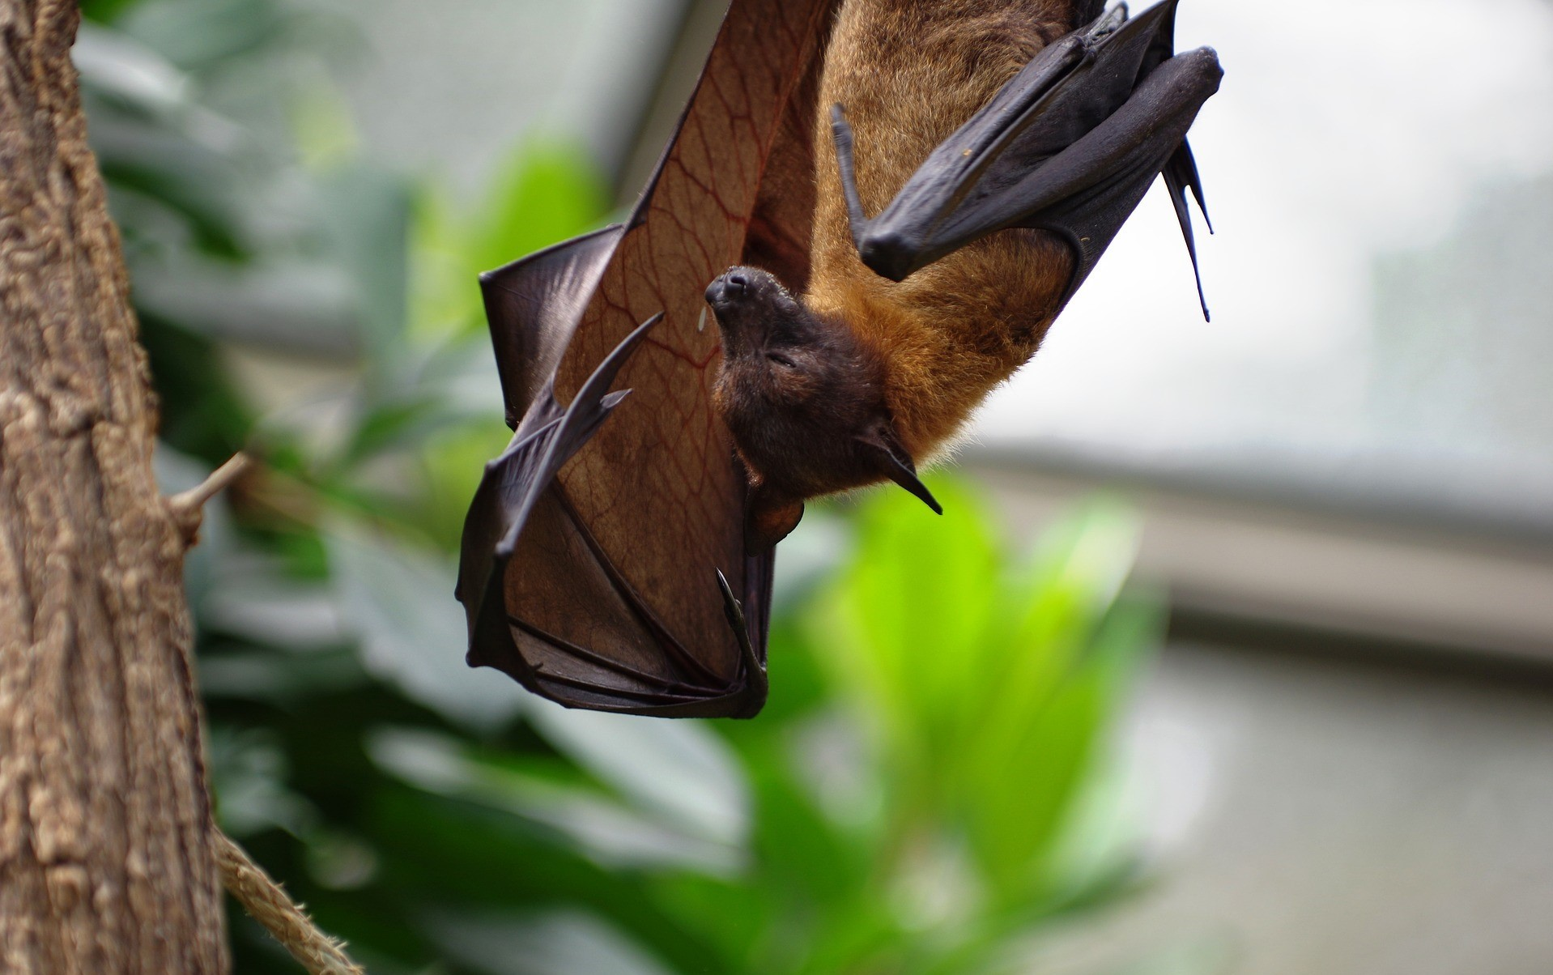
What do you notice? What do you wonder?
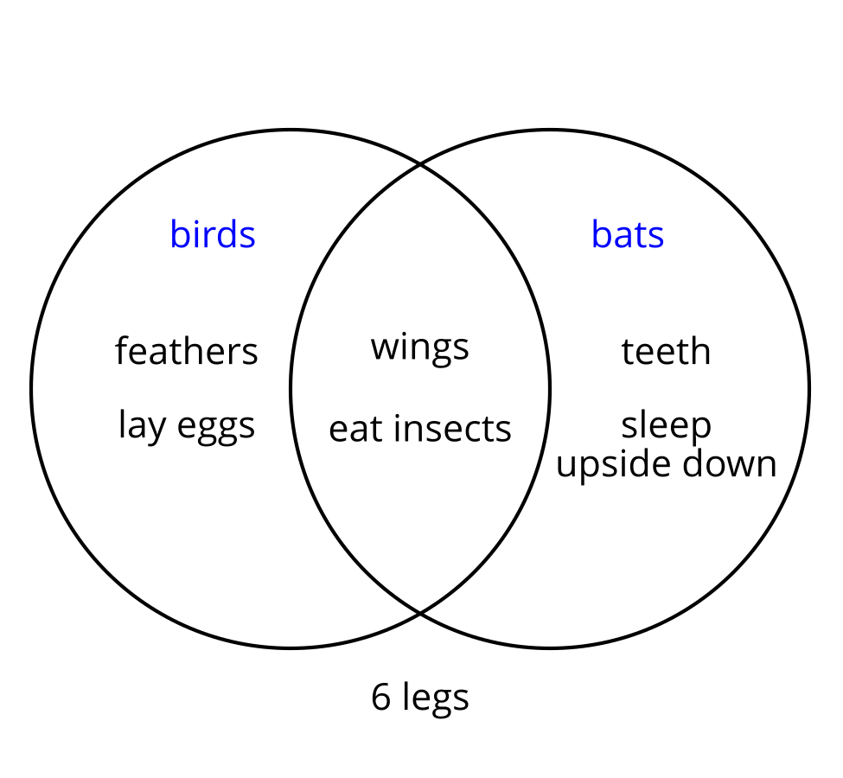

2 Eventful Islands

Student Task Statement
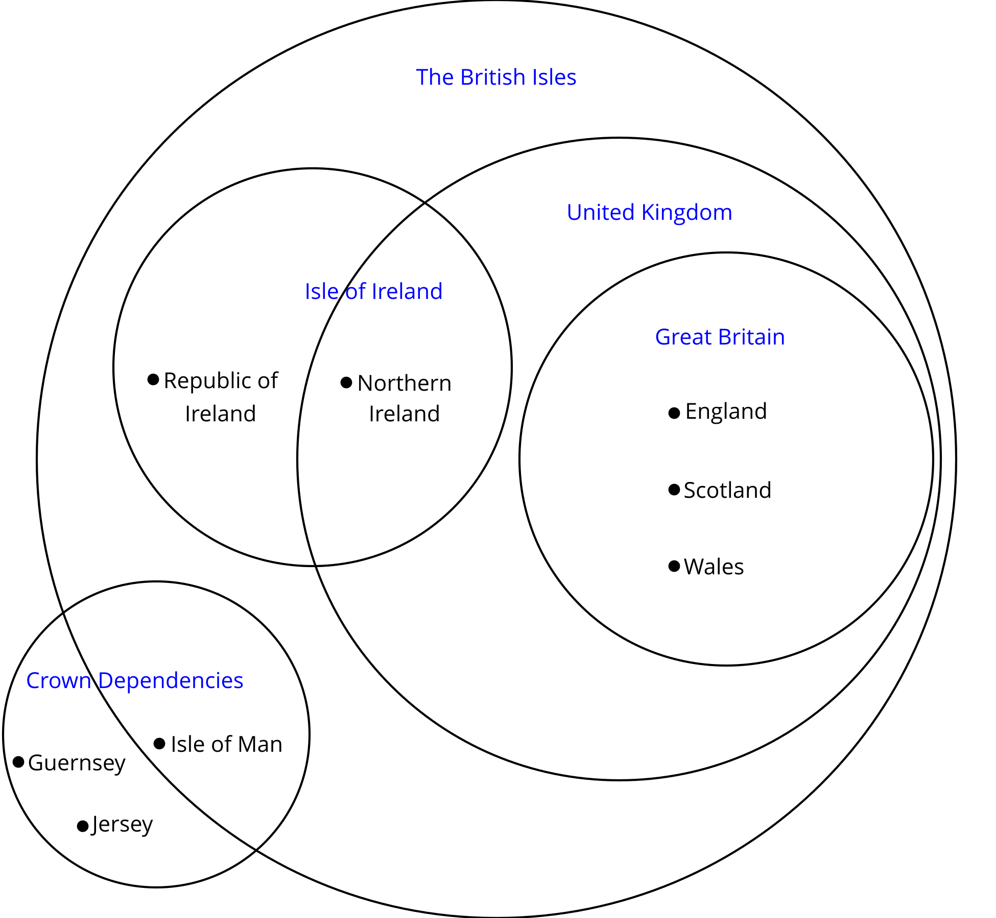
The small dots next to the names indicate that the name listed in the diagram is a country.
- Based on the categories in the Venn diagram, describe Northern Ireland in a way that will not include any other countries.
- Based on the categories in the Venn diagram, describe the Republic of Ireland in a way that will not include any other countries.
- How many countries displayed are not part of The British Isles?
- How many countries displayed are part of the United Kingdom?
- How many countries displayed are part of the Isle of Ireland?
- How many places displayed are part of the United Kingdom and the Isle of Ireland?
- How many places displayed are part of the United Kingdom or the Isle of Ireland?
- If one of the crown dependencies (there are 3) is chosen at random, what is the probability that it is part of The British Isles?
- Northern Ireland, England, Scotland and Wales are all part of the United Kingdom. If one of them is selected at random, what is the probability that it is also considered part of Great Britain?
- Given that the Republic of Ireland, Northern Ireland, England, Scotland, Wales, and the Isle of Man are all part of The British Isles, what is the probability that one of them selected at random is part of the Isle of Ireland?

3 Info Gap: College and Career Planning

Student Task Statement
Your teacher will give you either a problem card or a data card. Do not show or read your card to your partner.
If your teacher gives you the data card:
- Silently read the information on your card.
- Ask your partner “What specific information do you need?” and wait for your partner to ask for information. Only give information that is on your card. (Do not figure out anything for your partner!)
- Before telling your partner the information, ask “Why do you need to know (that piece of information)?”
- Read the problem card, and solve the problem independently.
- Share the data card, and discuss your reasoning.
If your teacher gives you the problem card:
- Silently read your card and think about what information you need to answer the question.
- Ask your partner for the specific information that you need.
- Explain to your partner how you are using the information to solve the problem.
- When you have enough information, share the problem card with your partner, and solve the problem independently.
- Read the data card, and discuss your reasoning.

4 Number Cube Descriptions (Optional)

Student Task Statement
- Roll two standard number cubes twenty times. Record your results in the table.
- first cube | - second cube

- first cube | - second cube
- List all the possible outcomes in each event. The first one is done for you.
  - The first cube is a 6. 6,1; 6,2; 6,3; 6,4; 6,5; 6,6
  - The cubes have a 4 and a 6.
  - The cubes are doubles. (Doubles means that the number on the two number cubes is the same.)
  - The cubes are doubles and the first cube is a 6.
  - The cubes are doubles or the first cube is a 6.
  - The first cube is not a 6.
  - The cubes are doubles and the first cube is not a 6.
  - The cubes are not doubles.
- Use the information in the table to answer the questions.
  - What percentage of the rolls have a 6 on the first cube?
  - What percentage of the rolls have a 4 and a 6?
  - What percentage of the rolls are doubles?
  - What percentage of the rolls are doubles and have a 6 on the first cube?
  - What percentage of the rolls are doubles or have a 6 on the first cube?
  - What percentage of the rolls do not have a 6 on the first cube?
  - What percentage of the rolls are doubles and do not have a 6 on the first cube?
  - What percentage of the rolls are not doubles?
- The sample space has 36 outcomes. Use this and the number of outcomes in each event to find the actual probability for each event in the previous problem. Compare your answers.
- Why is the actual probability different from the percentage of rolls you made for each event?
© CC BY 2019 by Illustrative Mathematics®

