Unit 3 Lesson 12: Represent Division of Unit Fractions by Whole Numbers

WU Estimation Exploration: How Much is Shaded? (Warm up)

Student Task Statement
How much is shaded?
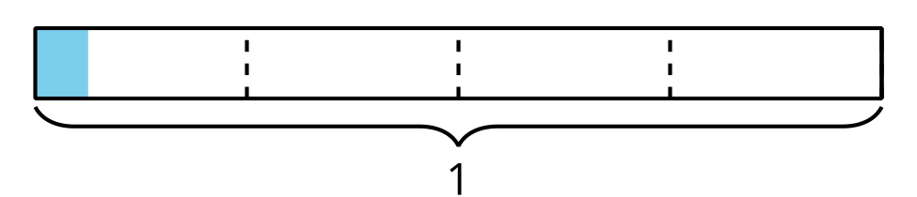
Record an estimate that is:
too low | about right | too high

Activity Synthesis
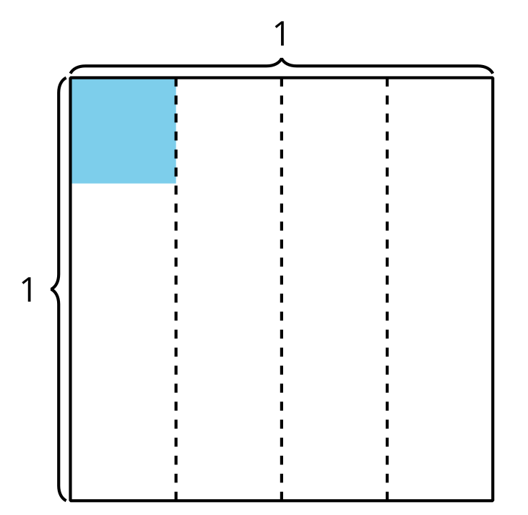

1 Diagrams, Equations, Situations

Student Task Statement
Priya and Mai used the diagrams below to find the value of $\frac{1}{3}÷4$.
Priya’s diagram:
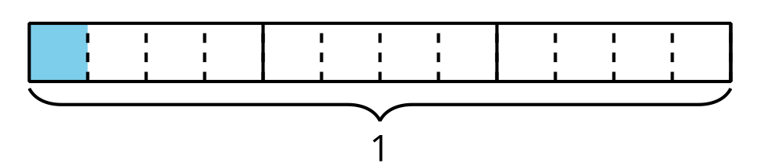
Mai’s diagram:
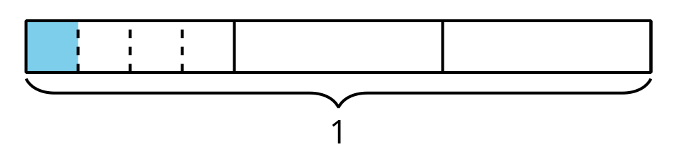
- What is the same about the diagrams?
- What is different?
- Find the value that makes the equation true.
- $\frac{1}{3}÷4=\underset{_}{}$
- Han drew this diagram to represent $\frac{1}{3}÷3$. Explain how the diagram
- shows $\frac{1}{3}÷3$.
- 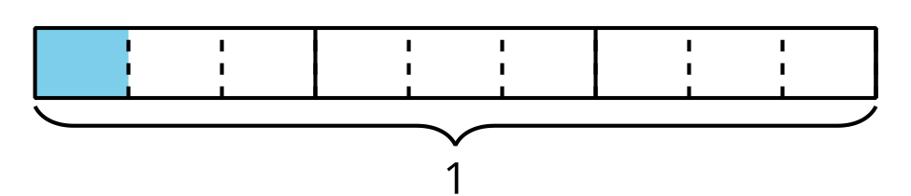
- Find the value that makes the equation true. Explain or show your reasoning.
- $\frac{1}{3}÷3=\underset{_}{}$

2 Priya’s Work

Student Task Statement
- Find the value of $\frac{1}{3}÷2$. Explain or show your reasoning.
- This is Priya’s work for finding the value of $\frac{1}{3}÷2$:
- 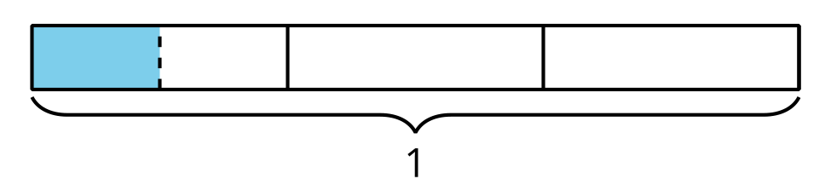
- $\frac{1}{3}÷2=\frac{1}{2}$ because I divided $\frac{1}{3}$ into 2 equal parts and $\frac{1}{2}$ of $\frac{1}{3}$ is shaded in.
  - What questions do you have for Priya?
  - Priya’s equation is incorrect. How can Priya revise her explanation?

Activity Synthesis

3 Look for Patterns

Student Task Statement
- Find the value that makes each equation true. Use a diagram if it is helpful.
  - $\frac{1}{4}÷2=\underset{_}{}$
  - $\frac{1}{4}÷3=\underset{_}{}$
  - $\frac{1}{4}÷4=\underset{_}{}$
- What patterns do you notice?
- How would you find the value of $\frac{1}{4}$ divided by any whole number? Explain or show your reasoning.

Images for Activity Synthesis
© CC BY 2021 Illustrative Mathematics®

