Unit 4 Lesson 14: Percent Error

1 Number Talk: Estimating a Percentage of a Number (Warm up)

Student Task Statement
Estimate.
25% of 15.8
9% of 38
1.2% of 127
0.53% of 6
0.06% of 202

2 Plants, Bicycles, and Crowds

Student Task Statement
- Instructions to care for a plant say to water it with $\frac{3}{4}$ cup of water every day. The plant has been getting 25% too much water. How much water has the plant been getting?
- The pressure on a bicycle tire is 63 psi. This is 5% higher than what the manual says is the correct pressure. What is the correct pressure?
- The crowd at a sporting event is estimated to be 3,000 people. The exact attendance is 2,486 people. What is the percent error?

3 Measuring in the Heat

Images for Launch
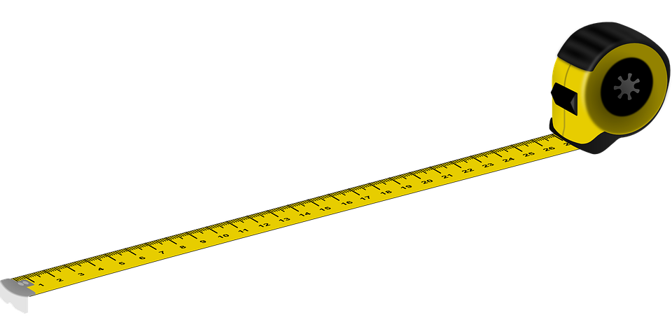

Student Task Statement
A metal measuring tape expands when the temperature goes above ${50}^{∘}\text{F}$. For every degree Fahrenheit above 50, its length increases by 0.00064%.
- The temperature is 100 degrees Fahrenheit. How much longer is a 30-foot measuring tape than its correct length?
- What is the percent error?
© CC BY Open Up Resources. Adaptations CC BY IM.

