Lesson 2 Practice Problems
- Write each expression with a single exponent:
  - ${10}^{3}⋅{10}^{9}$
  - $10⋅{10}^{4}$
  - ${10}^{10}⋅{10}^{7}$
  - ${10}^{3}⋅{10}^{3}$
  - ${10}^{5}⋅{10}^{12}$
  - ${10}^{6}⋅{10}^{6}⋅{10}^{6}$

- A large rectangular swimming pool is 1,000 feet long, 100 feet wide, and 10 feet deep. The pool is filled to the top with water.
  - What is the area of the surface of the water in the pool?
  - How much water does the pool hold?
  - Express your answers to the previous two questions as powers of 10.
- Here is triangle $ABC$. Triangle $DEF$ is similar to triangle $ABC$, and the length of $EF$ is 5 cm. What are the lengths of sides $DE$ and $DF$, in centimeters?
- 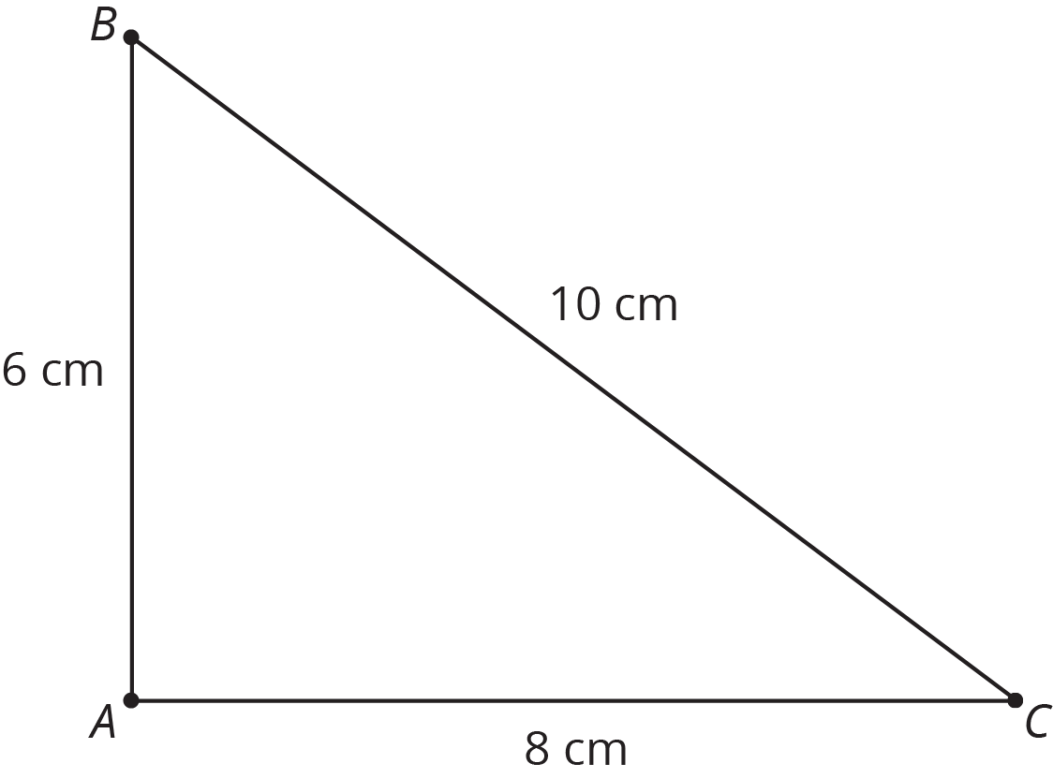
- (From Unit 2, Lesson 7.)
- Elena and Jada distribute flyers for different advertising companies. Elena gets paid 65 cents for every 10 flyers she distributes, and Jada gets paid 75 cents for every 12 flyers she distributes.
- Draw graphs on the coordinate plane representing the total amount each of them earned, $y$, after distributing $x$ flyers. Use the graph to decide who got paid more after distributing 14 flyers.
- (From Unit 3, Lesson 3.)
© CC BY Open Up Resources. Adaptations CC BY IM.

