Lesson 2 Practice Problems

  - Match each diagram with a description and an equation.
  - 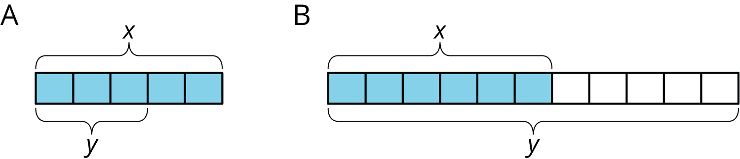

  - Descriptions:
  - An increase by $\frac{2}{3}$
  - An increase by $\frac{5}{6}$
  - A decrease by $\frac{2}{5}$
  - A decrease by $\frac{5}{11}$
  - Equations:
  - $y=1.8\overset{¯}{3}x$
  - $y=1.\overset{¯}{6}x$
  - $y=0.6x$
  - $y=0.4x$
  - Draw a diagram for one of the unmatched equations.
- At the beginning of the month, there were 80 ounces of peanut butter in the pantry. Since then, the family ate 0.3 of the peanut butter. How many ounces of peanut butter are in the pantry now?
  - $0.7⋅80$
  - $0.3⋅80$
  - $80−0.3$
  - $\left(1+0.3\right)⋅80$

  - On a hot day, a football team drank an entire 50-gallon cooler of water and half as much again. How much water did they drink?
  - Jada has 12 library books checked out and Han has $\frac{1}{3}$ less than that. How many books does Han have checked out?
- (From Unit 6, Lesson 1.)
- If $x$ represents a positive number, select all expressions whose value is greater than $x$.
  - $\left(1−\frac{1}{4}\right)x$
  - $\left(1+\frac{1}{4}\right)x$
  - $\frac{7}{8}x$
  - $\frac{9}{8}x$
- (From Unit 6, Lesson 1.)
- A person's resting heart rate is typically between 60 and 100 beats per minute. Noah looks at his watch, and counts 8 heartbeats in 10 seconds.
  - Is his heart rate typical? Explain how you know.
  - Write an equation for $h$, the number of times Noah’s heart beats (at this rate) in $m$ minutes.
- (From Unit 5, Lesson 3.)
© CC BY Open Up Resources. Adaptations CC BY IM.

