Lesson 9 Practice Problems
- Solve each equation.
  - $4x=\text{-}28$
  - $x−\text{-}6=\text{-}2$
  - $\text{-}x+4=\text{-}9$
  - $\text{-}3x+7=1$
  - $25x+\text{-}11=\text{-}86$
- Here is an equation $2x+9=\text{-}15$. Write three different equations that have the same solution as $2x+9=\text{-}15$. Show or explain how you found them.
- Select all the equations that match the diagram.
- 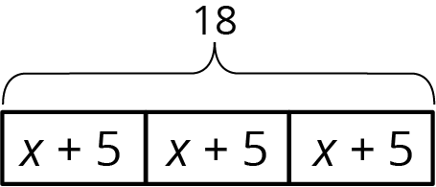
  - $x+5=18$
  - $18÷3=x+5$
  - $3\left(x+5\right)=18$
  - $x+5=\frac{1}{3}⋅18$
  - $3x+5=18$
- (From Unit 3, Lesson 3.)
- There are 88 seats in a theater. The seating in the theater is split into 4 identical sections. Each section has 14 red seats and some blue seats.
  - Draw a tape diagram to represent the situation.
  - What unknown amounts can be found by by using the diagram or reasoning about the situation?
- (From Unit 3, Lesson 2.)
- Match each story to an equation.
  - A stack of nested paper cups is 8 inches tall. The first cup is 4 inches tall and each of the rest of the cups in the stack adds $\frac{1}{4}$ inch to the height of the stack.
  - A baker uses 4 cups of flour. She uses $\frac{1}{4}$ cup to flour the counters and the rest to make 8 identical muffins.
  - Elena has an 8-foot piece of ribbon. She cuts off a piece that is $\frac{1}{4}$ of a foot long and cuts the remainder into four pieces of equal length.
  - $\frac{1}{4}+4x=8$
  - $4+\frac{1}{4}x=8$
  - $8x+\frac{1}{4}=4$
- (From Unit 3, Lesson 4.)
© CC BY Open Up Resources. Adaptations CC BY IM.

