Unit 6 Lesson 2: Introduction to Functions

1 Square Me (Warm up)

Student Task Statement
Here are some numbers in a list:
1, -3, $\text{-}\frac{1}{2}$, 3, 2, $\frac{1}{4}$, 0.5
- How many different numbers are in the list?
- Make a new list containing the squares of all these numbers.
- How many different numbers are in the new list?
- Explain why the two lists do not have the same number of different numbers.

2 You Know This, Do You Know That?

Images for Launch
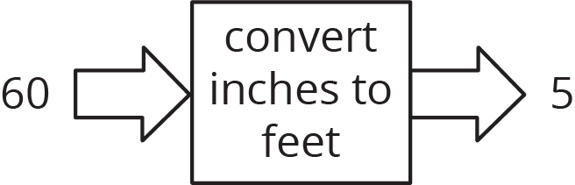
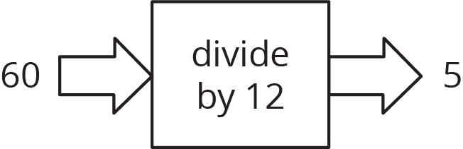

Student Task Statement
Say yes or no for each question. If yes, draw an input-output diagram. If no, give examples of two different outputs that are possible for the same input.
- A person is 5.5 feet tall. Do you know their height in inches?
- A number is 5. Do you know its square?
- The square of a number is 16. Do you know the number?
- A square has a perimeter of 12 cm. Do you know its area?
- A rectangle has an area of 16 cm². Do you know its length?
- You are given a number. Do you know the number that is $\frac{1}{5}$ as big?
- You are given a number. Do you know its reciprocal?

3 Using Function Language

Student Task Statement
Here are the questions from the previous activity. For the ones you said yes to, write a statement like, “The height a rubber ball bounces to depends on the height it was dropped from” or “Bounce height is a function of drop height.” For all of the ones you said no to, write a statement like, “The day of the week does not determine the temperature that day” or “The temperature that day is not a function of the day of the week.”
- A person is 5.5 feet tall. Do you know their height in inches?
- A number is 5. Do you know its square?
- The square of a number is 16. Do you know the number?
- A square has a perimeter of 12 cm. Do you know its area?
- A rectangle has an area of 16 cm². Do you know its length?
- You are given a number. Do you know the number that is $\frac{1}{5}$ as big?
- You are given a number. Do you know its reciprocal?

4 Same Function, Different Rule? (Optional)

Student Task Statement
Which input-output rules could describe the same function (if any)? Be prepared to explain your reasoning.
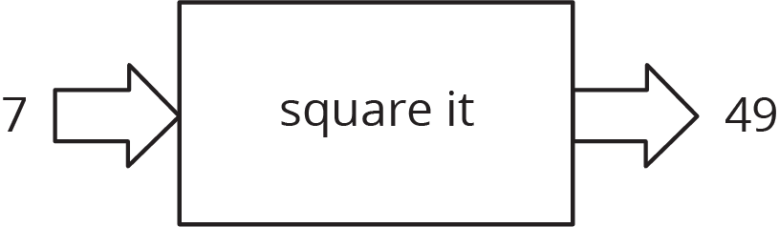
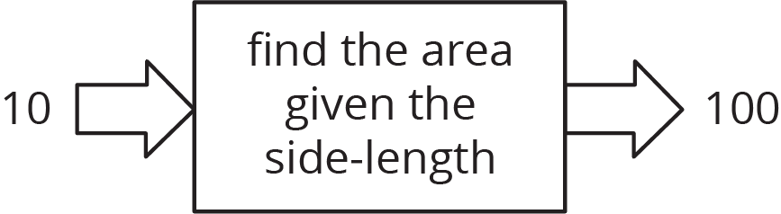
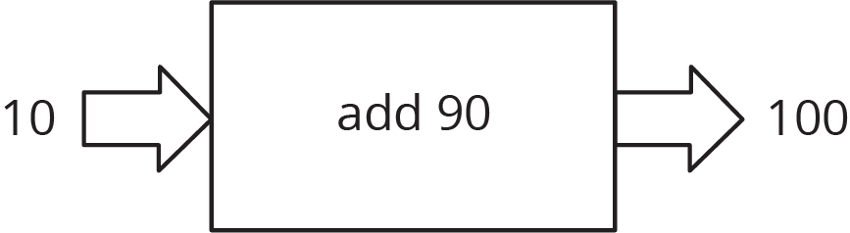

© CC BY Open Up Resources. Adaptations CC BY IM.

