Unit 3 Lesson 1: Human Frequency Table

1 Estimation: Percents (Warm up)

Student Task Statement
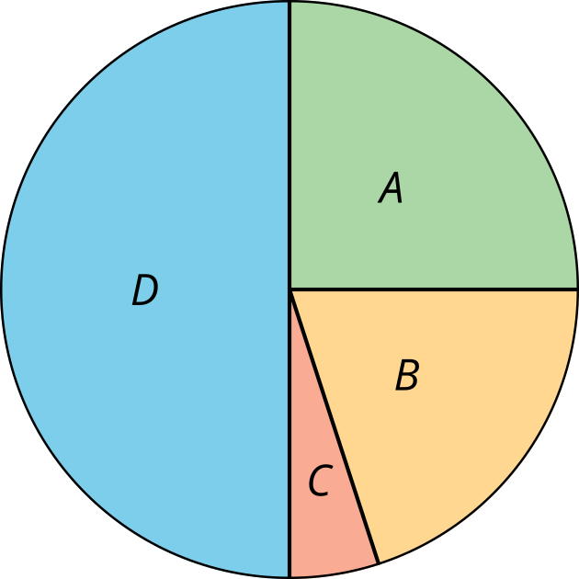
What percentage of the graph is labeled B?
- Record an estimate that is:
- too low | - about right | - too high
- Explain your reasoning.

2 Human Frequency Table

Student Task Statement
Follow your teacher’s instructions to create a two-way table with your class. Then, using the data from the table your class creates, answer the questions:
- How many students prefer tablets?
- How many students prefer basketball?
- How many students prefer both laptops and baseball?
- Of the students who prefer tablets, how many prefer basketball?

3 Class Celebration

Student Task Statement
Han’s teacher is planning a celebration for the class. Here is a table that displays the students’ preferences for the celebration.
 | prefers Monday | prefers Friday | total
prefers indoors | 4 | 8
prefers outdoors | 6 | 9
total
Use the table to answer the questions.
- Complete the table with the missing values.
- How many students were surveyed?
- How many students prefer Monday?
- How many students prefer Friday?
- On which day should Han’s teacher plan to have the celebration?
- How many students prefer to stay indoors?
- How many students prefer to go outdoors?
- How many students prefer Friday and prefer to stay indoors?
- How many students prefer Monday and prefer to go outdoors?
© CC BY 2019 by Illustrative Mathematics®

