Lesson 12: Completing the Square (Part 1)
- Let’s learn a new method for solving quadratic equations.

12.1: Perfect or Imperfect?
Select all expressions that are perfect squares. Explain how you know.
- $\left(x+5\right)\left(5+x\right)$
- $\left(x+5\right)\left(x−5\right)$
- ${\left(x−3\right)}^{2}$
- $x−3^{2}$
- $x^{2}+8x+16$
- $x^{2}+10x+20$

12.2: Building Perfect Squares
Complete the table so that each row has equivalent expressions that are perfect squares.
standard form | factored form
1. $x^{2}+6x+9$
2. $x^{2}−10x+25$
3. | ${\left(x−7\right)}^{2}$
4. $x^{2}−20x+\underset{_}{}$ | ${\left(x−\underset{_}{}\right)}^{2}$
5. $x^{2}+16x+\underset{_}{}$ | ${\left(x+\underset{_}{}\right)}^{2}$
6. $x^{2}+7x+\underset{_}{}$ | ${\left(x+\underset{_}{}\right)}^{2}$
7. $x^{2}+bx+\underset{_}{}$ | ${\left(x+\underset{_}{}\right)}^{2}$

12.3: Dipping Our Toes in Completing the Square
One technique for solving quadratic equations is called completing the square. Here are two examples of how Diego and Mai completed the square to solve the same equation.
Diego:
$\begin{matrix}x^{2}+10x+9 & =0 \\ x^{2}+10x & =\text{-}9 \\ x^{2}+10x+25 & =\text{-}9+25 \\ x^{2}+10x+25 & =16 \\ {\left(x+5\right)}^{2} & =16 \\ x+5=4 & \text{or} x+5=\text{-}4 \\ x=\text{-}1 & \text{or} x=\text{-}9\end{matrix}$
Mai:
$\begin{matrix}x^{2}+10x+9 & =0 \\ x^{2}+10x+9+16 & =16 \\ x^{2}+10x+25 & =16 \\ {\left(x+5\right)}^{2} & =16 \\ x+5=4 & \text{or} x+5=\text{-}4 \\ x=\text{-}1 & \text{or} x=\text{-}9\end{matrix}$
Study the worked examples. Then, try solving these equations by completing the square:
- $x^{2}+6x+8=0$
- $x^{2}+12x=13$
- $0=x^{2}−10x+21$
- $x^{2}−2x+3=83$
- $x^{2}+40=14x$

Are you ready for more?
Here is a diagram made of a square and two congruent rectangles. Its total area is $x^{2}+35x$ square units.
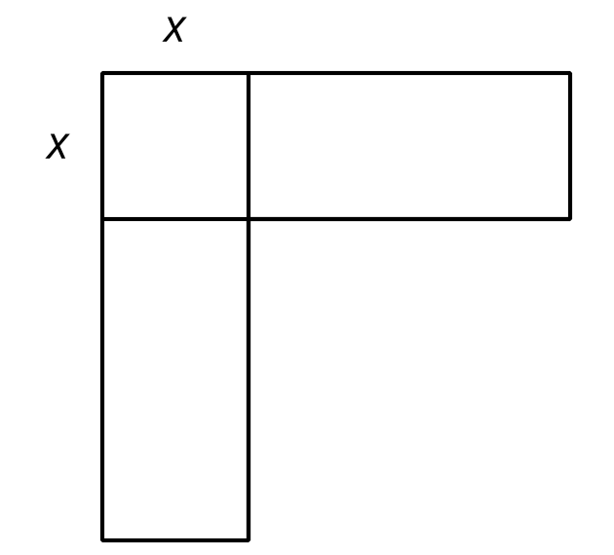
- What is the length of the unlabeled side of each of the two rectangles?
- If we add lines to make the figure a square, what is the area of the entire figure?
- How is the process of finding the area of the entire figure like the process of building perfect squares for expressions like $x^{2}+bx$?

Lesson 12 Summary
Turning an expression into a perfect square can be a good way to solve a quadratic equation. Suppose we wanted to solve $x^{2}−14x+10=\text{-}30$.
The expression on the left, $x^{2}−14x+10$, is not a perfect square, but $x^{2}−14x+49$ is a perfect square. Let’s transform that side of the equation into a perfect square (while keeping the equality of the two sides).
- One helpful way to start is by first moving the constant that is not a perfect square out of the way. Let’s subtract 10 from each side:​​​​​​
$\begin{matrix}x^{2}−14x+10−10 & =\text{-}30−10 \\ x^{2}−14x & =\text{-}40\end{matrix}$
- And then add 49 to each side:​​​​​​
$\begin{matrix}x^{2}−14x+49 & =\text{-}40+49 \\ x^{2}−14x+49 & =9\end{matrix}$
- The left side is now a perfect square because it’s equivalent to $\left(x−7\right)\left(x−7\right)$ or ${\left(x−7\right)}^{2}$. Let’s rewrite it:
${\left(x−7\right)}^{2}=9$
- If a number squared is 9, the number has to be 3 or -3. To finish up:​​​​​​
$\begin{matrix}x−7=3 & \text{or} x−7=\text{-}3 \\ x=10 & \text{or} x=4\end{matrix}$
This method of solving quadratic equations is called completing the square. In general, perfect squares in standard form look like $x^{2}+bx+{\left(\frac{b}{2}\right)}^{2}$, so to complete the square, take half of the coefficient of the linear term and square it.
In the example, half of -14 is -7, and ${\left(\text{-}7\right)}^{2}$ is 49. We wanted to make the left side $x^{2}−14x+49.$ To keep the equation true and maintain equality of the two sides of the equation, we added 49 to each side.
© CC BY 2019 by Illustrative Mathematics®

