Lesson 1: Congruent Parts, Part 1
- Let’s figure out what the corresponding sides and angles in figures have to do with congruence.

1.1: Notice and Wonder: Transformed Rectangles
What do you notice? What do you wonder?
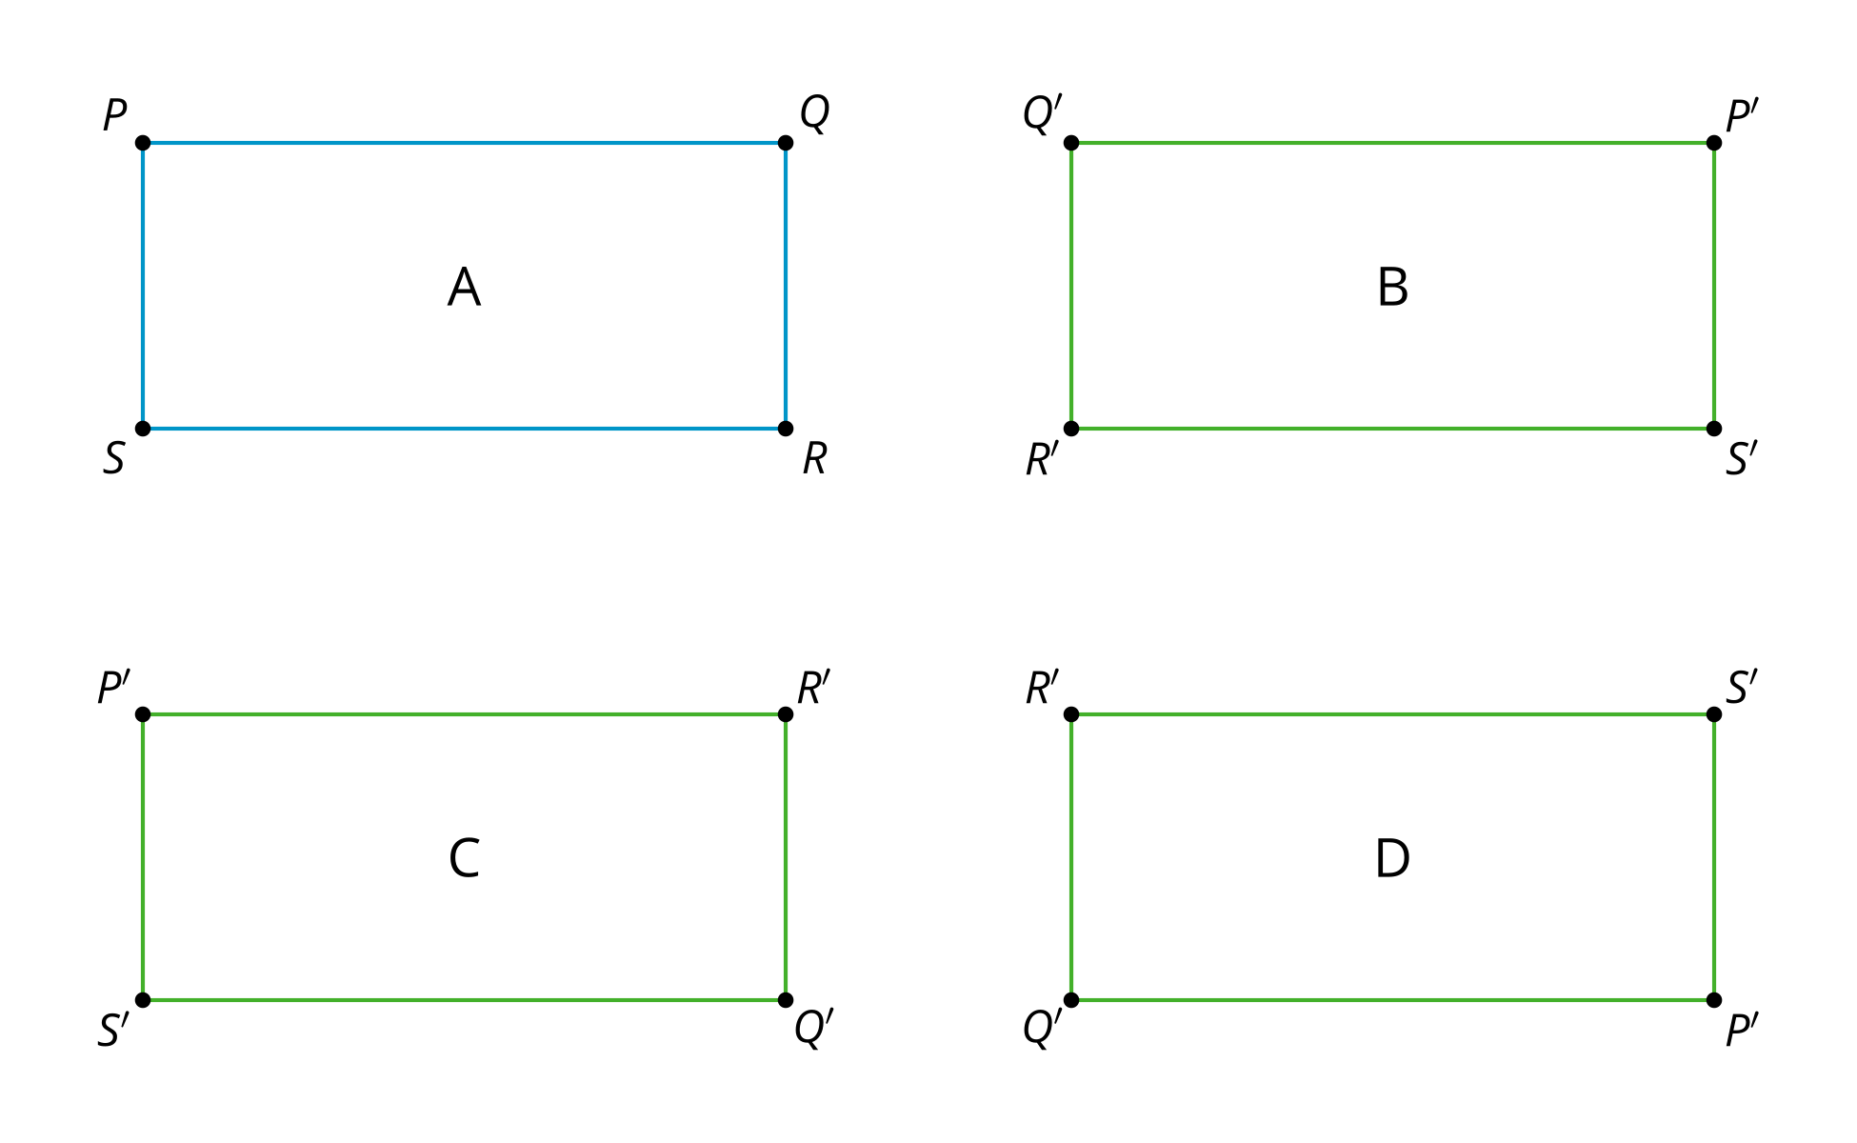

1.2: If We Know This, Then We Know That...
Triangle $ABC$ is congruent to triangle $DEF$.

$△ABC≅△DEF$
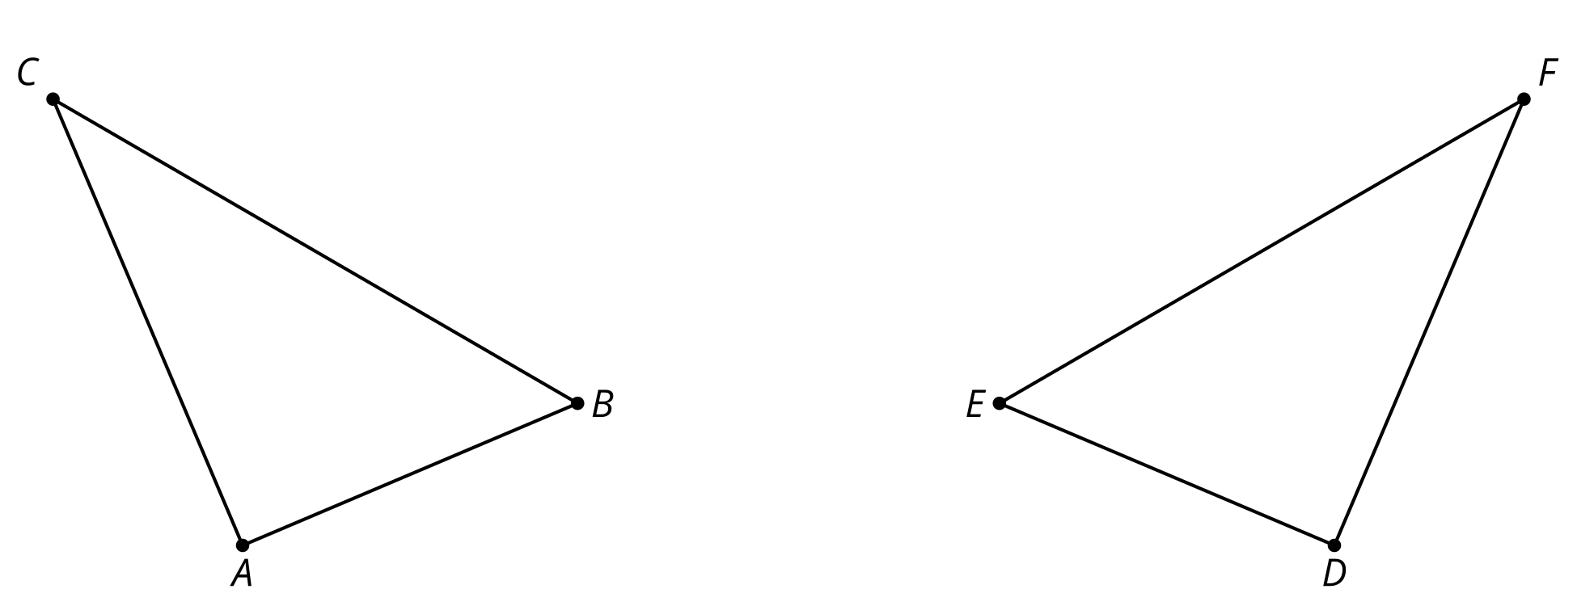
- Find a sequence of rigid motions that takes triangle $ABC$ to triangle $DEF$.
- What is the image of segment $BC$ after that transformation?
- Explain how you know those segments are congruent.
- Justify that angle $ABC$ is congruent to angle $DEF$.

Are you ready for more?
For each figure, draw additional line segments to divide the figure into 2 congruent polygons. Label any new vertices and identify the corresponding vertices of the congruent polygons.
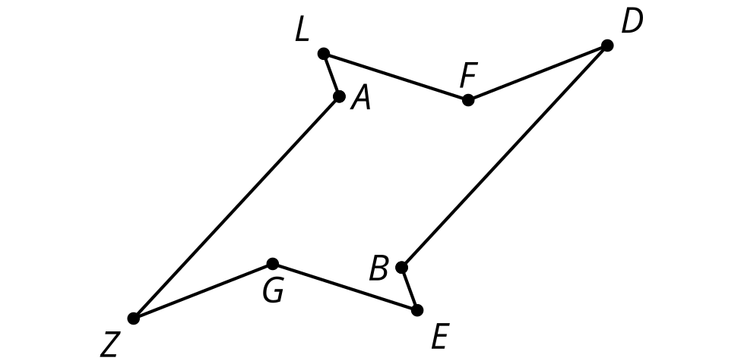
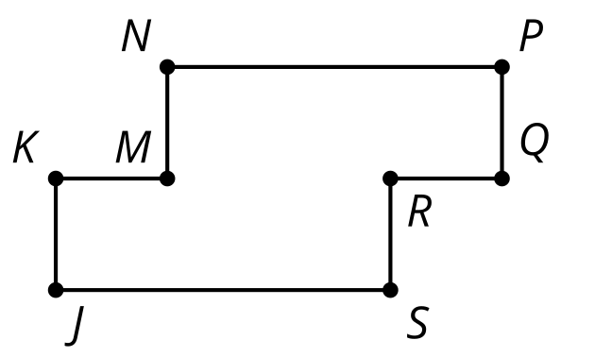

1.3: Making Quadrilaterals
- Draw a triangle.
- Find the midpoint of the longest side of your triangle.
- Rotate your triangle ${180}^{∘}$ using the midpoint of the longest side as the center of the rotation.
- Label the corresponding parts and mark what must be congruent.
- Make a conjecture and justify it.
  - What type of quadrilateral have you formed?
  - What is the definition of that quadrilateral type?
  - Why must the quadrilateral you have fit the definition?

Lesson 1 Summary
If a part of the image matches up with a part of the original figure, we call them corresponding parts. The part could be an angle, point, or side. We can find corresponding angles, corresponding points, or corresponding sides.
If 2 figures are not congruent, then there is not a rigid transformation that takes one figure onto the other. If 2 figures are congruent, then there is a rigid transformation that takes one figure onto the other. The same rigid transformation can also be applied to individual parts of the figure, such as segments and angles, because rigid transformations move every point on the plane. Therefore, the corresponding parts of 2 congruent figures are congruent to each other.
Knowing that corresponding parts of congruent figures are congruent can help prove that 2 line segments or 2 angles are congruent, if they are corresponding parts of congruent figures.
© CC BY 2019 by Illustrative Mathematics®

