Unit 8 Lesson 6: The Addition Rule

1 Hats Off, Sneakers On (Warm up)

Student Task Statement
The table displays information about people at a neighborhood park.
 | wearing sneakers | not wearing sneakers | total
wearing a hat | 8 | 2 | 10
not wearing a hat | 3 | 12 | 15
total | 11 | 14 | 25
- Andre says the number of people wearing sneakers or wearing a hat is 21, because there are a total of 10 people wearing a hat and a total of 11 people wearing sneakers. Is Andre correct? Explain your reasoning.
- What is the probability that a person selected at random from those in the park is wearing sneakers or wearing a hat?

2 State Names

Student Task Statement
Jada has a way to find the probability of a random outcome being in event A or event B. She says, “We use the probability of the outcome being in event A, then add the probability of the outcome being in category B. Now some outcomes have been counted twice, so we have to subtract the probability of the outcome being in both events so that those outcomes are only counted once.”
Jada's method can be rewritten as:
$P\left(\text{A or B}\right)=P\left(\text{A}\right)+P\left(\text{B}\right)−P\left(\text{A and B}\right)$
- The table of data summarizes information about the 50 states in the United States from a census in the year 2000. A state is chosen at random from the list of 50. Let event A be “the state name begins with A through M” and event B be “the population of the state is less than 4 million.”
 | - population less than 4 million | - population at least 4 million
- name begins with A through M | - 11 | - 15
- name begins with N through Z | - 13 | - 11
- Alaska is one of the 11 states in the top left cell of the table. California is one of the 15 states in the top right cell of the table. Nebraska is one of the 13 states in the bottom left cell of the table. New York is one of the 11 states in the bottom right cell of the table. For each event, write which of the four states listed here is an outcome in that event.
  - A or B
  - A
  - B
  - A and B
- Find each of the probabilities when a state is chosen at random:
  - $P\left(\text{A or B}\right)$
  - $P\left(\text{A}\right)$
  - $P\left(\text{B}\right)$
  - $P\left(\text{A and B}\right)$
- Does Jada's formula work for these events? Show your reasoning.
- Seniors at a high school are allowed to go off campus for lunch if they have a grade of A in all their classes or perfect attendance. An assistant principal in charge of academics knows that the probability of a randomly selected senior having A's in all their classes is 0.1. An assistant principal in charge of attendance knows that the probability of a randomly selected senior having perfect attendance is 0.16. The cafeteria staff know that the probability of a randomly selected senior being allowed to go off campus for lunch is 0.18. Use Jada's formula to find the probability that a randomly selected senior has all As and perfect attendance.

3 Coffee or Juice?

Student Task Statement
- At a cafe, customers order coffee at the bar, and then either go to another table where the cream and sugar are kept, or find a seat. Based on observations, a worker estimates that 70% of customers go to the second table for cream or sugar. The worker also observes that about 60% of all customers use cream for their coffee and 50% of all customers use sugar. Use the worker's estimates to find the percentage of all customers who use both cream and sugar for their coffee. Explain or show your reasoning.
- 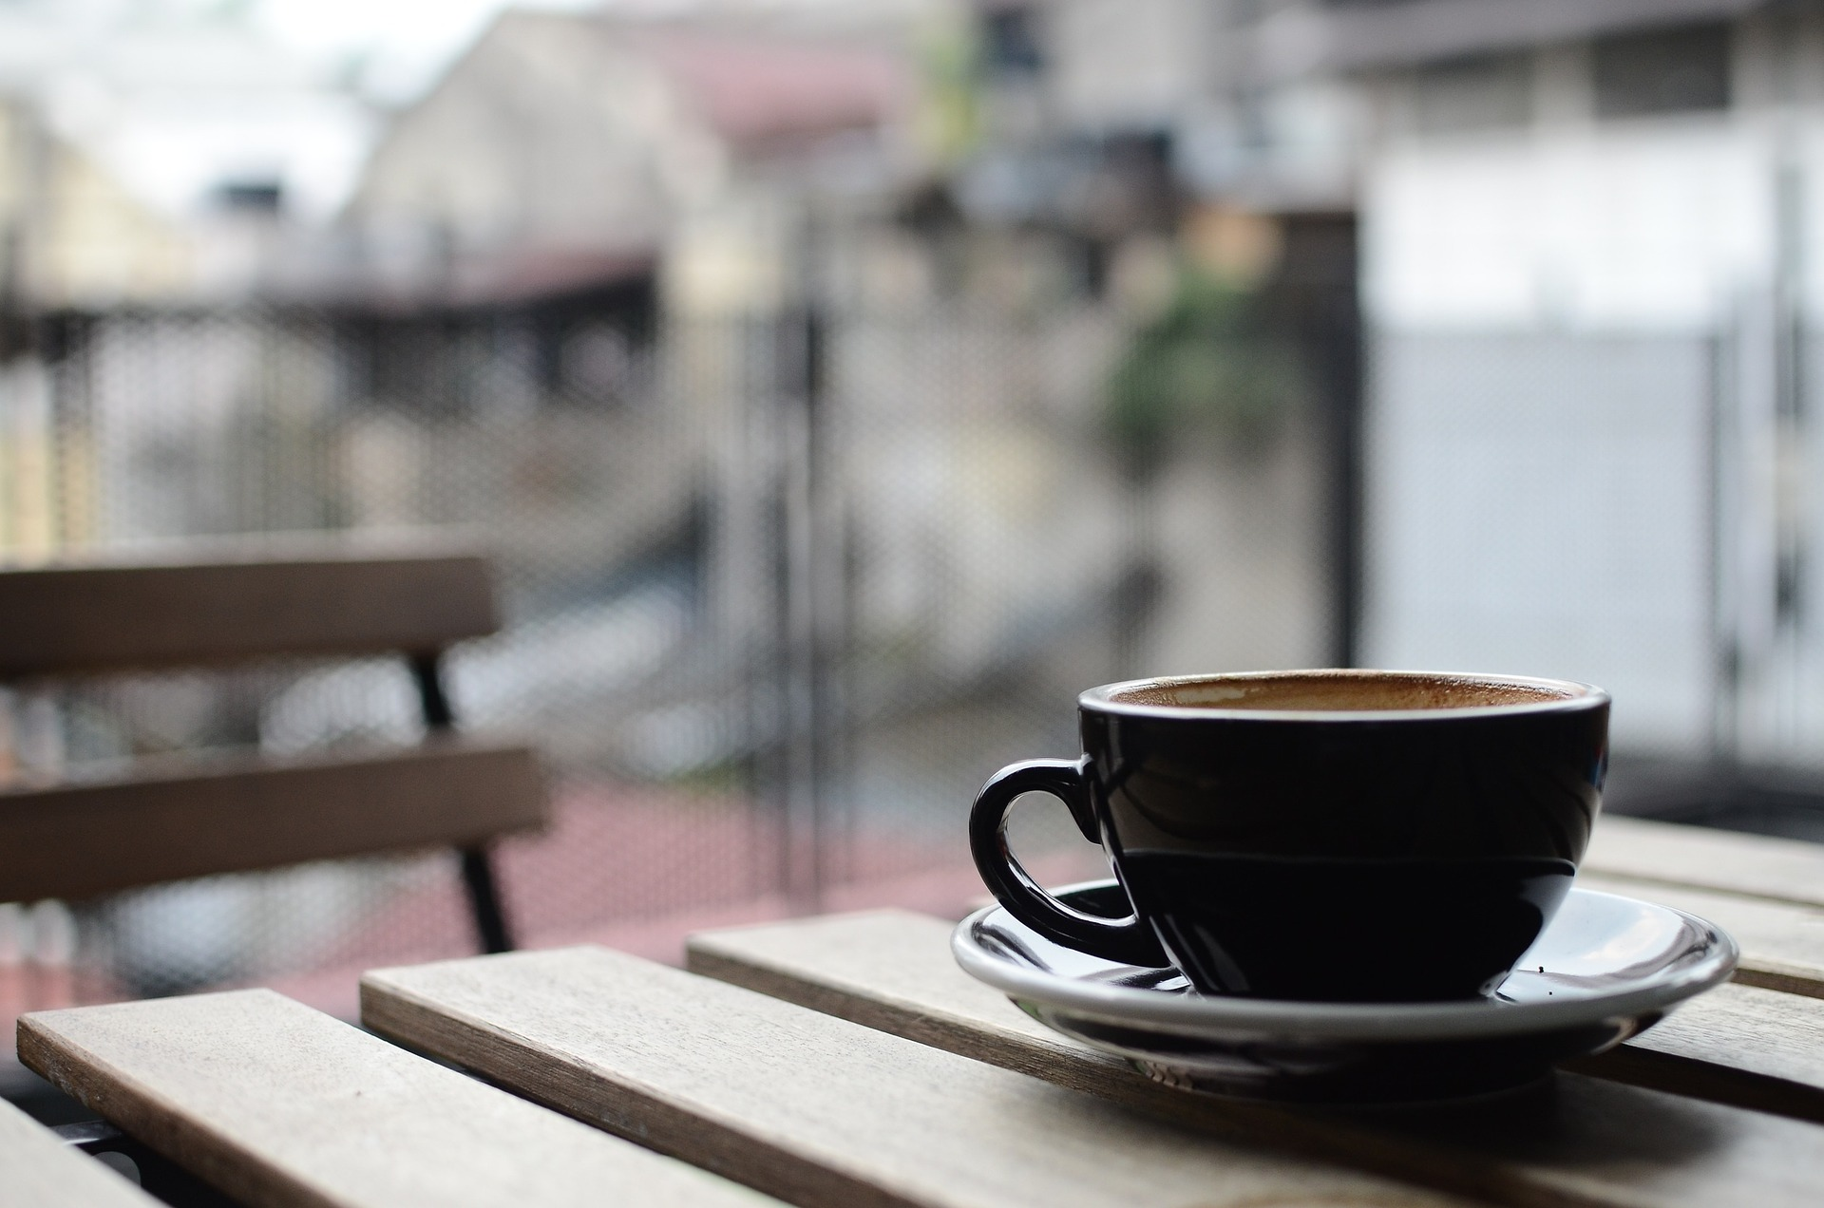
- At the grocery store, 70% of the different types of juice come in a bottle holding at least 400 milliliters (mL) and 40% of the different types of juice come in a low-sugar version. Only 25% of the juice varieties are in bottles holding at least 400 mL and have a low-sugar version. What percentage of the different types of juice come in a bottle holding at least 400 mL or are low-sugar? Explain your reasoning.
- Complete the table showing the number of cans and bottles of low-sugar and regular juice in one of the shelves at a grocery store. You may not use zero in any of the empty spaces.
 | - less than 400 mL | - at least 400 mL | - total
- low-sugar available |  |  | - 80
- no low-sugar available
- total | - 60 | - 140
- Use the table to find the probabilities for a juice chosen from the shelf at random.
  - $P\left(\text{less than 400 mL}\right)$
  - $P\left(\text{no low-sugar available}\right)$
  - $P\left(\text{no low-sugar available or less than 400 mL}\right)$
  - $P\left(\text{no low-sugar available and less than 400 mL}\right)$
© CC BY 2019 by Illustrative Mathematics®

