Lesson 6: Compare Decimals on the Number Line
- Let’s locate and label decimals on number lines.

Warm-up: Notice and Wonder: Nested Lines
What do you notice? What do you wonder?
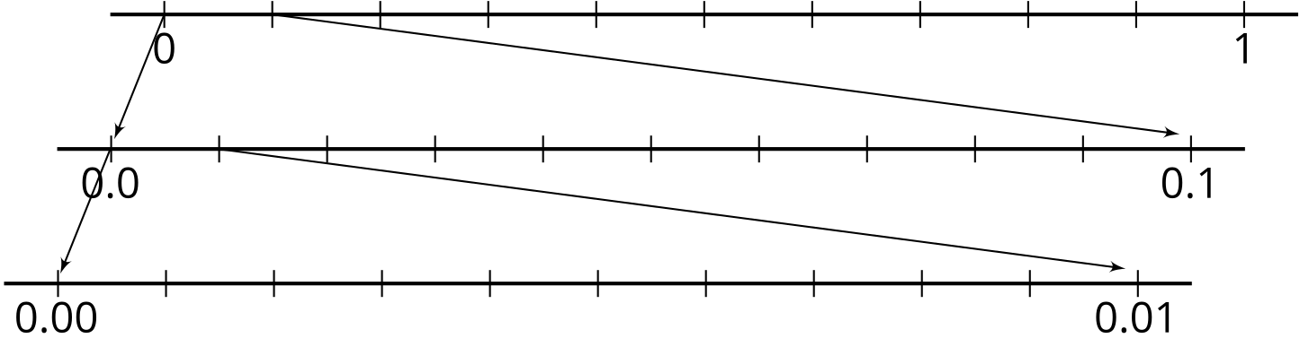

6.1: Locate 1 Thousandth
On each number line:
- Label all of the tick marks.
- Locate and label the number 0.001.

6.2: Label and Compare Decimals
- Label the tick marks on each number line.
- Which of the number lines would you use to compare 0.534 and 0.537? Explain or show your reasoning.

6.3: Locate and Compare With Symbols
- Use the symbol < or > to compare the decimals 0.2 and 0.02. Use the number line to explain or show your thinking.
- Use the symbol < or > to compare the decimals 0.3 and 0.14. Use the number line to explain or show your thinking.
- Use the symbol < or > to compare the decimals 0.23 and 0.216. Use the number line to explain or show your thinking.
© CC BY 2021 Illustrative Mathematics®

