Lesson 15: Problem Solving with Line Plots
- Let’s solve problems using a line plot.

Warm-up: Number Talk: Multiply by 18
Find the value of each expression mentally.
- $\frac{1}{3}×18$
- $\frac{2}{3}×18$
- $\frac{4}{3}×18$
- $\frac{5}{3}×18$

15.1: Info Gap: Picking Fruit
Your teacher will give you either a problem card or a data card. Do not show or read your card to your partner.
Pause here so your teacher can review your work.
Ask your teacher for a new set of cards and repeat the activity, trading roles with your partner.

15.2: Mathematical Questions
This line plot shows the weights of some apricots that Mai picked.
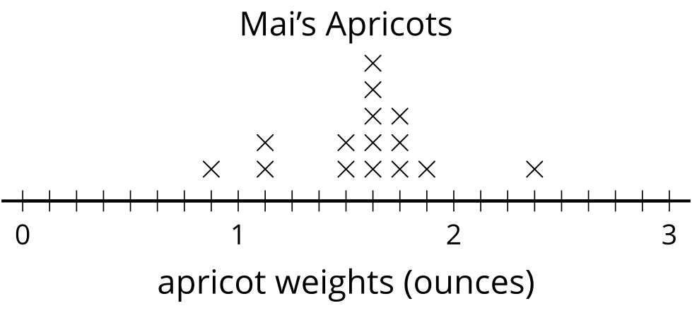
- What fraction of the apricots weigh less than $1\frac{1}{2}$ ounces? Explain or show your reasoning.
- Write a multiplication equation that represents the total weight of the apricots that each weigh $1\frac{5}{8}$ ounces.
- Do all of Mai’s apricots together weigh more or less than a pound? Explain or show your reasoning.

Section Summary
Section Summary
In this section we learned to add and subtract fractions. When the denominators are the same, such as $\frac{7}{10}+\frac{4}{10}$, we can just add the tenths and see that there are 11 of them so $\frac{7}{10}+\frac{4}{10}=\frac{11}{10}$. When the denominators are not the same, such as $\frac{1}{6}+\frac{3}{8}$, we look for a common denominator so that we can add parts of the same size. One way to find a common denominator is to use the product of the two denominators, $6×8$, because that’s always a multiple of both denominators. Using 48 as a denominator we find $\frac{1}{6}+\frac{3}{8}=\frac{1×8}{6×8}+\frac{3×6}{8×6}$. This means $\frac{1}{6}+\frac{3}{8}=\frac{26}{48}$. For the expression $\frac{1}{6}+\frac{3}{8}$ we can also use a smaller common denominator. Since $24$ is a multiple of 6 and 8 we can also rewrite $\frac{1}{6}+\frac{3}{8}$ as $\frac{4}{24}+\frac{9}{24}$ which is $\frac{13}{24}$.
© CC BY 2021 Illustrative Mathematics®

