Lesson 1: Count 2 Groups of Objects
- Let’s find out how many objects there are in two groups.

Warm-up: Which One Doesn’t Belong: Groups
Which one doesn’t belong?
A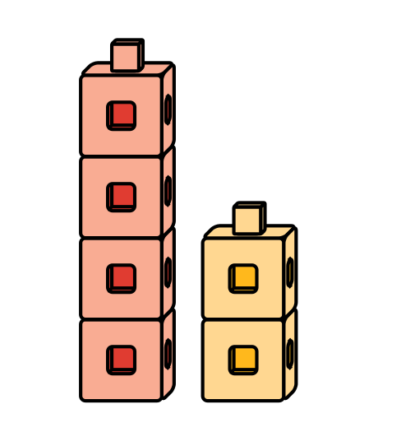
B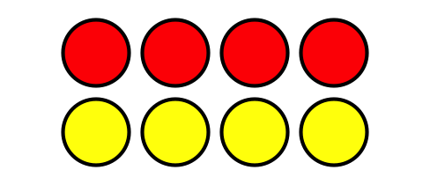
C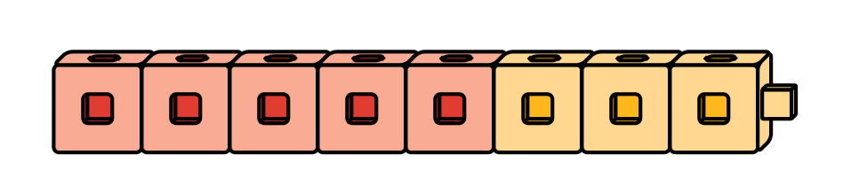
D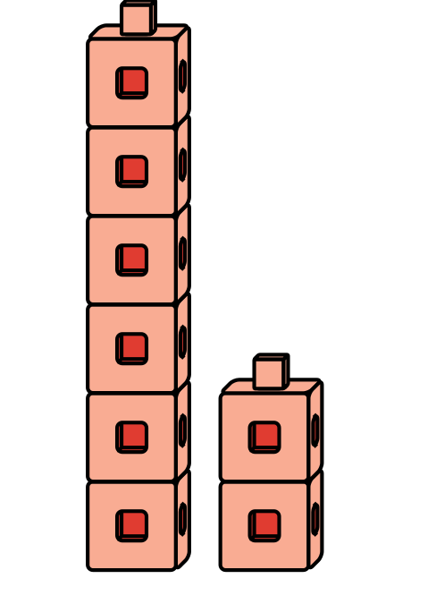

1.1: Put Together Pattern Blocks
How many pattern blocks do you have?
I have
pattern blocks.

1.2: Put Together Connecting Cubes
How many cubes do you and your partner have together?
We have
cubes.
We have
cubes.

1.3: Centers: Choice Time
Choose a center.
Math Libs
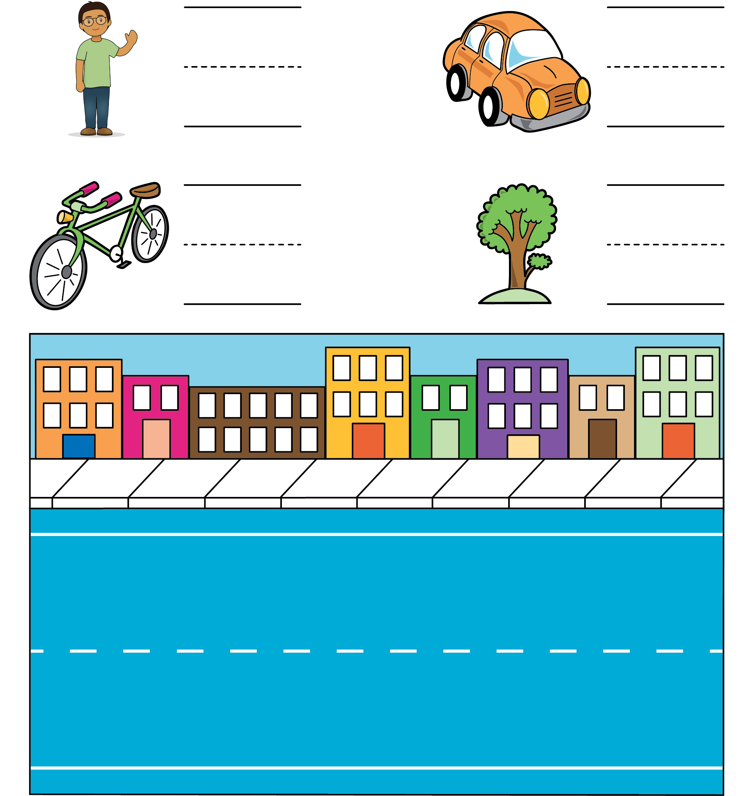
Match Mine
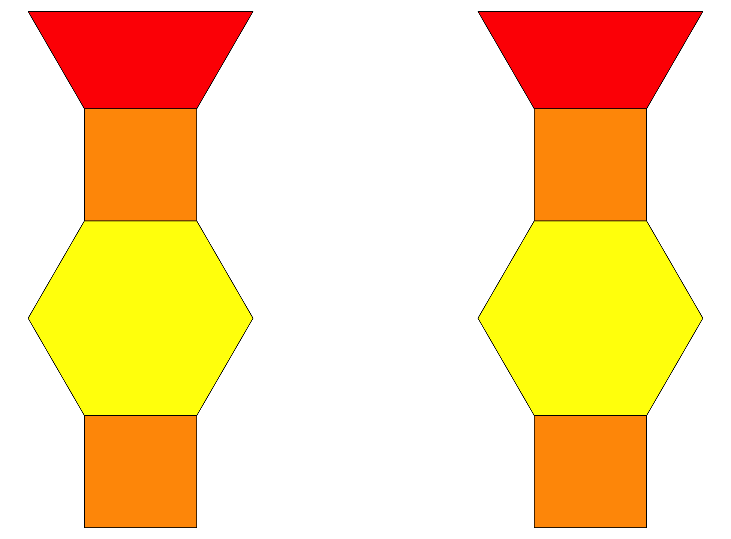
© CC BY 2021 Illustrative Mathematics®

