Unit 4 Lesson 1: Count Large Collections

WU Choral Count: Count by 10 (Warm up)

Student Task Statement
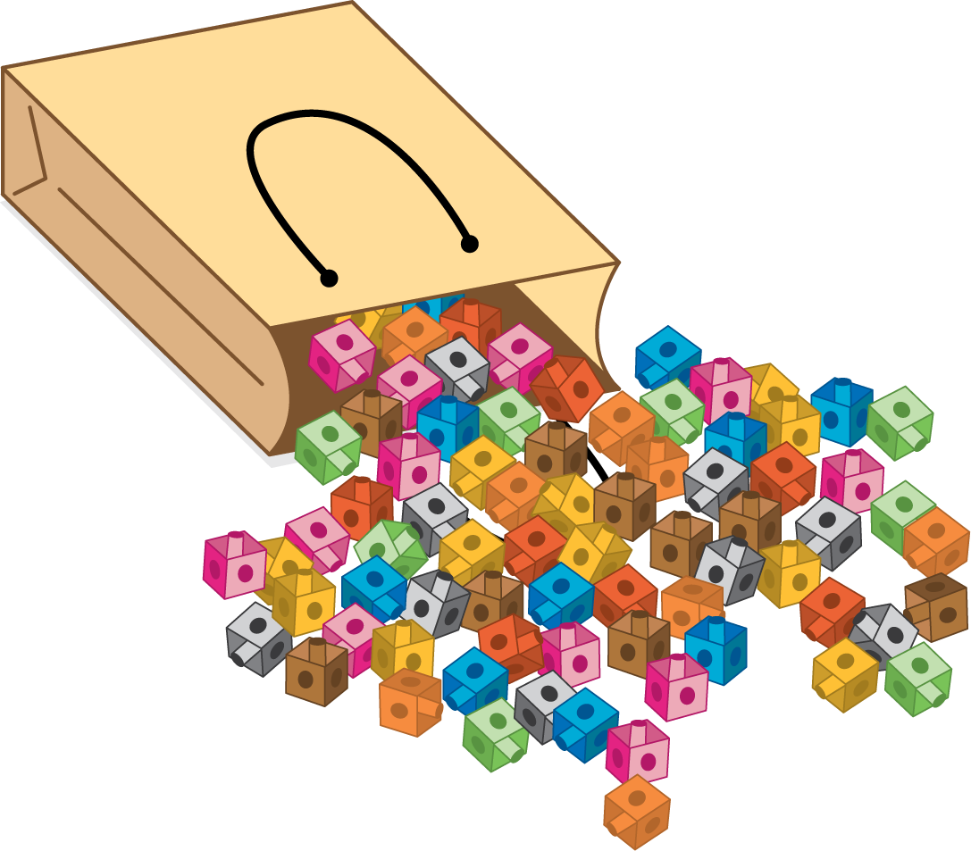

1 Count a Collection

Student Task Statement

2 Count More Than One Collection

Student Task Statement

3 Centers: Choice Time

Student Task Statement
Choose a center.
How Close?
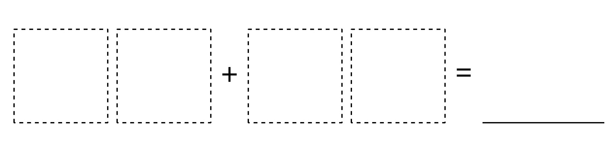
Five in a Row
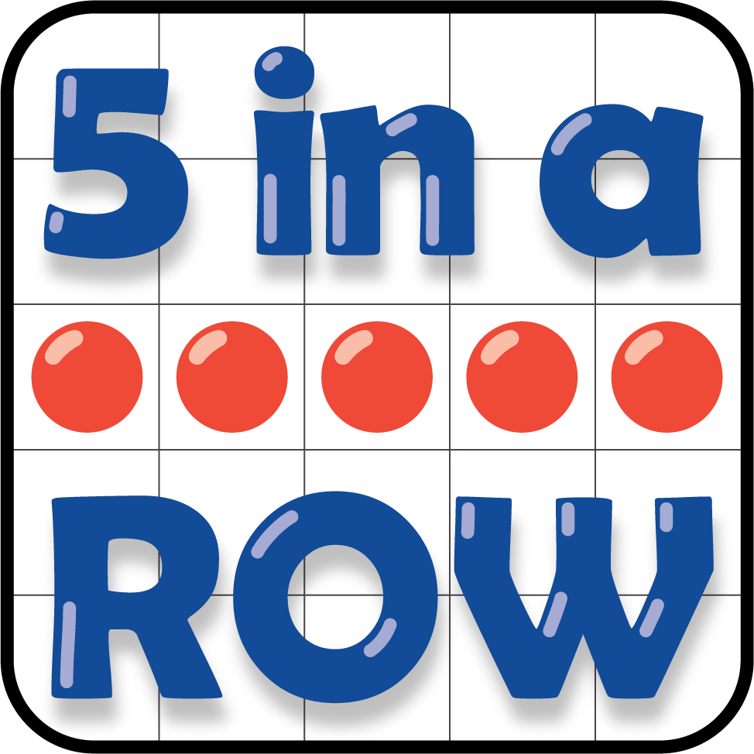
Number Puzzles
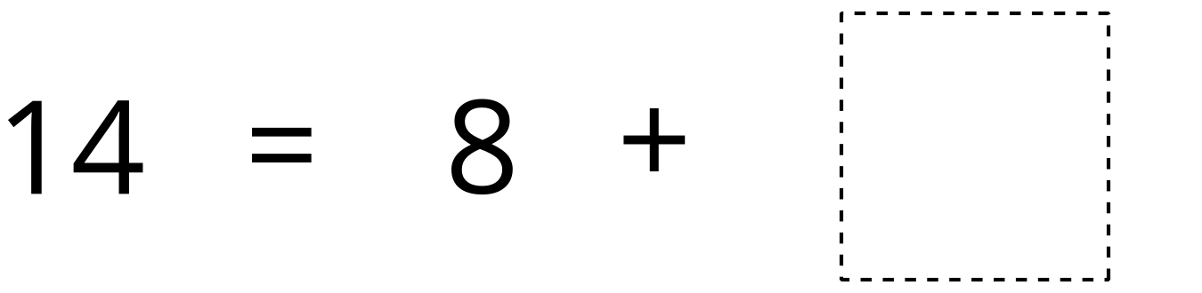
© CC BY 2021 Illustrative Mathematics®

