Lesson 4: Create Scaled Picture Graphs
- Let’s make a scaled picture graph.

Warm-up: How Many Do You See: More Groups of Dots
How many do you see? How do you see them?
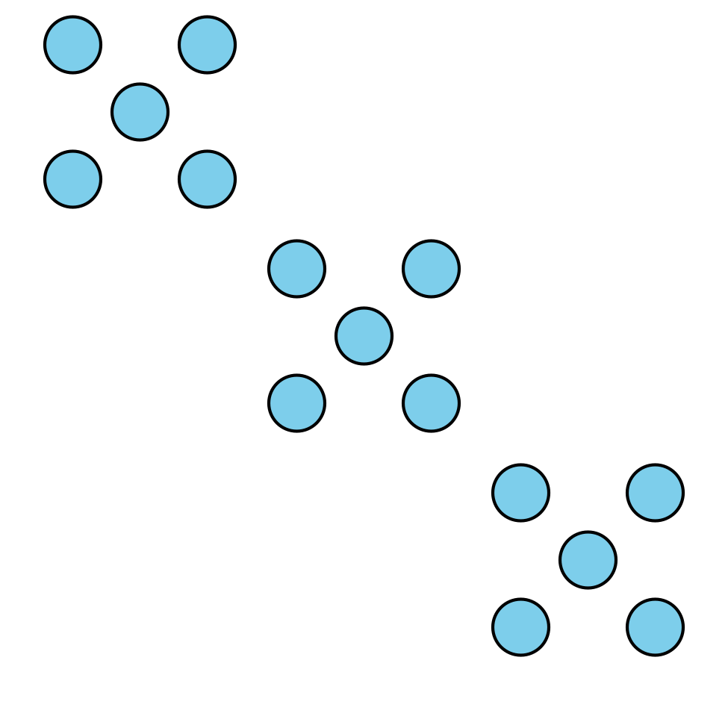
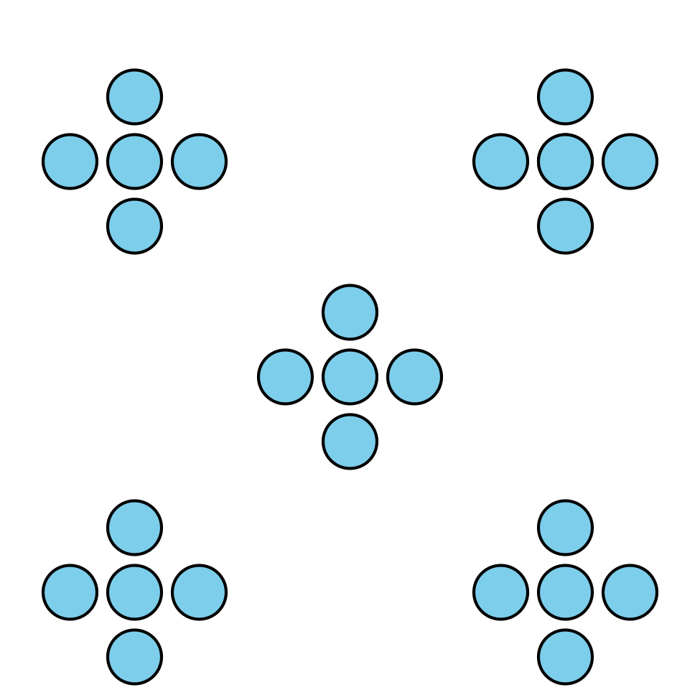

4.1: Ways to Travel
How would you like to travel?
- car (C)
- train (T)
- boat (B)
- balloon (Bal)
- plane (P)
- helicopter (H)
student's name | way of traveling

4.2: Create a Scaled Picture Graph
Represent our survey data in a scaled picture graph where each picture represents 2 students.
© CC BY 2021 Illustrative Mathematics®

