Unit 8 Lesson 1 Cumulative Practice Problems
- Tyler asked 10 students at his school how much time in minutes it takes them to get from home to school. Determine if each of these dot plots could represent the data Tyler collected. Explain your reasoning for each dot plot.
- 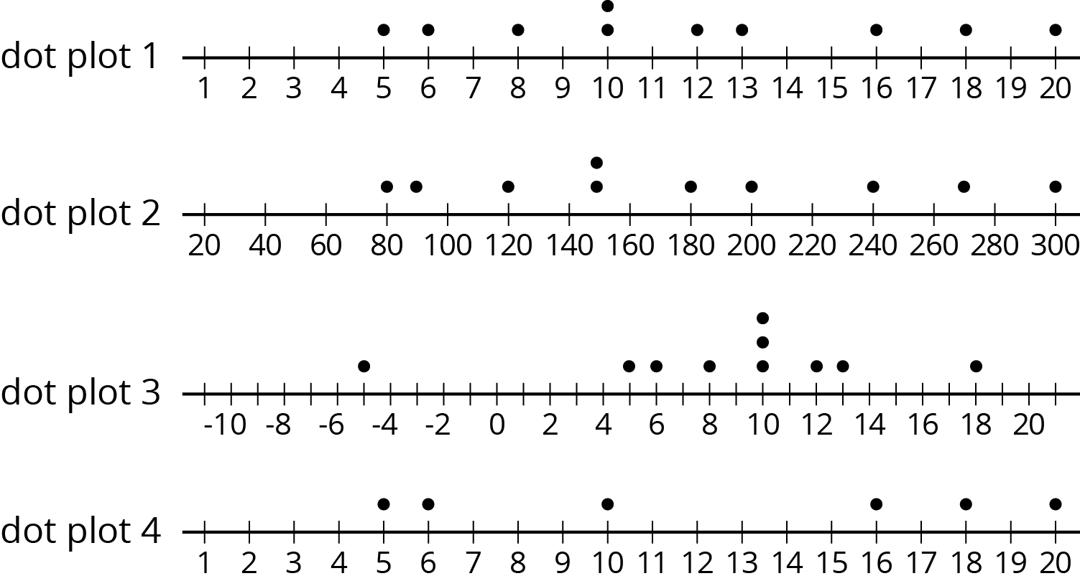

- Here is a list of questions. For each question, decide if the responses will produce numerical data or categorical data and give two possible responses.
  - What is your favorite breakfast food?
  - How did you get to school this morning?
  - How many different teachers do you have?
  - What is the last thing you ate or drank?
  - How many minutes did it take you to get ready this morning—from waking up to leaving for school?
  - Write two questions that you could ask the students in your class that would result in categorical data. For each question, explain how you know that responses to it would produce categorical data.
  - Write two questions that you could ask the students in your class that would result in numerical data. For each question, explain how you know that responses to it would produce numerical data.
- Triangle $DEF$ has vertices $D=(\text{-}4,\text{-}4),E=(\text{-}2,\text{-}4)$, and $F=(\text{-}3,\text{-}1)$.
- 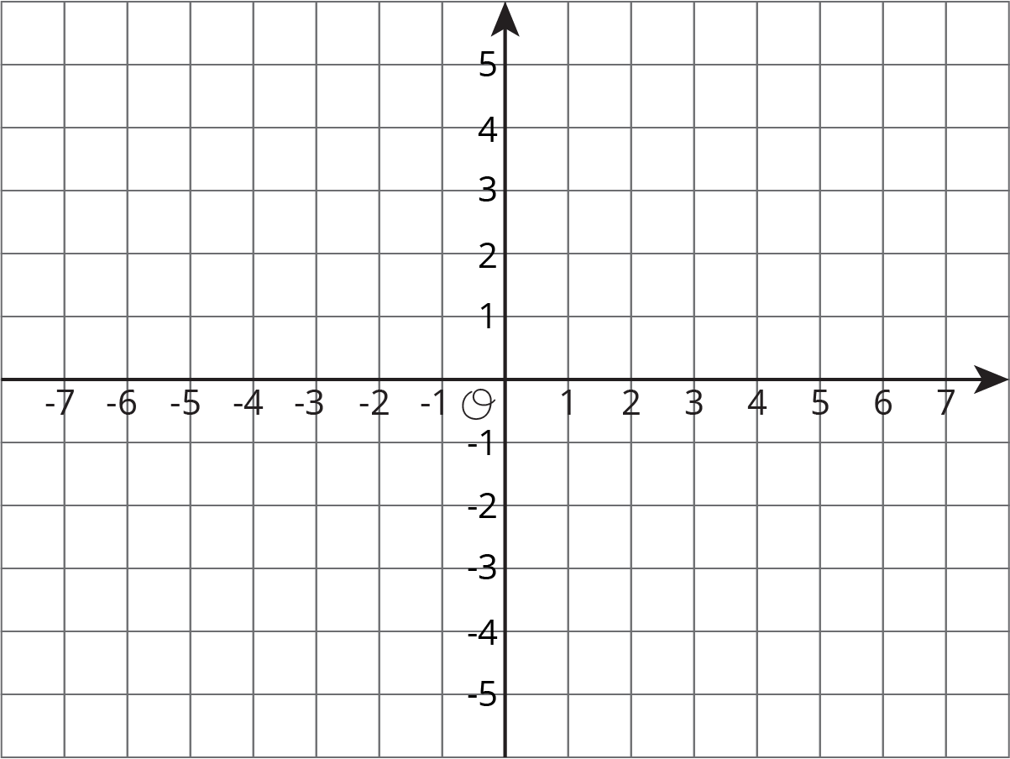
  - Plot the triangle in the coordinate plane and label the vertices.
  - Name the coordinates of 3 points that are inside the triangle.
  - What is the area of the triangle? Show your reasoning.
- (From Unit 7, Lesson 15.)
© CC BY Open Up Resources. Adaptations CC BY IM.

