Unit 3 Lesson 2: Talking Percents

1 Math Talk: Percents (Warm up)

Student Task Statement
Evaluate mentally.
50% of 200
25% of 200
6% of 200
3.2% of 200

2 Shapes Galore

Student Task Statement
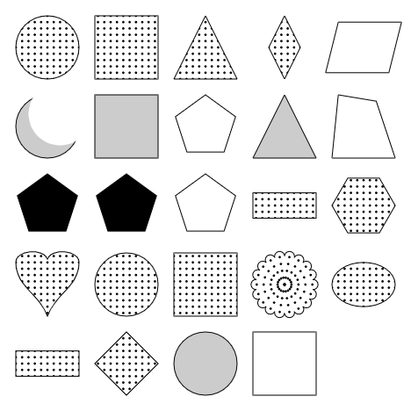
Use the image to fill in one word or number for each of the blanks. Round each percentage to the nearest whole number.
- $\underset{_}{​}$of the 13 shapes with dots are circles. $\underset{_}{​}$% of the shapes with dots are circles.
- 5 of the $\underset{_}{​}$ $\underset{_}{​}$ are white. $\underset{_}{​}$% of the shapes are white.
- $\underset{_}{​}$of the $\underset{_}{​}$ shapes are quadrilaterals. $\underset{_}{​}$% of the shapes are quadrilaterals.
- $\underset{_}{​}$ of the 4 $\underset{_}{​}$ are $\underset{_}{​}$. $\underset{_}{​}$% of the 4 $\underset{_}{​}$ are $\underset{_}{​}$ .
- $\underset{_}{​}$ of the $\underset{_}{​}$ $\underset{_}{​}$ ​​​​​​are $\underset{_}{​}$ . $\underset{_}{​}$% of the $\underset{_}{​}$ are $\underset{_}{​}$ .

3 Favorite Movies and Favorite Classes

Student Task Statement
For each question:
- Explain to a partner what categories you would use to calculate the percentage.
- Write an expression to use to find the percentage.
- Calculate the percentage to the nearest whole number.
 | prefer sci-fi movies | prefer drama movies | total
prefer science class
prefer English class
total
- What percentage of the class prefer sci-fi movies?
- What percentage of the class prefer science class?
- What percentage of the class prefer dramas?
- What percentage of the class prefer science class and dramas?
- What percentage of the class prefer English class?
- Of the students who prefer dramas, $\underset{_}{​}$% prefer English class.
- Of the students who prefer science class, $\underset{_}{​}$% prefer sci-fi movies.
© CC BY 2019 by Illustrative Mathematics®

