Lesson 2: Count 2 Groups of Images
- Let’s find out how many things there are in two groups.

2.1: Put Together Dots on 5-Frames
There are
dots.
There are
dots.
There are
dots.
There are
dots.
There are
dots.

2.2: How Many Apples?

- 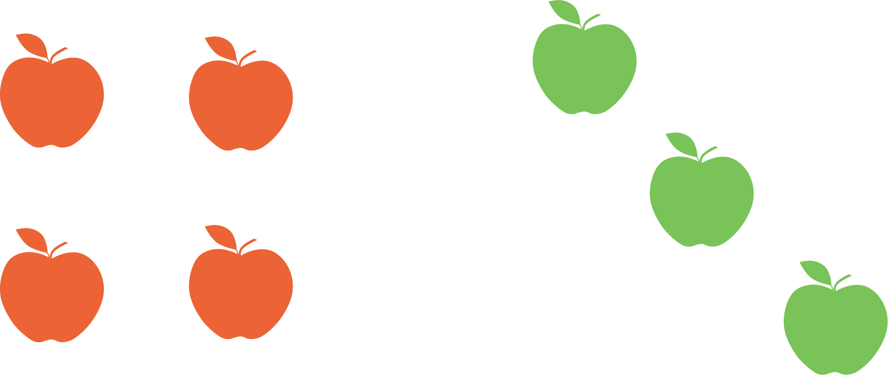
- There are
- apples.

- 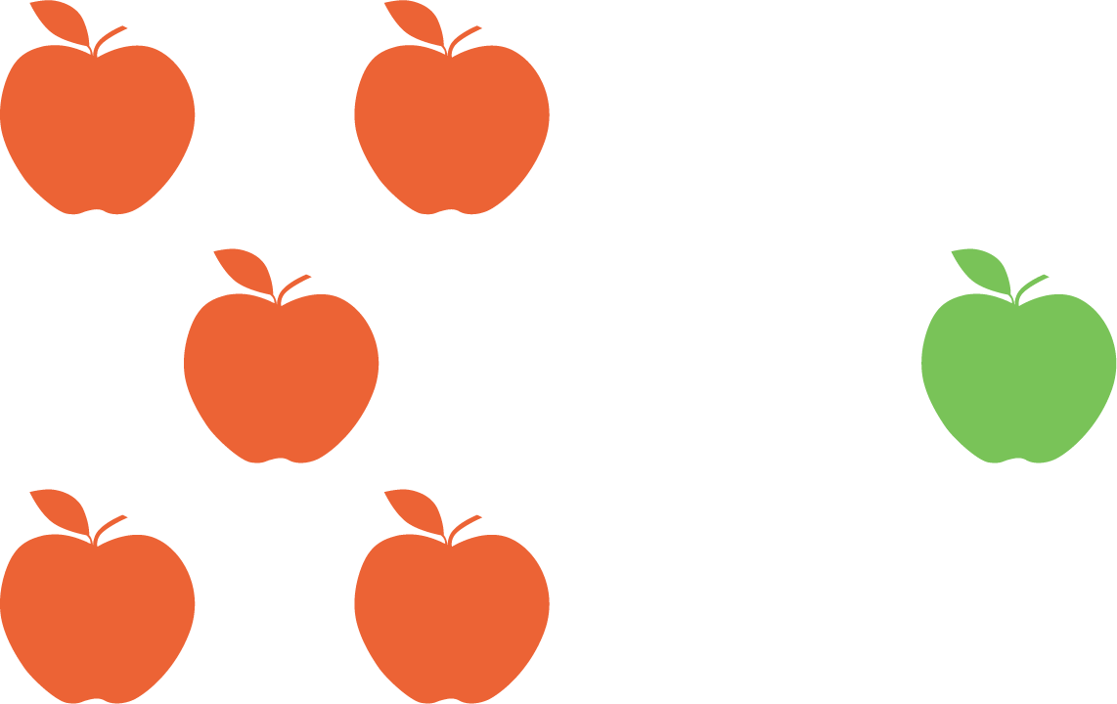
- There are
- apples.

- 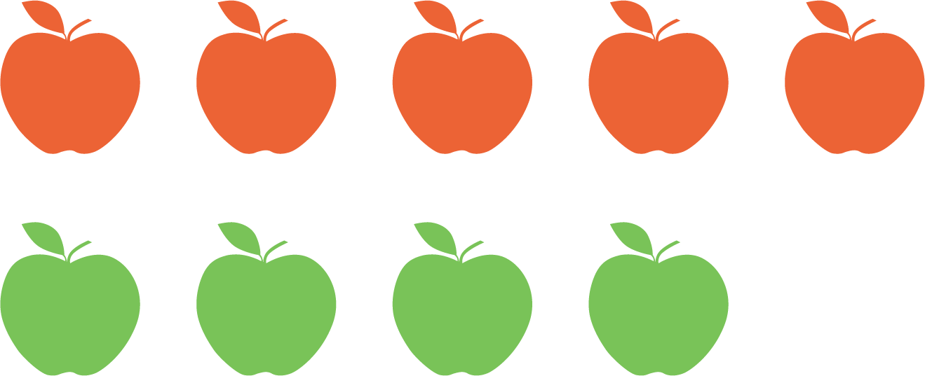
- There are
- apples.

- 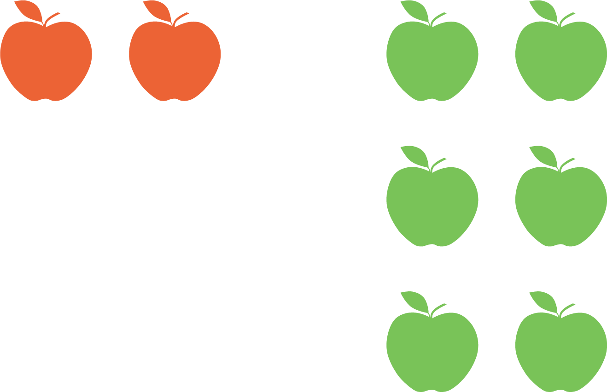
- There are
- apples.

2.3: Introduce Roll and Add, Dots
How many dots?
Choose a center.
Roll and Add
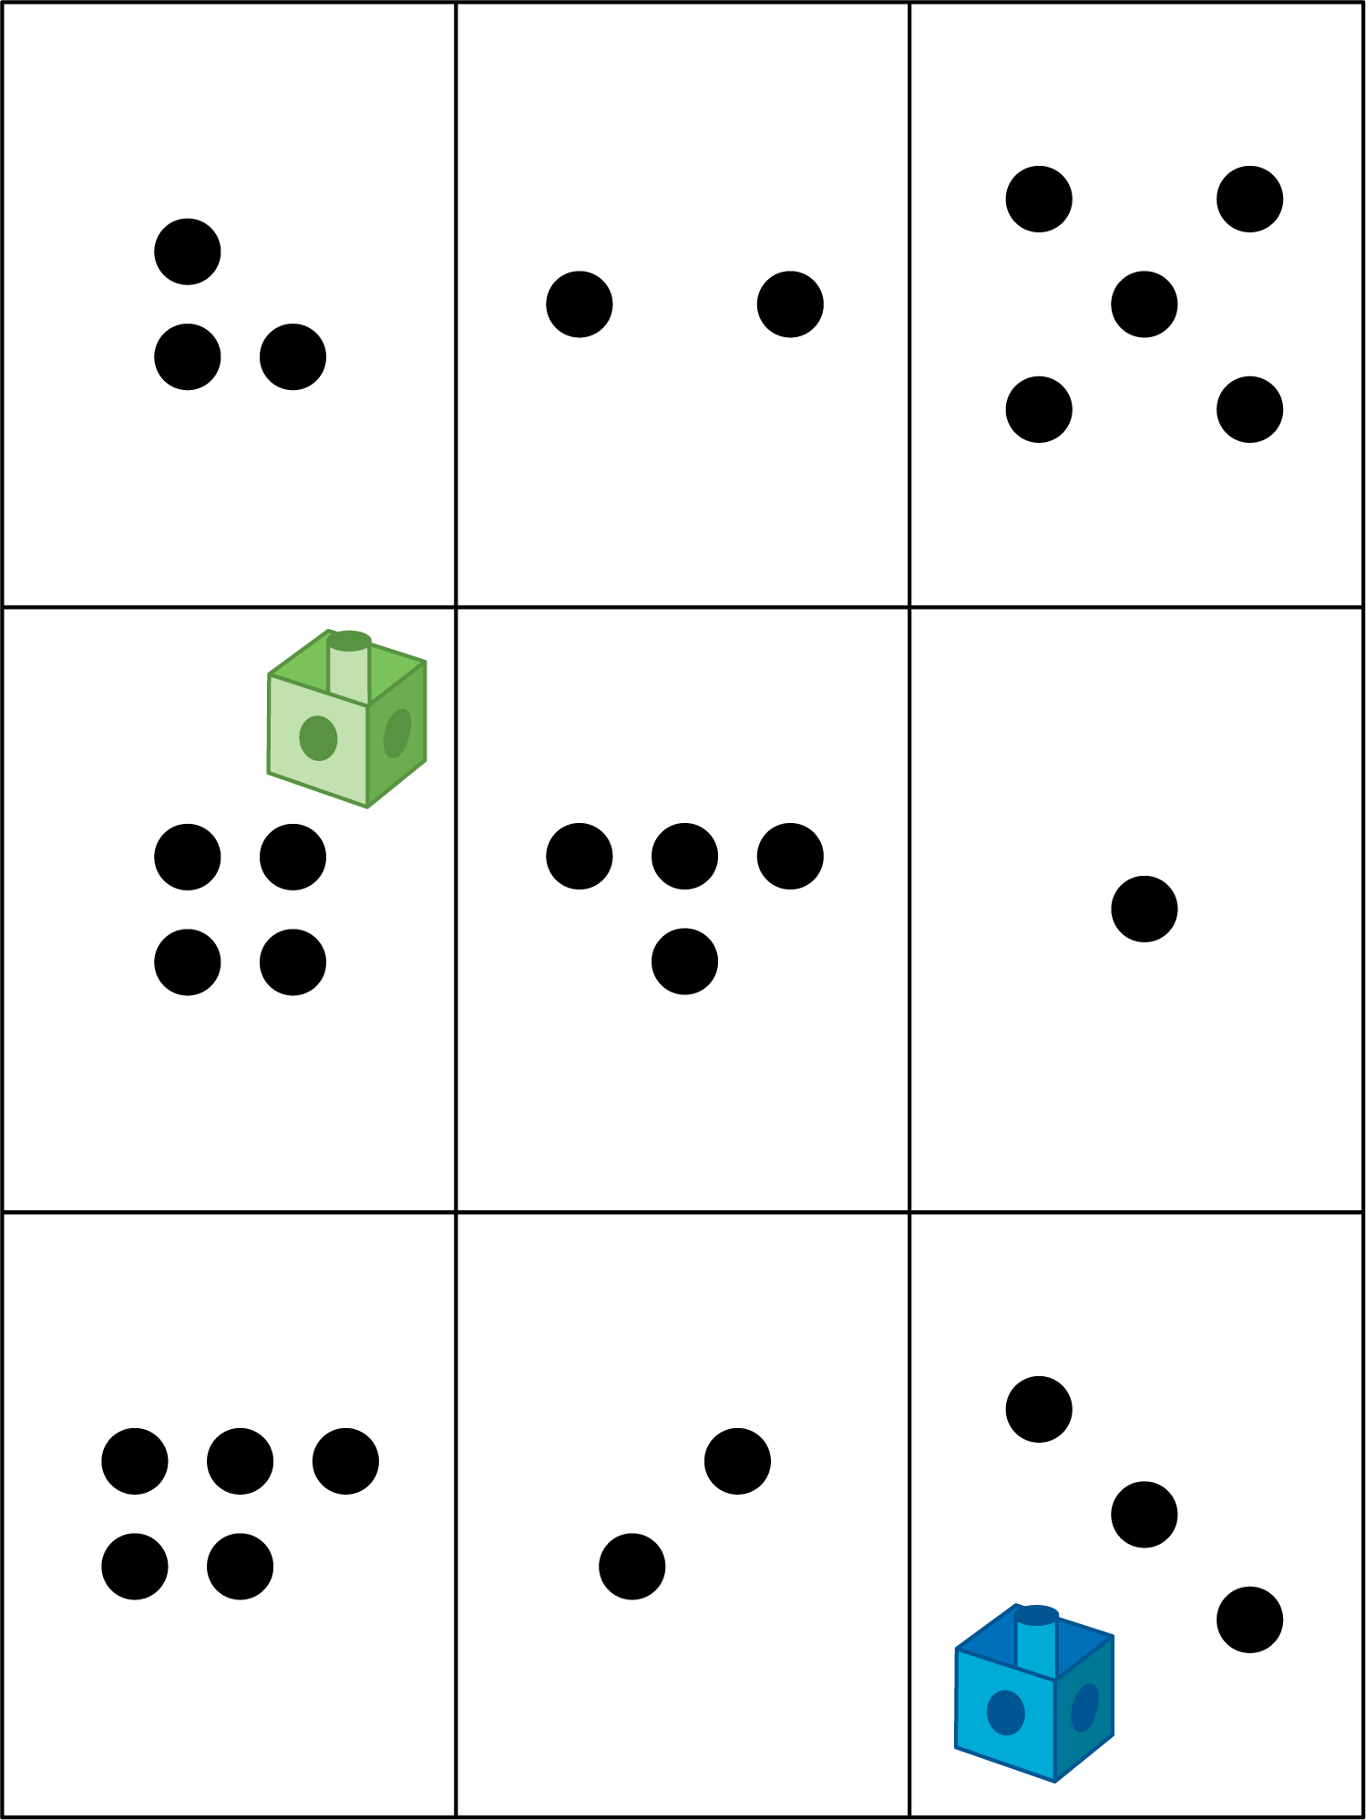
Math Libs
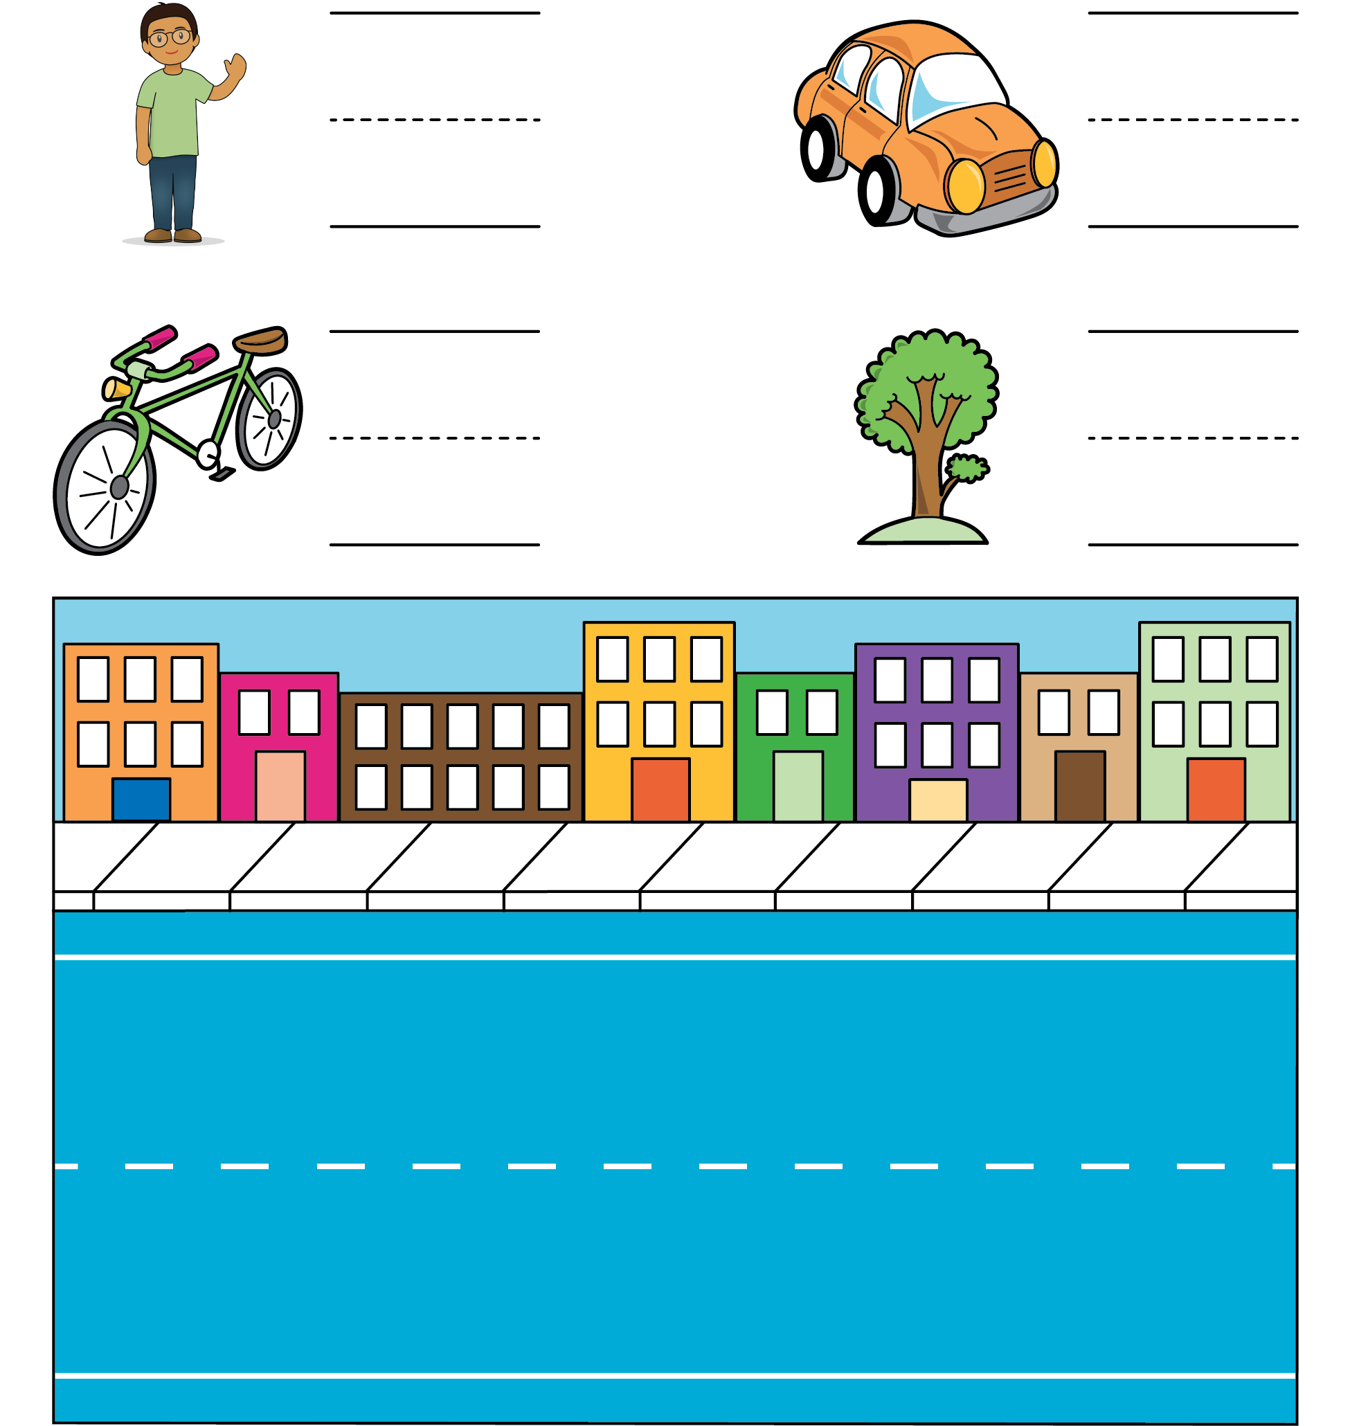
Match Mine
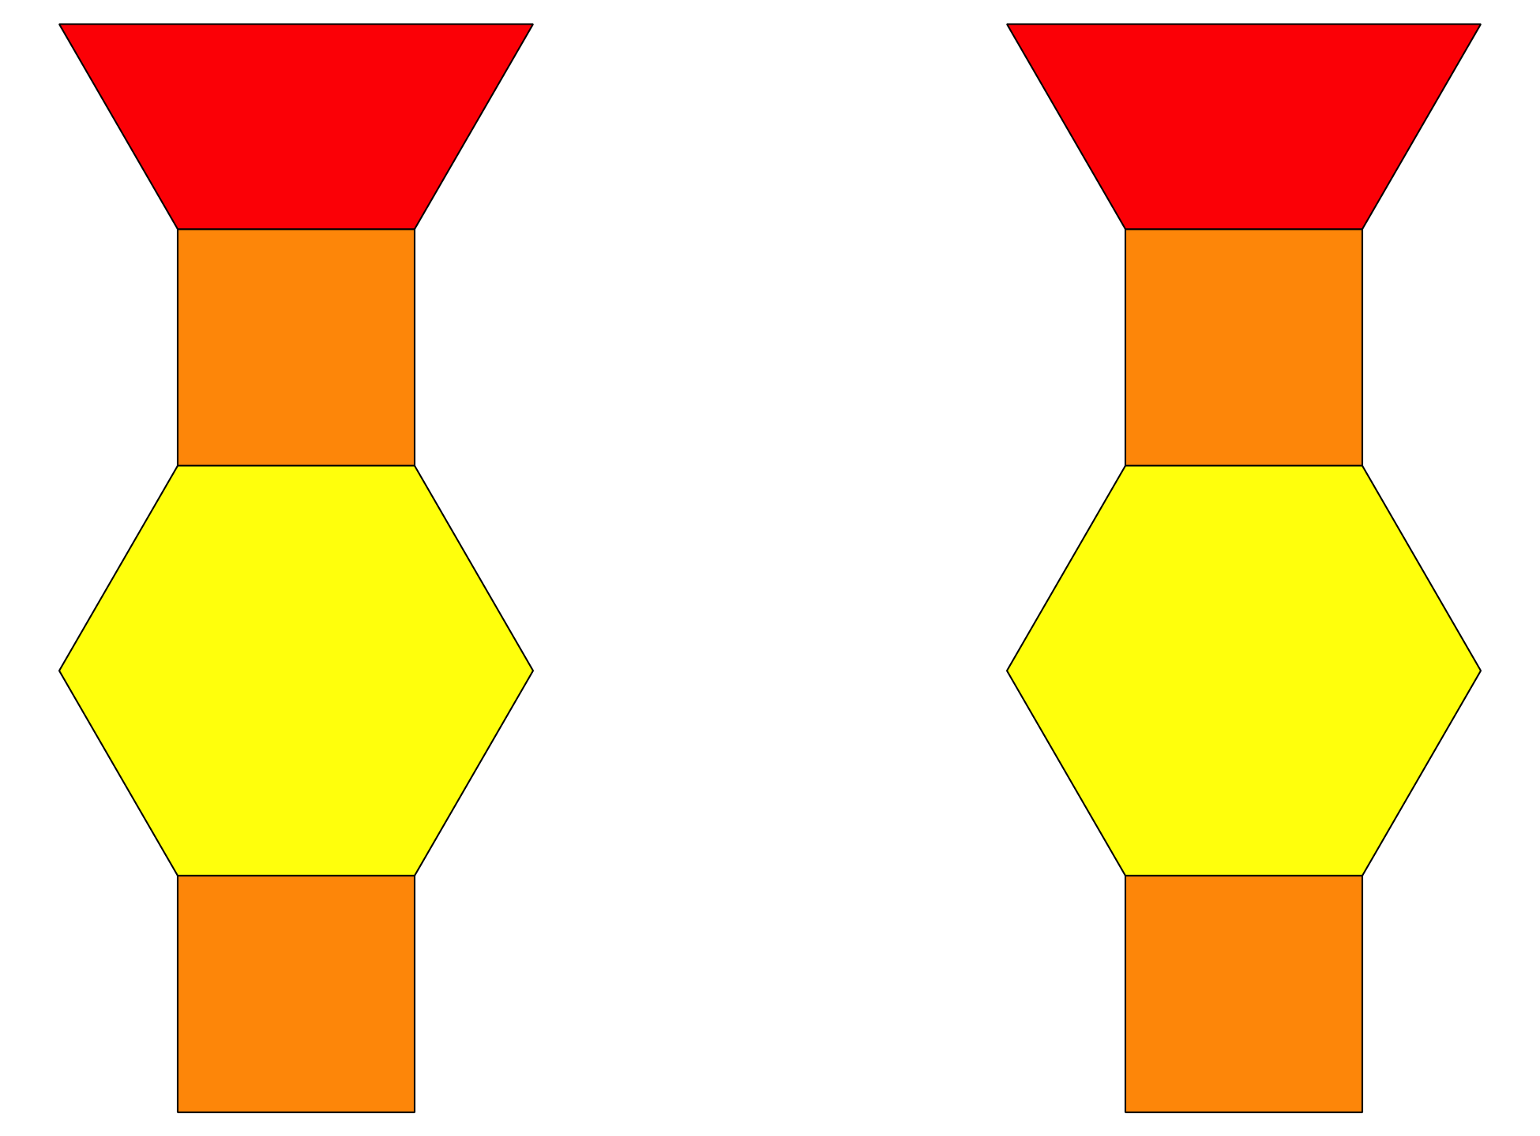
© CC BY 2021 Illustrative Mathematics®

