Unit 4 Lesson 2: Match Representations of Tens

WU Estimation Exploration: Cubes and Towers (Warm up)

Student Task Statement
Round 1: How many cubes?
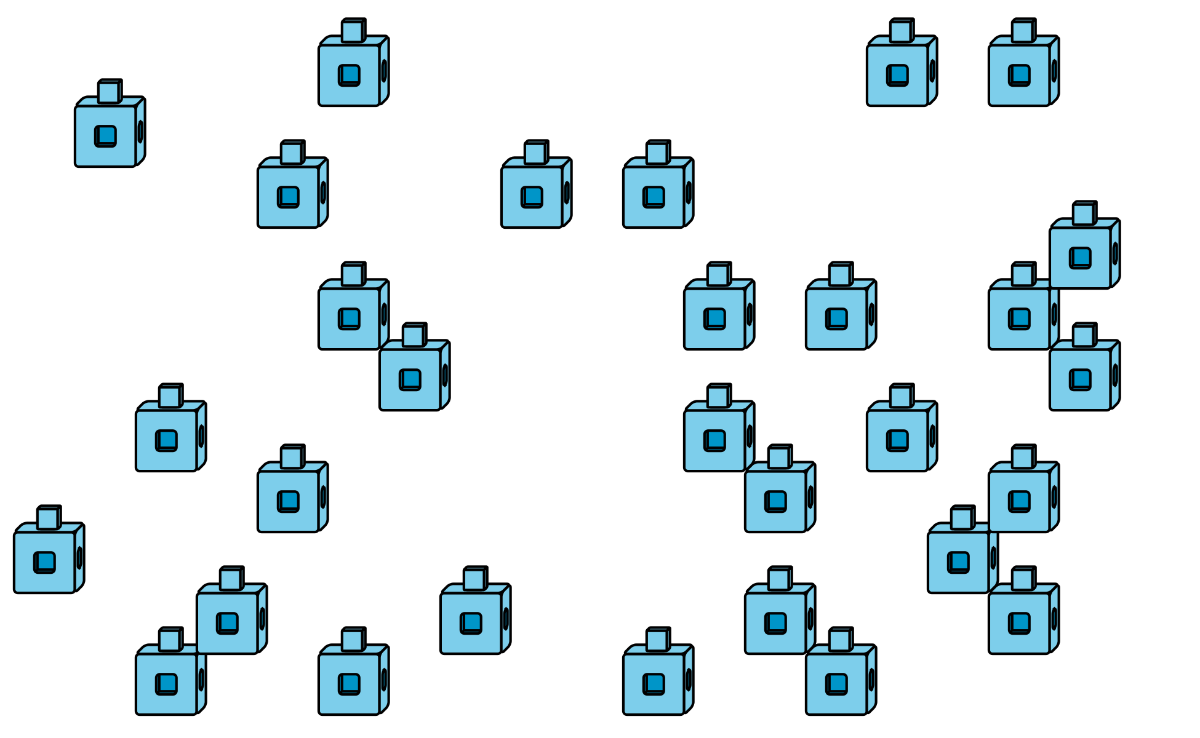
Record an estimate that is:
too low | about right | too high
Round 2: How many cubes?
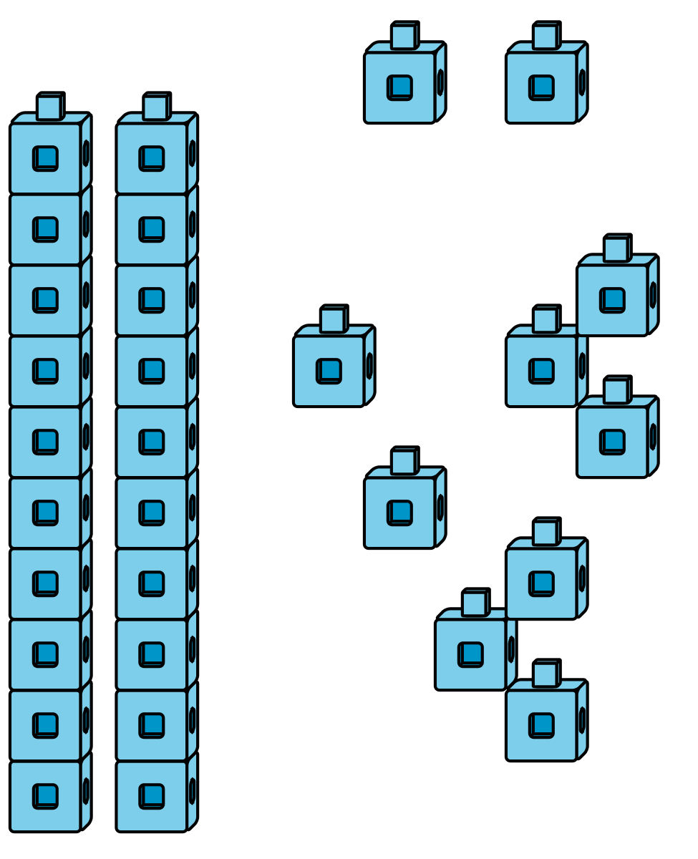
Record an estimate that is:
too low | about right | too high

1 Representations of Tens

Student Task Statement

2 It's a Match!

Student Task Statement
© CC BY 2021 Illustrative Mathematics®

