Unit 4 Lesson 4 Cumulative Practice Problems
- Mai and Tyler work on the equation $\frac{2}{5}b+1=\text{-}11$ together. Mai's solution is $b=\text{-}25$ and Tyler's is $b=\text{-}28$. Here is their work. Do you agree with their solutions? Explain or show your reasoning.
- Mai:
$\frac{2}{5}b+1=\text{-}11$
$\frac{2}{5}b=\text{-}10$
$b=\text{-}10⋅\frac{5}{2}$
$b=\text{-}25$
- Tyler:
$\frac{2}{5}b+1=\text{-}11$
$2b+1=\text{-}55$
$2b=\text{-}56$
$b=\text{-}28$

- Solve $3(x−4)=12x$
- Describe what is being done in each step while solving the equation.
  - $2(\text{-}3x+4)=5x+2$
  - $\text{-}6x+8=5x+2$
  - $8=11x+2$
  - $6=11x$
  - $x=\frac{6}{11}$
- Andre solved an equation, but when he checked his answer he saw his solution was incorrect. He knows he made a mistake, but he can’t find it. Where is Andre’s mistake and what is the solution to the equation?
- $\begin{matrix}\text{-}2(3x−5) & =4(x+3)+8 \\ \text{-}6x+10 & =4x+12+8 \\ \text{-}6x+10 & =4x+20 \\ 10 & =\text{-}2x+20 \\ \text{-}10 & =\text{-}2x \\ 5 & =x\end{matrix}$

- Choose the equation that has solutions $(5,7)$ and $(8,13)$.
  - $3x−y=8$
  - $y=x+2$
  - $y−x=5$
  - $y=2x−3$
- (From Unit 3, Lesson 12.)
- A length of ribbon is cut into two pieces to use in a craft project. The graph shows the length of the second piece, $x$, for each length of the first piece, $y$.
  - How long is the ribbon? Explain how you know.
  - What is the slope of the line?
  - Explain what the slope of the line represents and why it fits the story.
- 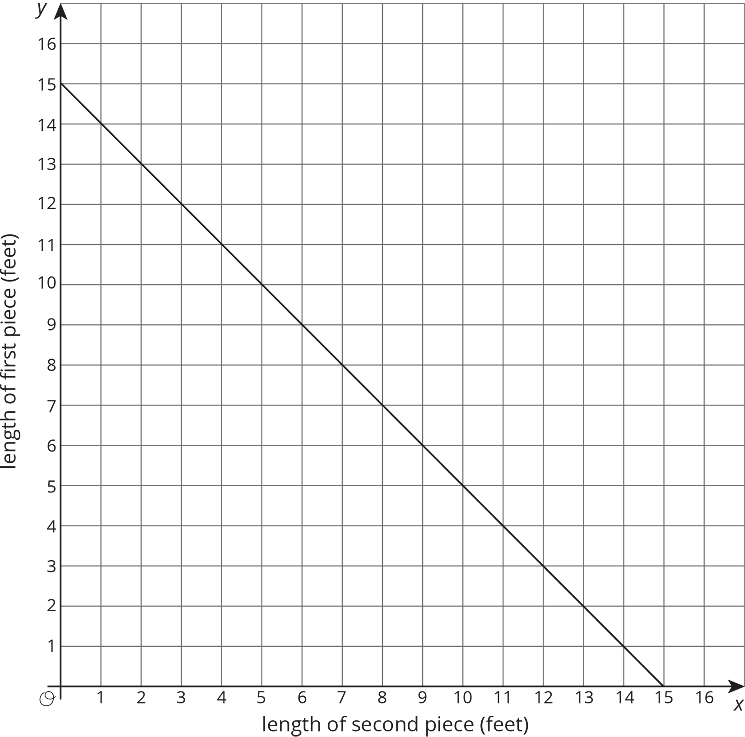
- (From Unit 3, Lesson 9.)
© CC BY Open Up Resources. Adaptations CC BY IM.

