Lesson 1: Represent Numbers in Different Ways
- Let’s represent numbers in different ways.

Warm-up: Which One Doesn’t Belong: Numbers within 1,000
Which one doesn't belong?
A.
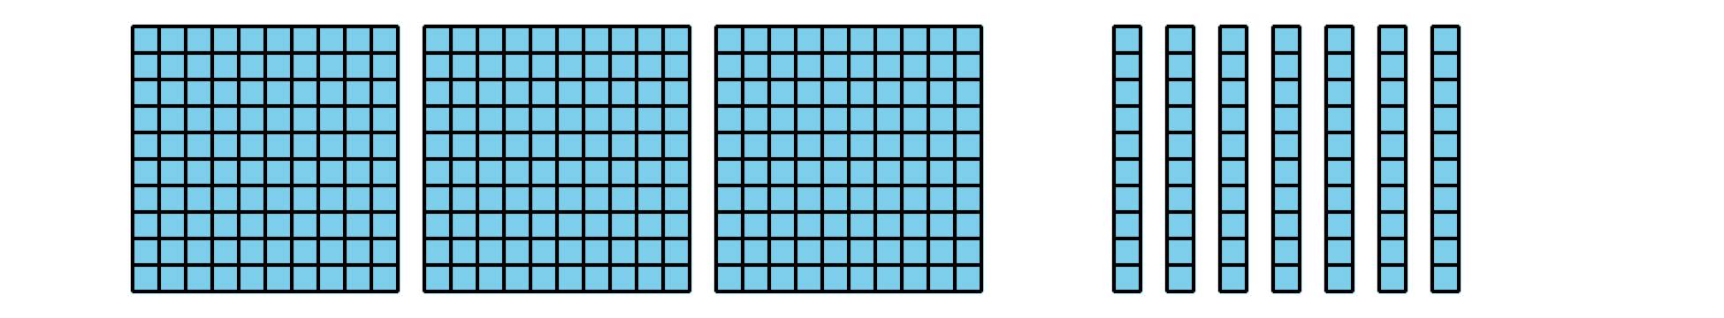
B. $300+70+1$
C. $300+60+10$
D. $400−30$

1.1: Card Sort: Numbers in Their Different Forms
Your teacher will give you a set of cards that show numbers in different forms.
Match the cards that represent the same number. Record your matches here. Be ready to explain your reasoning.
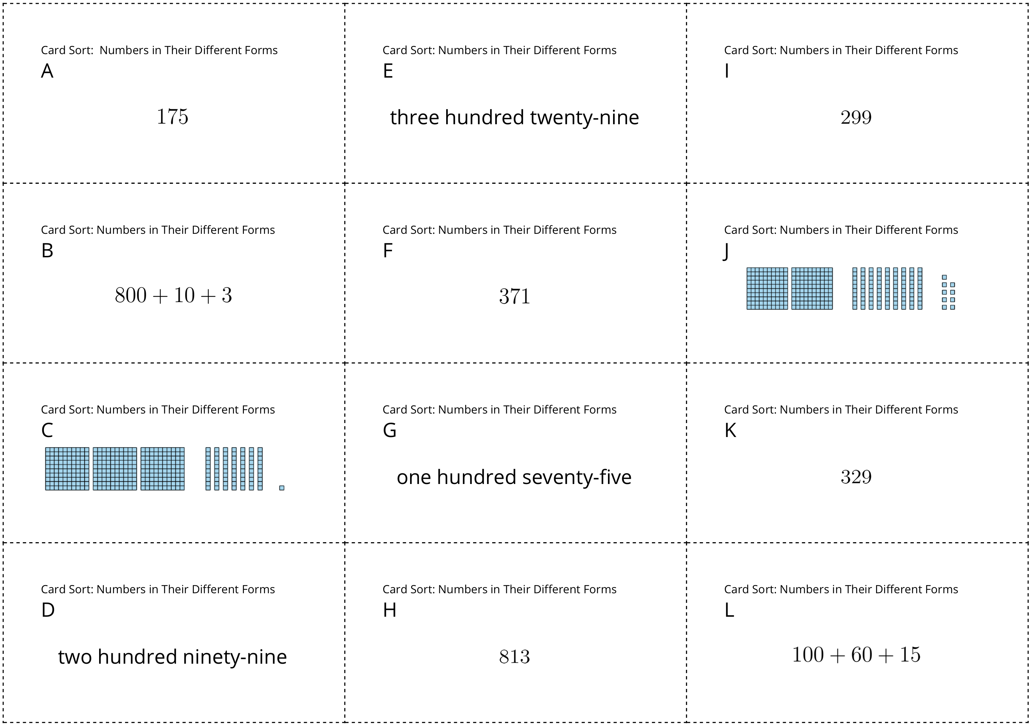

1.2: Numbers in Different Forms Round Table
Your teacher will give you a recording sheet.
Part 1
- In Box 1, write a three-digit number. (Pause for your teacher's instructions.)
- In Box 2, show a way that the number could be decomposed. (Pause for teacher instructions.)
- In Box 3, show a way that the number could be decomposed that’s different from Box 2. (Pause for teacher instructions.)
- In Box 4, show a way that the number could be decomposed that’s different from Boxes 2 and 3.
Part 2
- Look at the different ways your number was decomposed on your recording sheet. What connections do you see between them?
- Look at all of the recording sheets for your group. What patterns do you notice in the ways the numbers are decomposed?
© CC BY 2021 Illustrative Mathematics®

