Unit 4 Lesson 21: Compare Two-Digit Numbers Shown in Different Ways

WU Number Talk: Addition Within 20 (Warm up)

Student Task Statement
Find the value of each expression mentally.
- $10+6$
- $9+6$
- $10+7$
- $8+7$

1 Elena and Kiran Compare Collections

Student Task Statement
Elena and Kiran are comparing their collections.
Elena says, “I have 5 tens 32 ones.”
Kiran says, “I have 7 tens 2 ones.”
Who has more in their collection?
Show your thinking using drawings, numbers, words, or expressions.

2 Base-Ten Representation Compare

Student Task Statement
- What do you notice?
- 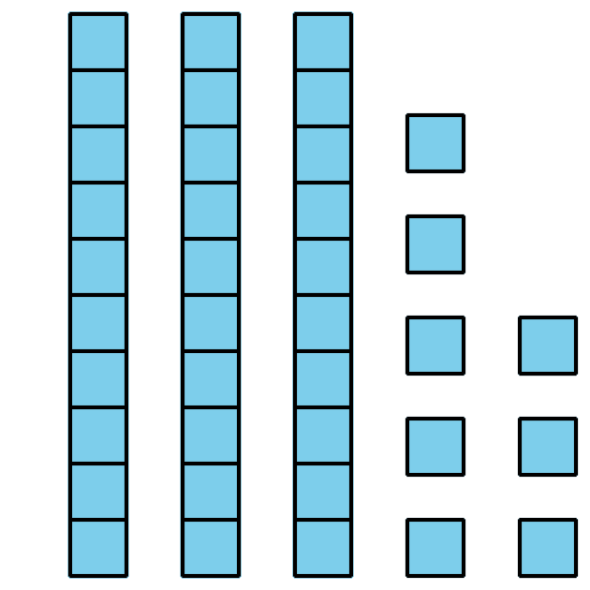
- 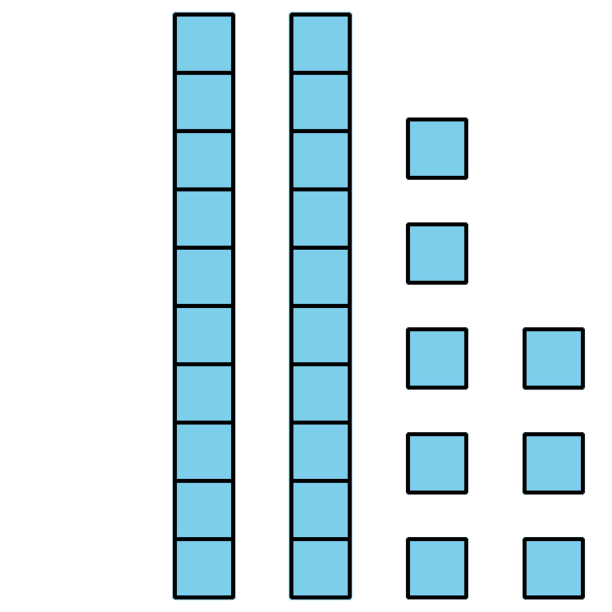
- aaaiaaai aaaiaaappa_ aaaiaaai
- Circle the representation that shows the greater number.
Write a number to match each representation.
Then write a comparison statement using <, >, or =.

  - 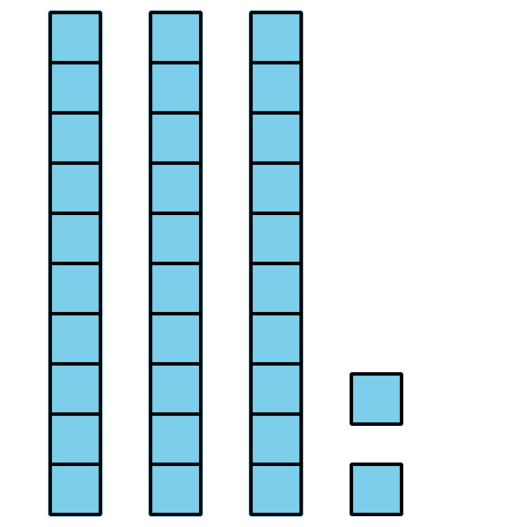
  - 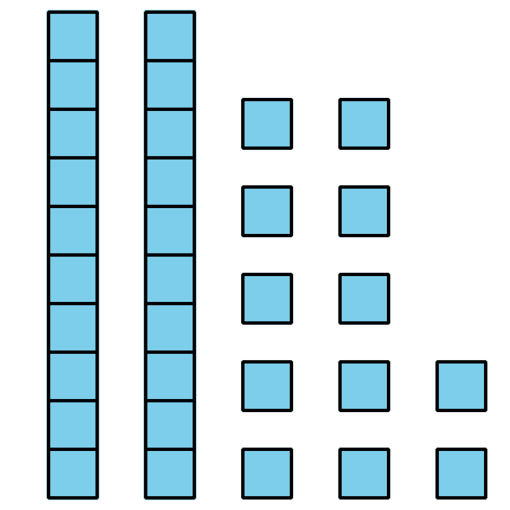
  - aaaiaaai aaaiaaappa_ aaaiaaai

  - 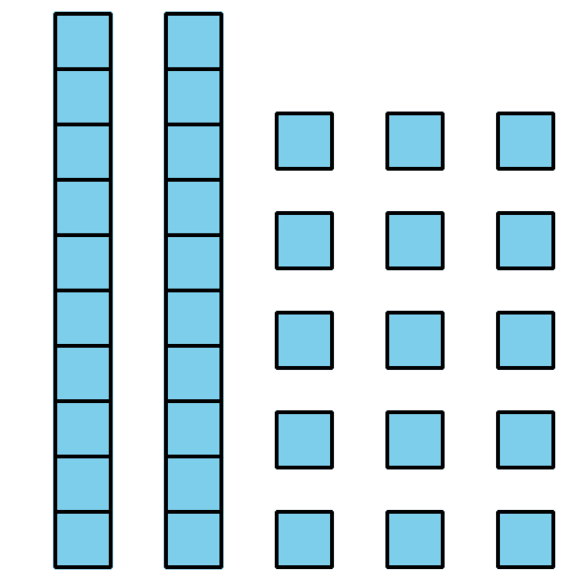
  - 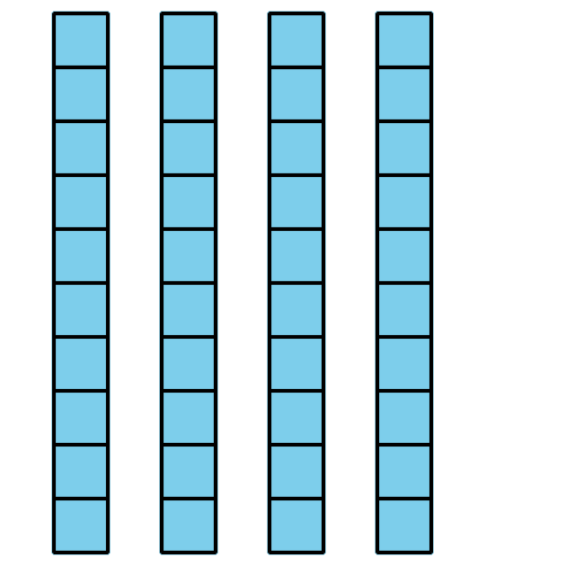
  - aaaiaaai aaaiaaappa_ aaaiaaai
  - 5 tens 2 ones
  - 12 ones 3 tens
  - aaaiaaai aaaiaaappa_ aaaiaaai
  - 1 ten 25 ones
  - 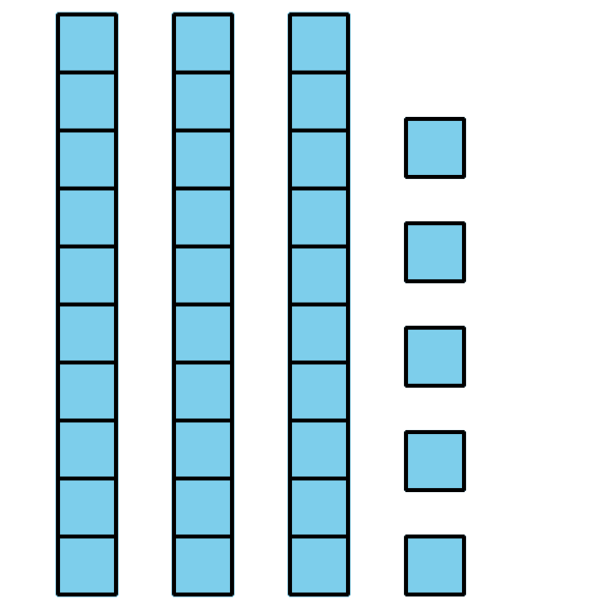
  - aaaiaaai aaaiaaappa_ aaaiaaai
  - 7 tens 29 ones
  - $50+39$
  - aaaiaaai aaaiaaappa_ aaaiaaai
© CC BY 2021 Illustrative Mathematics®

