Unit 6 Lesson 14: Situations Involving Factors and Multiples

WU Number Talk: Dividing by 7 (Warm up)

Student Task Statement
Find the value of each expression mentally.
- $21÷7$
- $35÷7$
- $140÷7$
- $196÷7$

1 Write Multiples

Student Task Statement
- Han starts writing multiples of a number. When he reaches 104, he has written 8 numbers.
- For each of the following questions, show your reasoning.
- 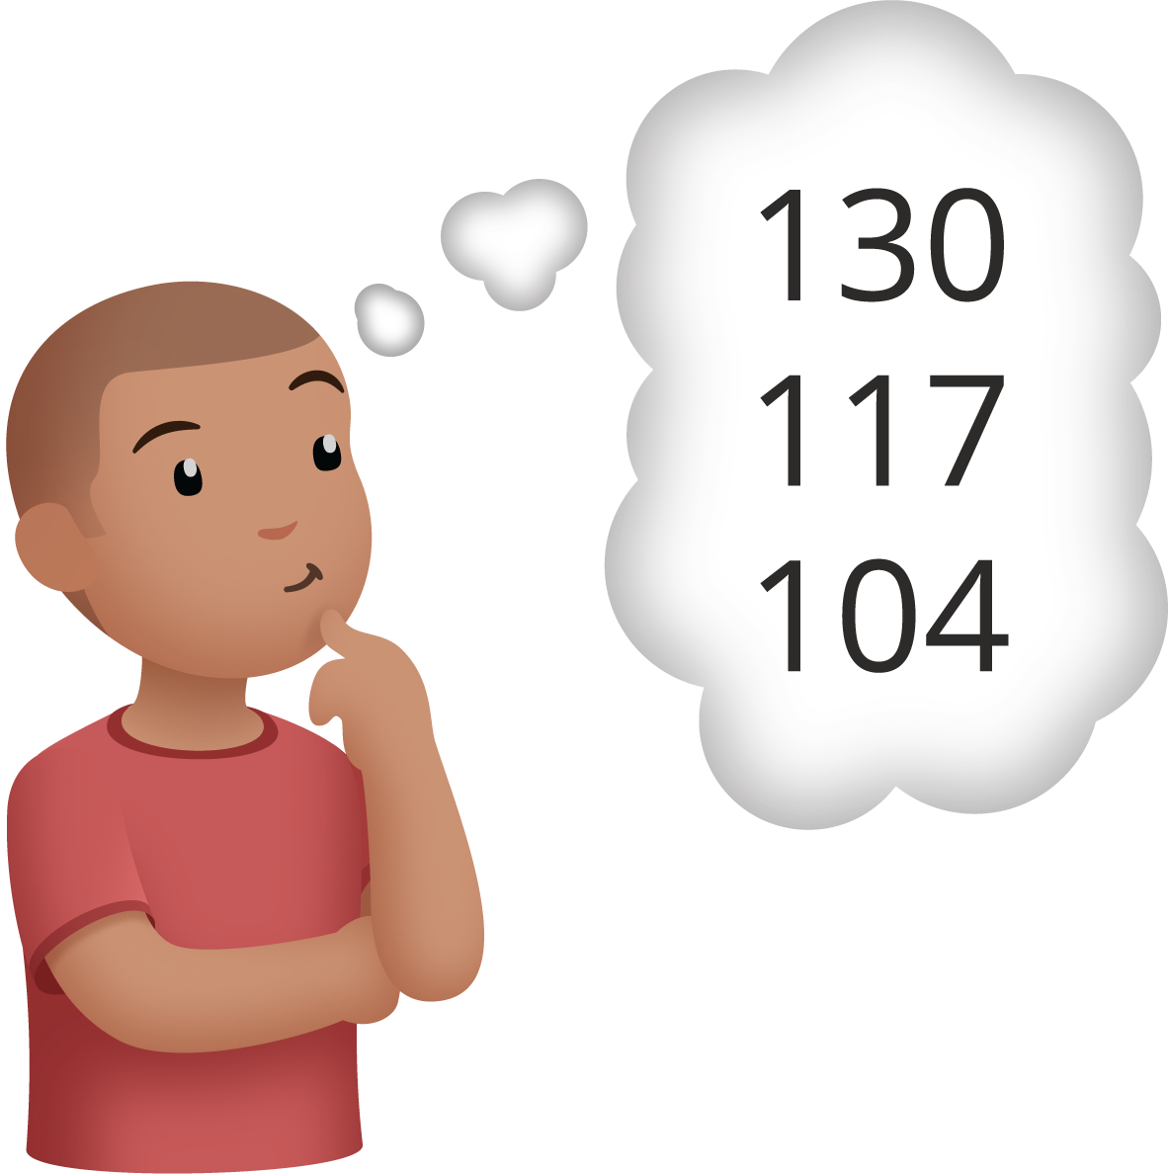
  - What number is Han writing multiples of?
  - What is the 15th multiple of this number?
  - Han gets to 286. How many numbers has he written at that point?
- Kiran wants to know how many multiples of 7 are between 0 and 150.
  - He thinks he can use division to find out. Do you agree? Explain your reasoning.
  - How many multiples will he find? Show your reasoning.
  - Is 150 a multiple of 7? Show how you know.

2 Jada’s Mystery Number

Student Task Statement
Jada is writing multiples of a mystery number. After writing a bunch of numbers, she writes out 126.
- Mai says 6 is the mystery number.
- Priya says 8 is the mystery number.
- Andre says 9 could be the mystery number.
- Which student do you agree with? Show your reasoning and include equations.
- Jada gives one more clue: “If I keep writing multiples, I’ll get to 153.”
- What is the mystery number? Explain or show your reasoning.
© CC BY 2021 Illustrative Mathematics®

