Unit 2 Lesson 5: Make Groups of More, Fewer, or the Same

WU How Many Do You See: Fingers on Two Hands (Warm up)

Images for Launch
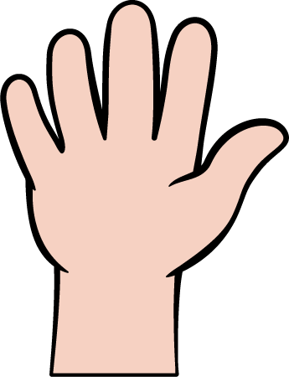

Student Task Statement

1 Introduce Less, Same, More, Groups of Objects

Student Task Statement

2 Introduce Math Fingers, Fewer or More

Student Task Statement

3 Center: Choice Time

Student Task Statement
Choose a center.
Less, Same, More
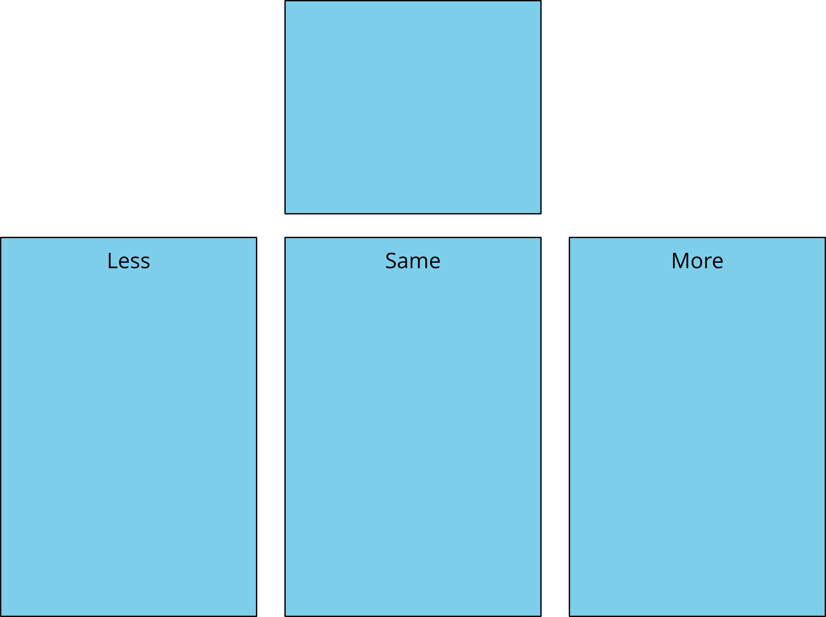
Shake and Spill
Number Race
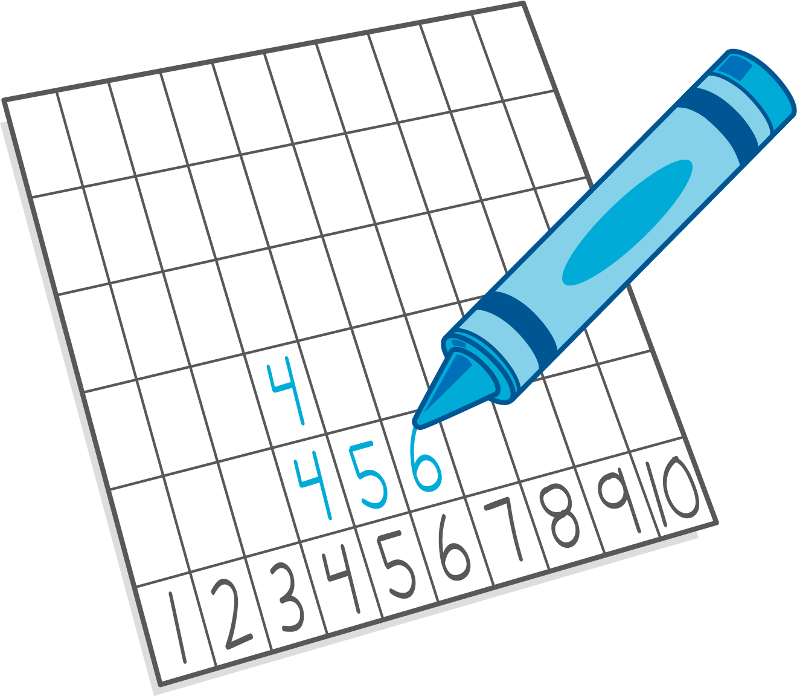
Math Fingers
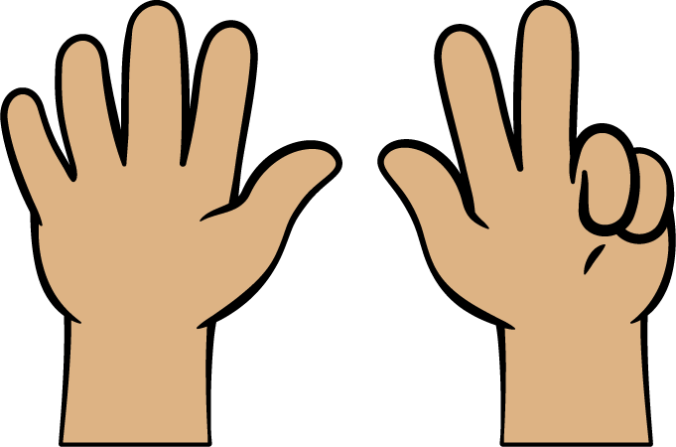
Pattern Blocks
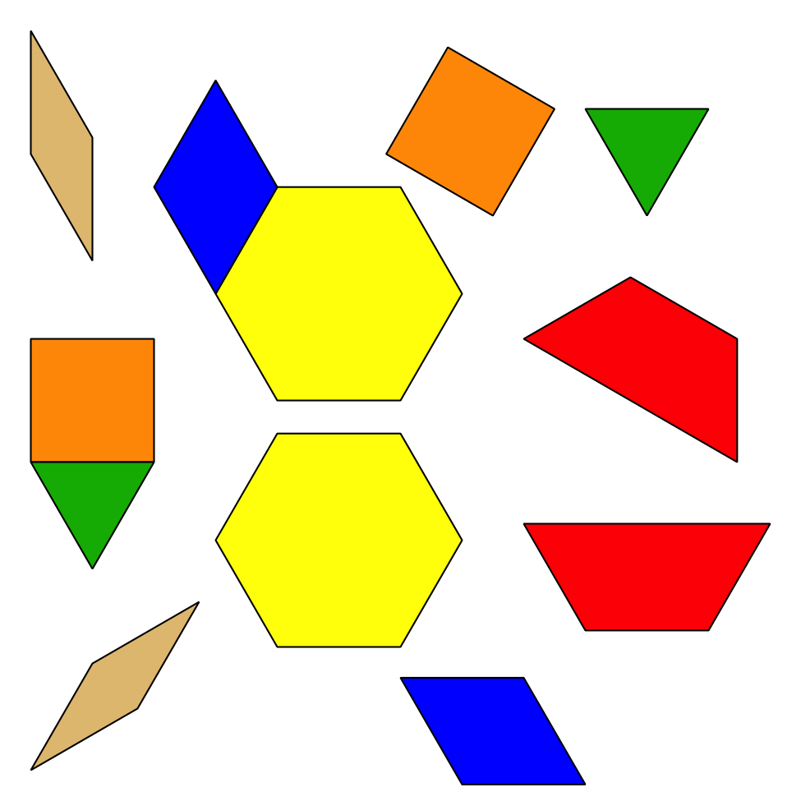
Picture Books
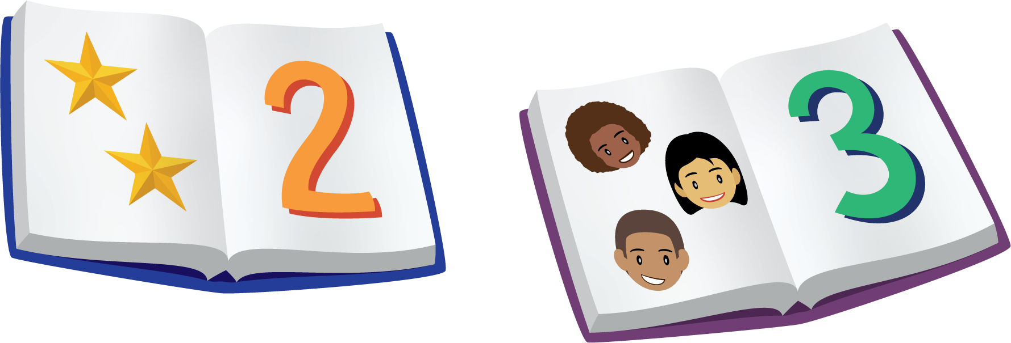
© CC BY 2021 Illustrative Mathematics®

