Unit 1 Lesson 11: Comparing and Contrasting Data Distributions

1 Math Talk: Mean (Warm up)

Student Task Statement
Evaluate the mean of each data set mentally.
27, 30, 33
61, 71, 81, 91, 101
0, 100, 100, 100, 100
0, 5, 6, 7, 12

2 Describing Data Distributions

Student Task Statement
- Your teacher will give you a set of cards. Take turns with your partner to match a data display with a written statement.
  - For each match that you find, explain to your partner how you know it’s a match.
  - For each match that your partner finds, listen carefully to their explanation. If you disagree, discuss your thinking and work to reach an agreement.
- After matching, determine if the mean or median is more appropriate for describing the center of the data set based on the distribution shape. Discuss your reasoning with your partner. If it is not given, calculate (if possible) or estimate the appropriate measure of center. Be prepared to explain your reasoning.

3 Visual Variability and Statistics

Student Task Statement
Each box plot summarizes the number of miles driven each day for 30 days in each month. The box plots represent, in order, the months of August, September, October, November, and December.
- The five box plots have the same median. Explain why the median is more appropriate for describing the center of the data set than the mean for these distributions.
- Arrange the box plots in order of least variability to greatest variability. Check with another group to see if they agree.
  - 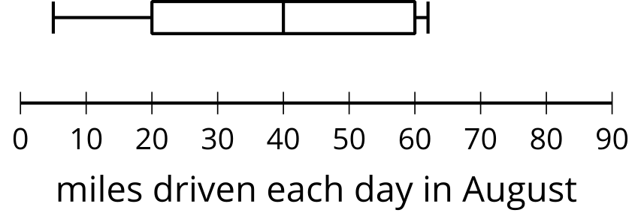
  - 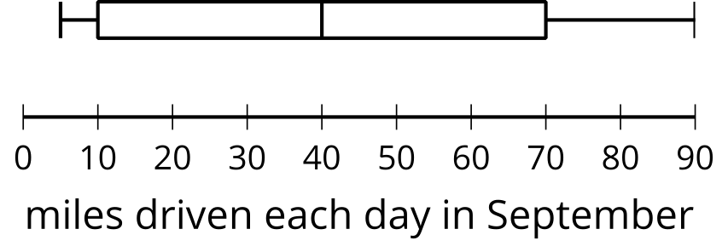
  - 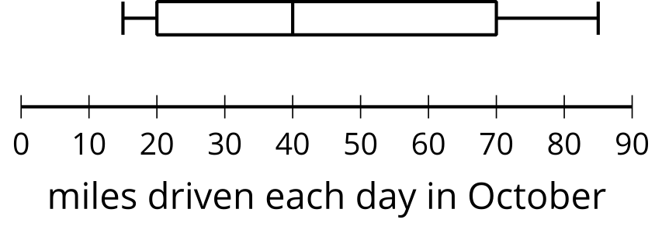
  - 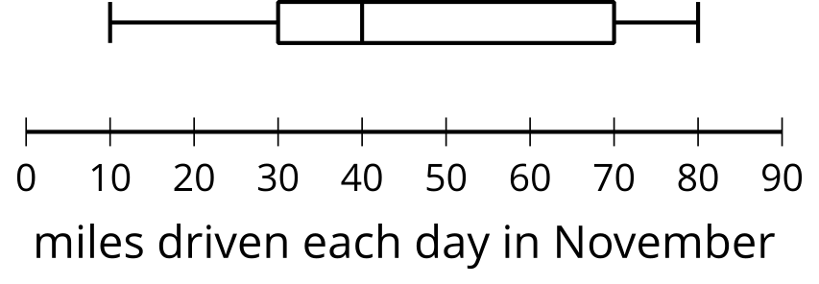
  - 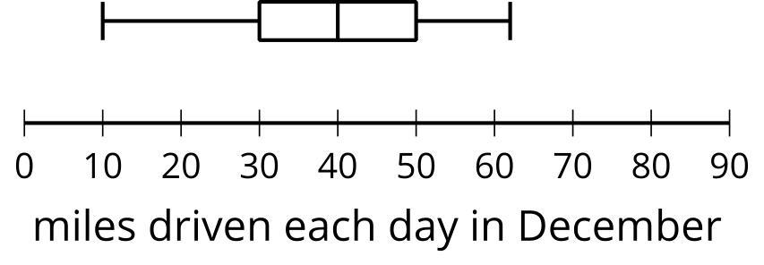
- The five dot plots have the same mean. Explain why the mean is more appropriate for describing the center of the data set than the median.
- Arrange the dot plots in order of least variability to greatest variability. Check with another group to see if they agree.
  - 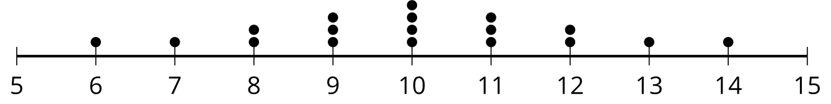
  - 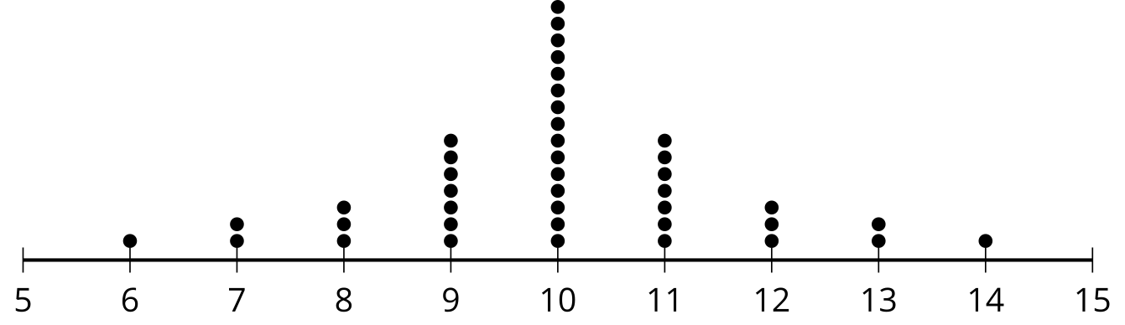
  - 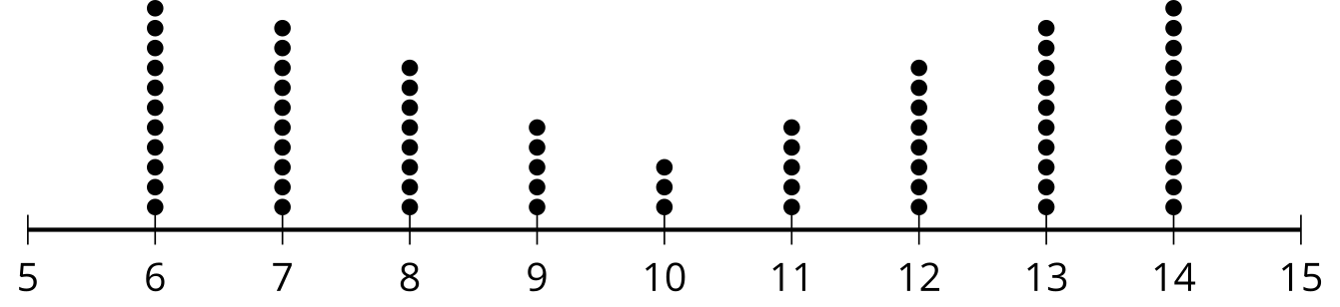
  - 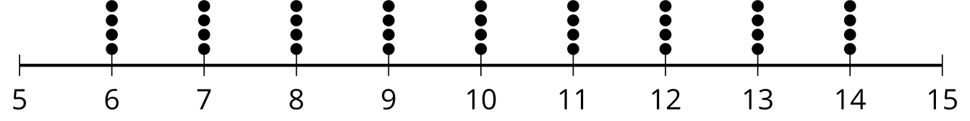
  - 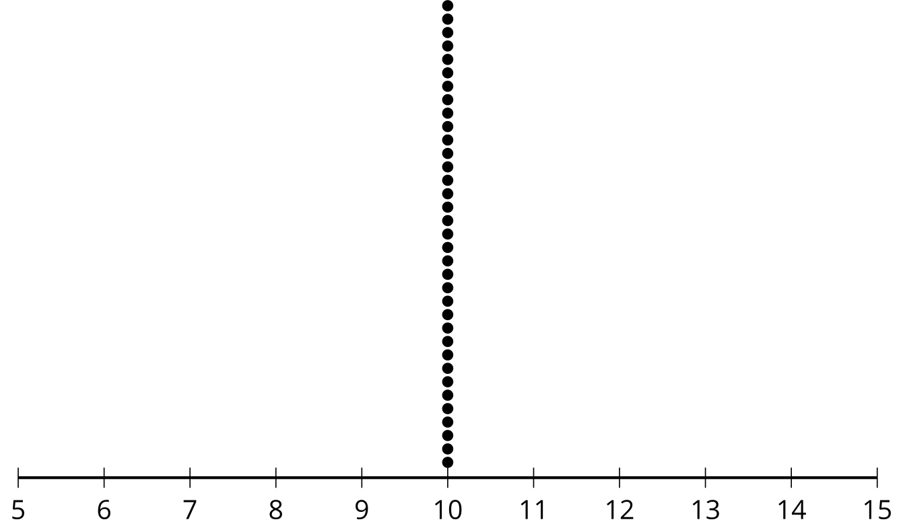

Activity Synthesis

IQR: 20

IQR: 40

IQR: 40

IQR: 50

IQR: 60

MAD: 0

MAD: 1.12

MAD: 1.56

MAD: 2.22

MAD: 2.68
© CC BY 2019 by Illustrative Mathematics®

