Unit 2 Lesson 25: Solving Problems with Systems of Linear Inequalities in Two Variables

1 Which One Doesn’t Belong: Graphs of Solutions (Warm up)

Student Task Statement
Which one doesn’t belong?

A
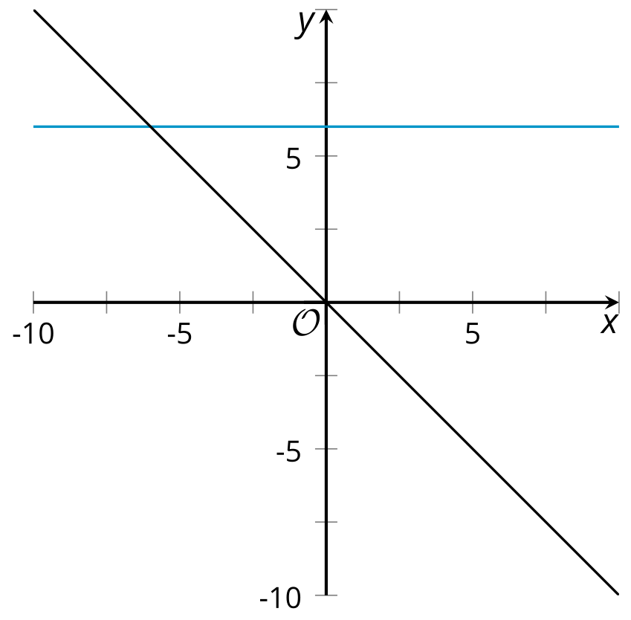

B
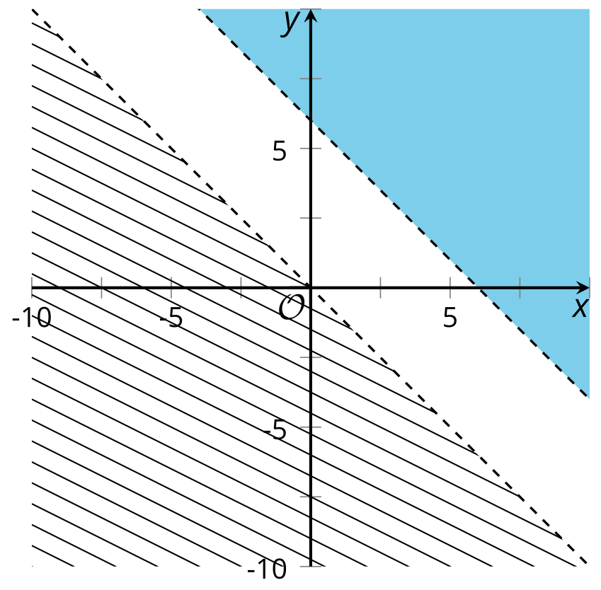

C
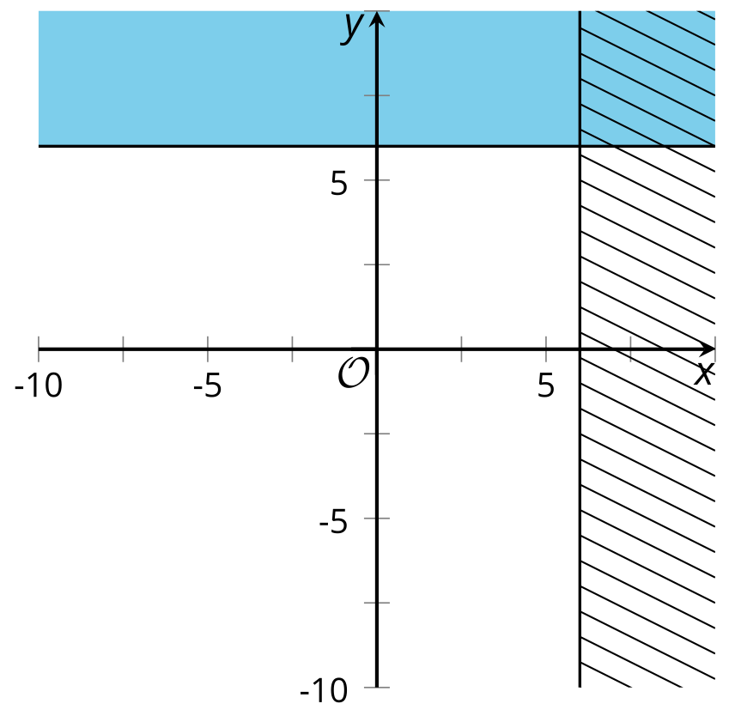

D
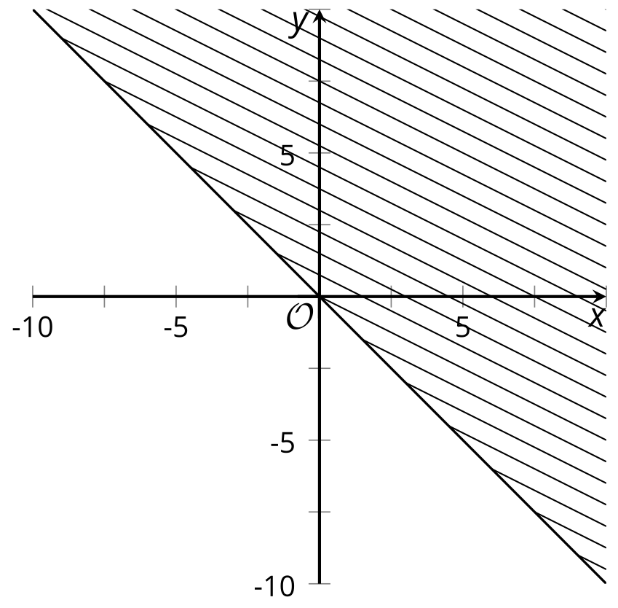

2 Focusing on the Details

Student Task Statement
Here are the graphs of the inequalities in this system:
$\left\{\begin{matrix}x<y \\ y≥\text{-}2x−6\end{matrix}\right.$
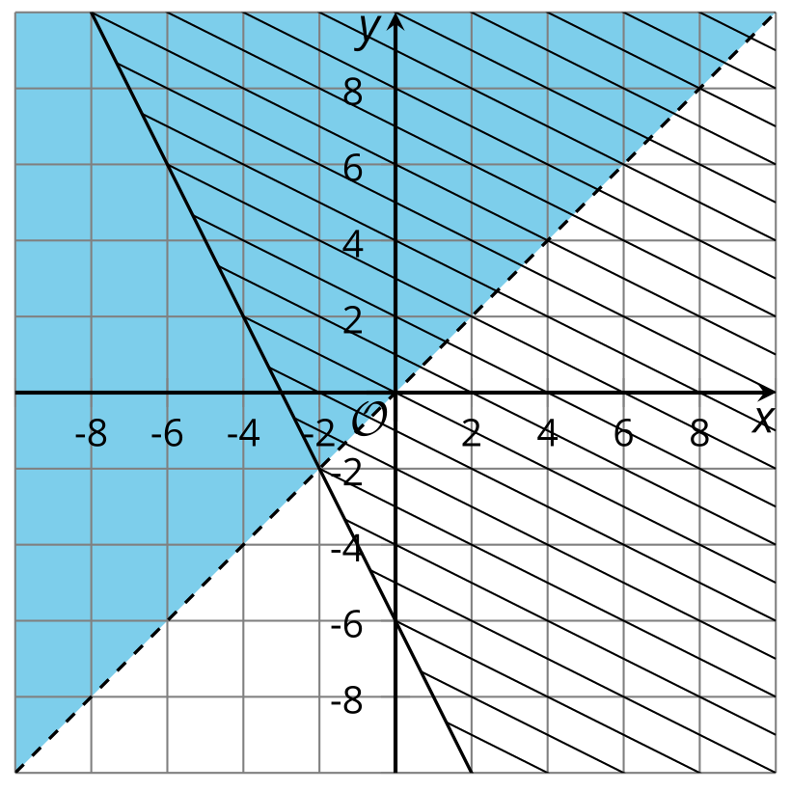
Decide whether each point is a solution to the system. Be prepared to explain how you know.
- $\left(3,\text{-}5\right)$
- $\left(0,5\right)$
- $\left(\text{-}6,6\right)$
- $\left(3,3\right)$
- $\left(\text{-}2,\text{-}2\right)$

3 Info Gap: Terms of A Team

Student Task Statement
Your teacher will give you either a problem card or a data card. Do not show or read your card to your partner.
If your teacher gives you the data card:
- Silently read the information on your card.
- Ask your partner “What specific information do you need?” and wait for your partner to ask for information. Only give information that is on your card. (Do not figure out anything for your partner!)
- Before telling your partner the information, ask “Why do you need to know (that piece of information)?”
- Read the problem card, and solve the problem independently.
- Share the data card, and discuss your reasoning.
If your teacher gives you the problem card:
- Silently read your card and think about what information you need to answer the question.
- Ask your partner for the specific information that you need.
- Explain to your partner how you are using the information to solve the problem.
- When you have enough information, share the problem card with your partner, and solve the problem independently.
- Read the data card, and discuss your reasoning.
Pause here so your teacher can review your work. Ask your teacher for a new set of cards and repeat the activity, trading roles with your partner.
The blank coordinate planes are provided here in case they are useful.
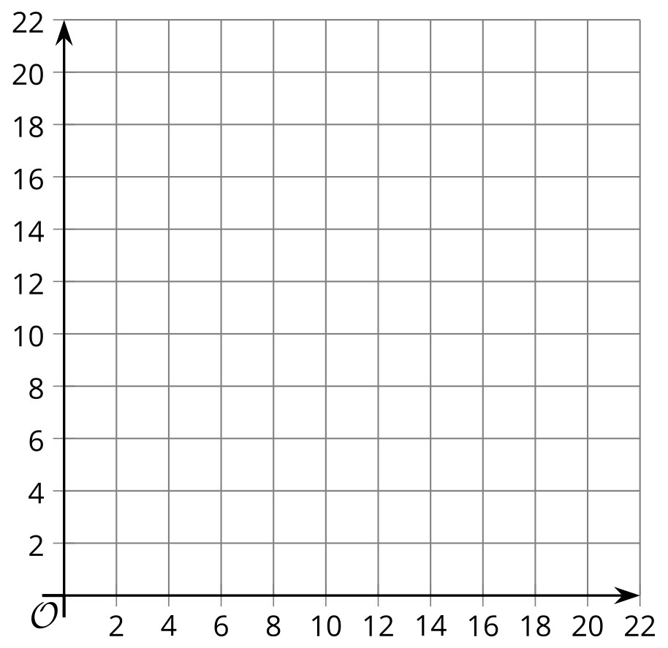

Activity Synthesis
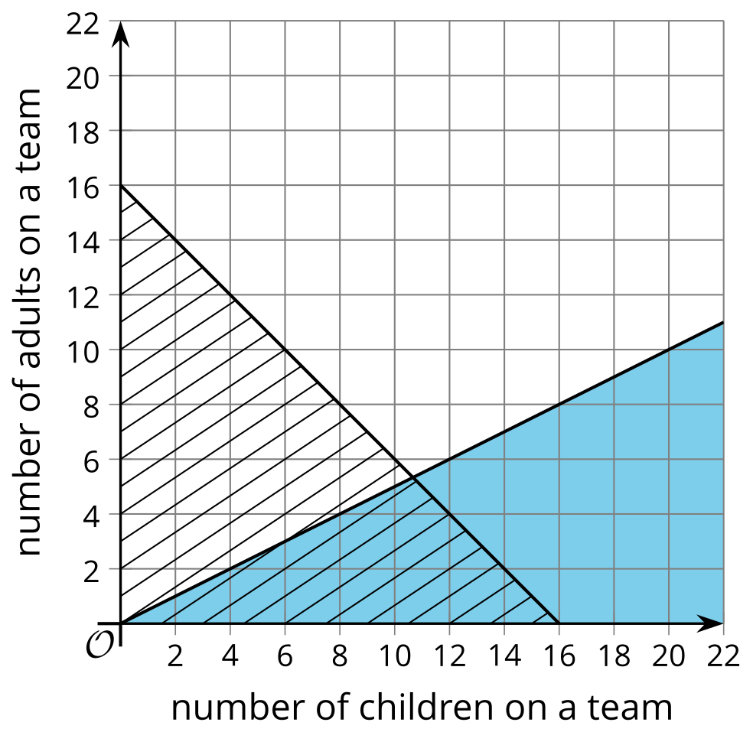
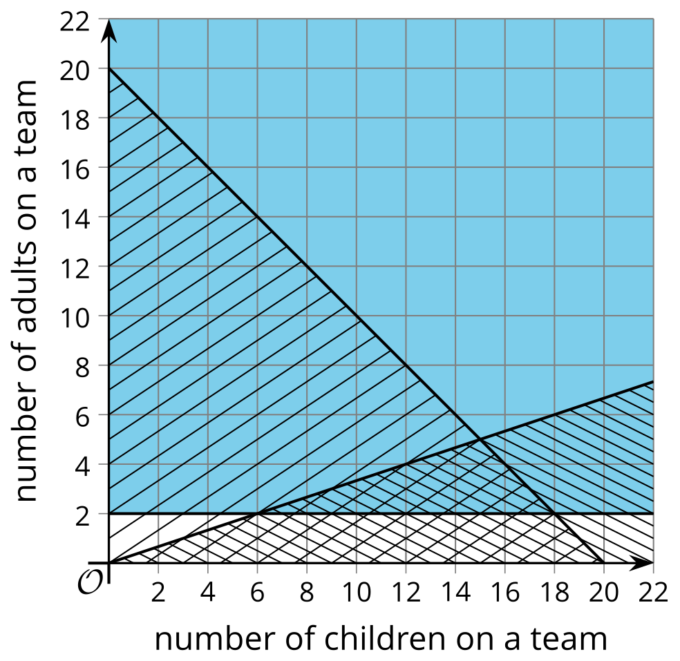

Images for Activity Synthesis
© CC BY 2019 by Illustrative Mathematics®

