Unit 5 Lesson 10: Looking at Rates of Change

1 Falling Prices (Warm up)

Student Task Statement
Let $p$ be the function that gives the cost $p\left(t\right)$, in dollars, of producing 1 watt of solar energy $t$ years after 1977. Here is a table showing the values of $p$ from 1977 to 1987.
$t$ | $p\left(t\right)$
0 | 80
1 | 60
2 | 45
3 | 33.75
4 | 25.31
5 | 18.98
6 | 14.24
7 | 10.68
8 | 8.01
9 | 6.01
10 | 4.51
Which expression best represents the average rate of change in solar cost between 1977 and 1987?
- $p\left(10\right)−p\left(0\right)$
- $p\left(10\right)$
- $\frac{p\left(10\right)−p\left(0\right)}{10−0}$
- $\frac{p\left(10\right)}{p\left(0\right)}$

2 Coffee Shops

Student Task Statement
Here are a table and a graph that show the number of coffee shops worldwide that a company had in its first 10 years, between 1987 and 1997. The growth in the number of stores was roughly exponential.
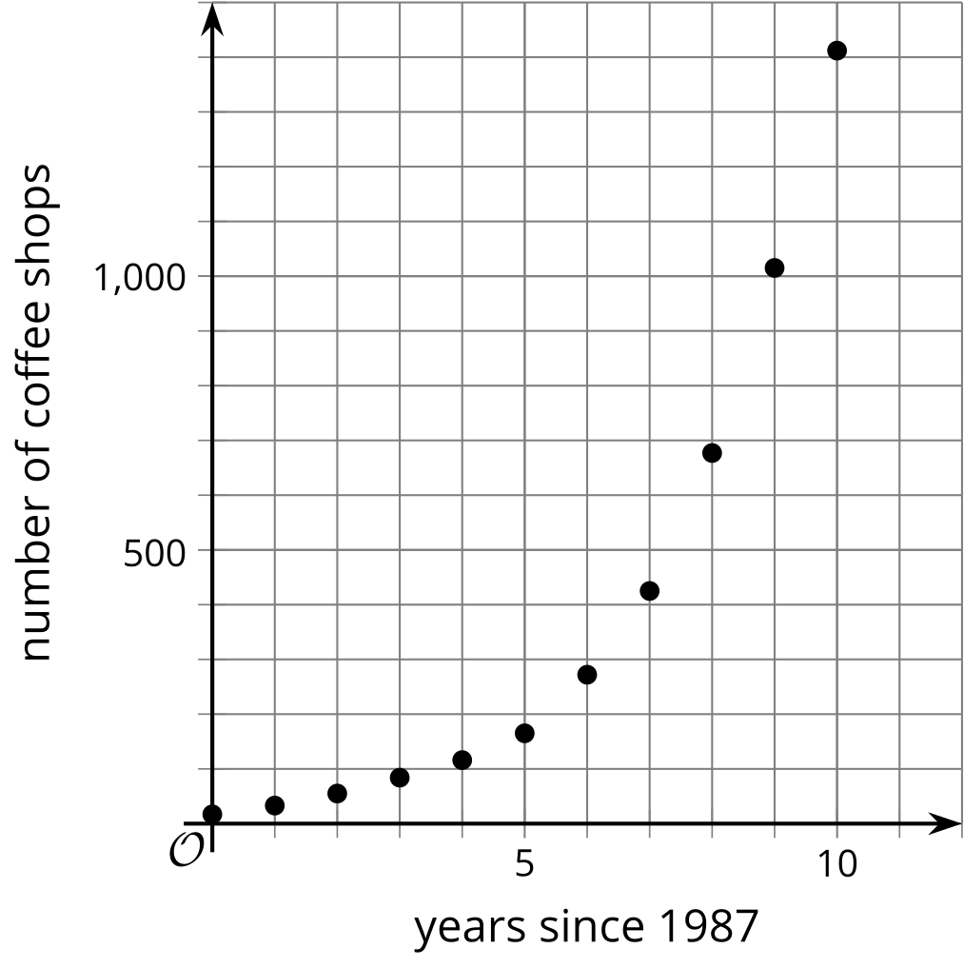
year | number of stores
1987 | 17
1988 | 33
1989 | 55
1990 | 84
1991 | 116
1992 | 165
1993 | 272
1994 | 425
1995 | 677
1996 | 1,015
1997 | 1,412
- Find the average rate of change for each period of time. Show your reasoning.
  - 1987 and 1990
  - 1987 and 1993
  - 1987 and 1997
- Make some observations about the rates of change you calculated. What do these average rates tell us about how the company was growing during this time period?
- Use the graph to support your answers to these questions. How well do the average rates of change describe the growth of the company in:
  - the first 3 years?
  - the first 6 years?
  - the entire 10 years?
- Let $f$ be the function so that$f\left(t\right)$ represents the number of stores $t$ years since 1987. The value of $f\left(20\right)$ is 15,011. Find $\frac{f\left(20\right)−f\left(10\right)}{20−10}$ and say what it tells us about the change in the number of stores.

Activity Synthesis
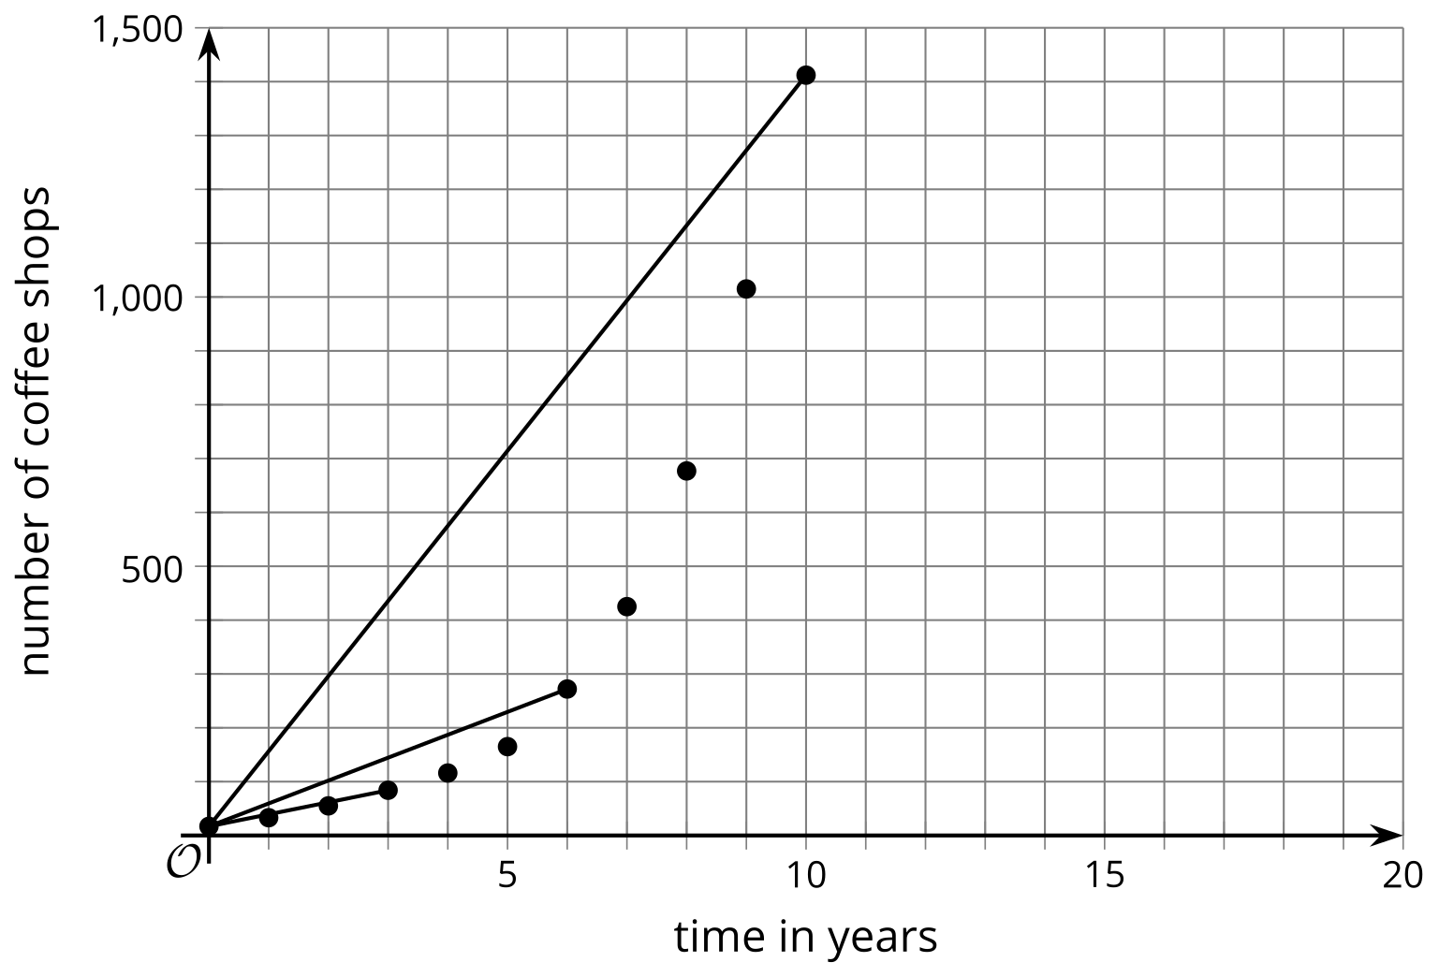

3 Revisiting Cost of Solar Cells

Student Task Statement
Here is a graph you saw in an earlier lesson. It represents the exponential function $p$, which models the cost $p\left(t\right)$, in dollars, of producing 1 watt of solar energy, from 1977 to 1988 where $t$ is years since 1977.
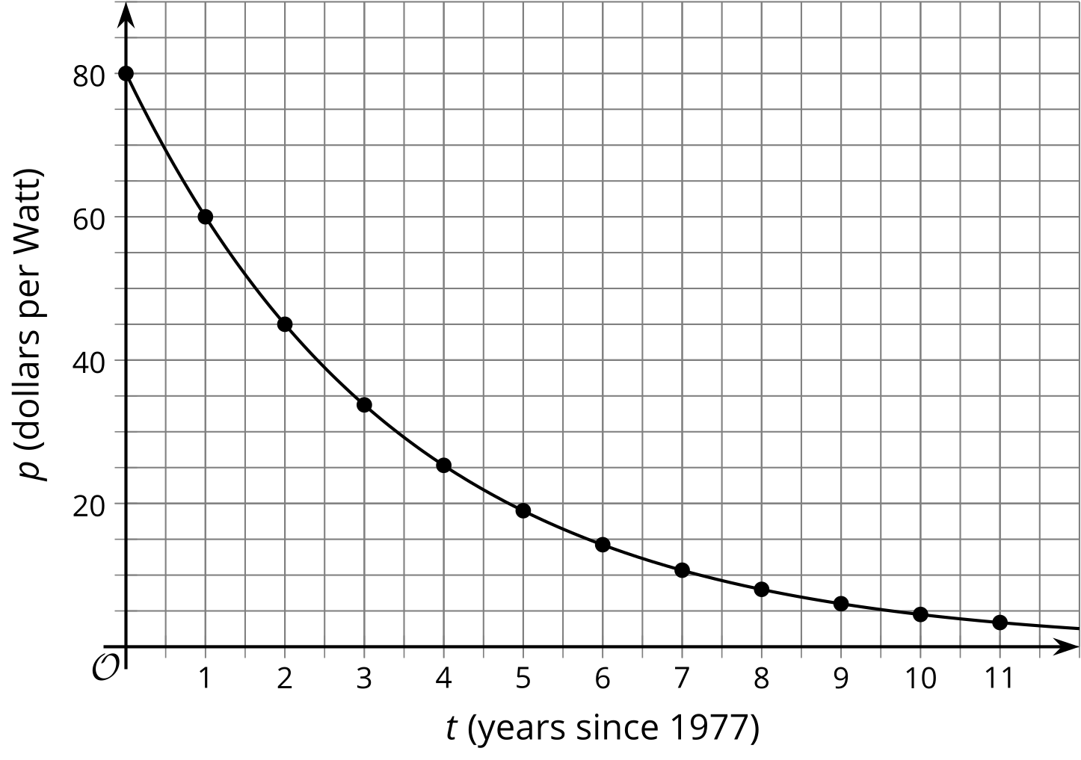
- Clare said, "In the first five years, between 1977 and 1982, the cost fell by about $12 per year. But in the second five years, between 1983 and 1988, the cost fell only by about $2 a year." Show that Clare is correct.
- If the trend continues, will the average decrease in price be more or less than $2 per year between 1987 and 1992? Explain your reasoning.
© CC BY 2019 by Illustrative Mathematics®

