Unit 6 Lesson 2: Revisiting Right Triangles

1 Notice and Wonder: A Right Triangle (Warm up)

Student Task Statement
What do you notice? What do you wonder?
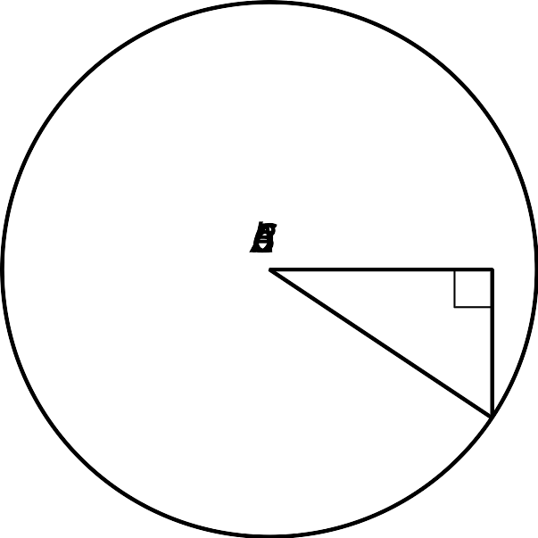

2 Recalling Right Triangle Trigonometry

Images for Launch

Student Task Statement
- Find $\text{cos}(A)$, $\text{sin}(A)$, and $\text{tan}(A)$ for triangle $ABC$.
- Sketch a triangle $DEF$ where $\text{sin}(D)=\text{cos}(D)$ and $E$ is a right angle. What is the value of $\text{tan}(D)$ for this triangle? Explain how you know.
- If the coordinates of point $I$ are $(9,12)$, what is the value of $\text{cos}(G)$, $\text{sin}(G)$, and $\text{tan}(G)$ for triangle $GHI$? Explain or show your reasoning.

3 Shrinking Triangles

Student Task Statement
- What are $\text{cos}(D)$, $\text{sin}(D)$, and $\text{tan}(D)$? Explain how you know.
- 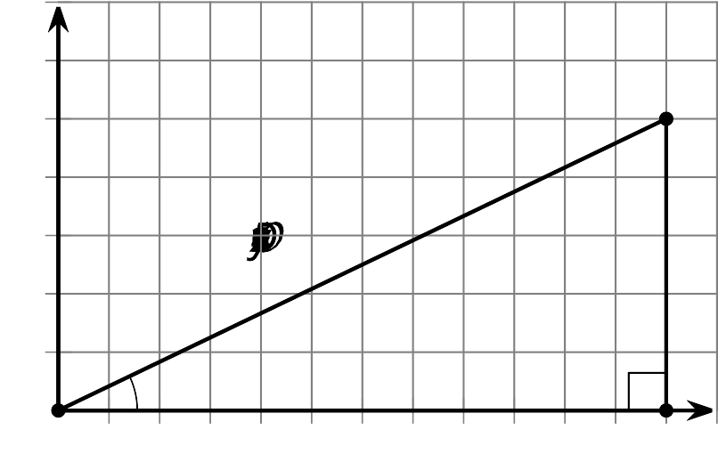
- Here is a triangle similar to triangle $DEF$.
- 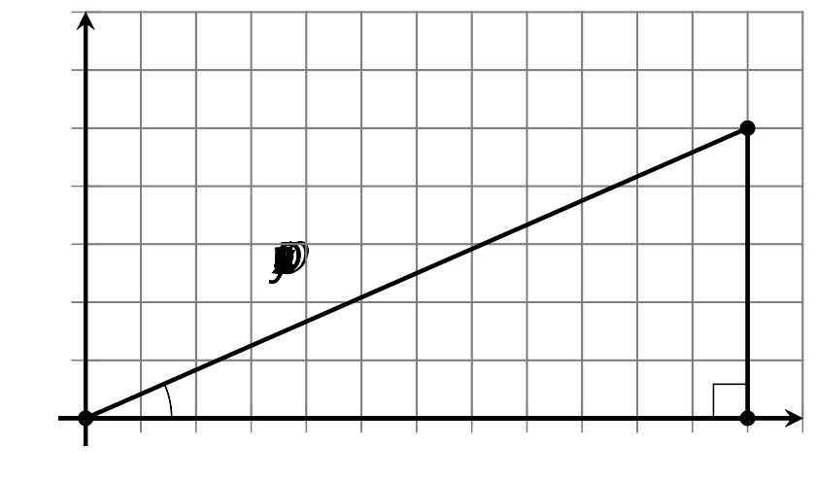
  - What is the scale factor from $△DEF$ to $△D^{′}E^{′}F^{′}$? Explain how you know.
  - What are $\text{cos}(D^{′})$, $\text{sin}(D^{′})$, and $\text{tan}(D^{′})$?
- Here is another triangle similar to triangle $DEF$.
- 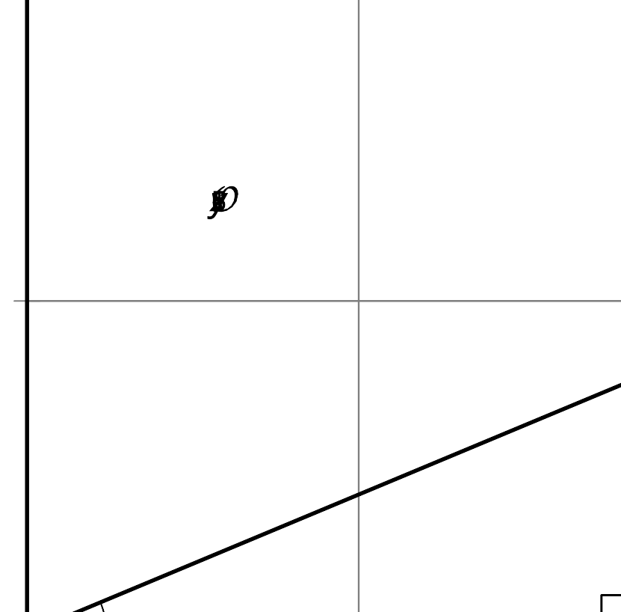
  - Label the triangle $D^{″}E^{″}F^{″}$.
  - What is the scale factor from triangle $DEF$ to triangle $D^{″}E^{″}F^{″}$?
  - What are the coordinates of $F^{″}$? Explain how you know.
  - What are $\text{cos}(D^{″})$, $\text{sin}(D^{″})$, and $\text{tan}(D^{″})$?

Images for Activity Synthesis
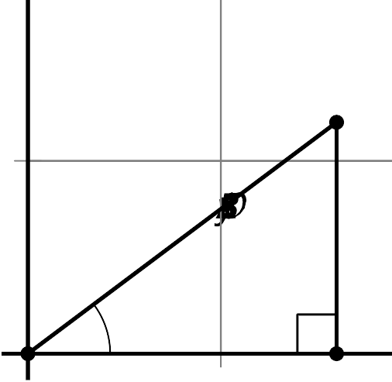
© CC BY 2019 by Illustrative Mathematics®

