Unit 2 Lesson 3: Groups that Look Very Different

WU Choral Count: Represent with Fingers and Numbers (Warm up)

Student Task Statement

1 More or Fewer Pattern Blocks

Student Task Statement

2 Create Groups with More and Fewer

Student Task Statement

3 Introduce Number Race, Numbers 1–10

Student Task Statement
Choose a center.
Number Race
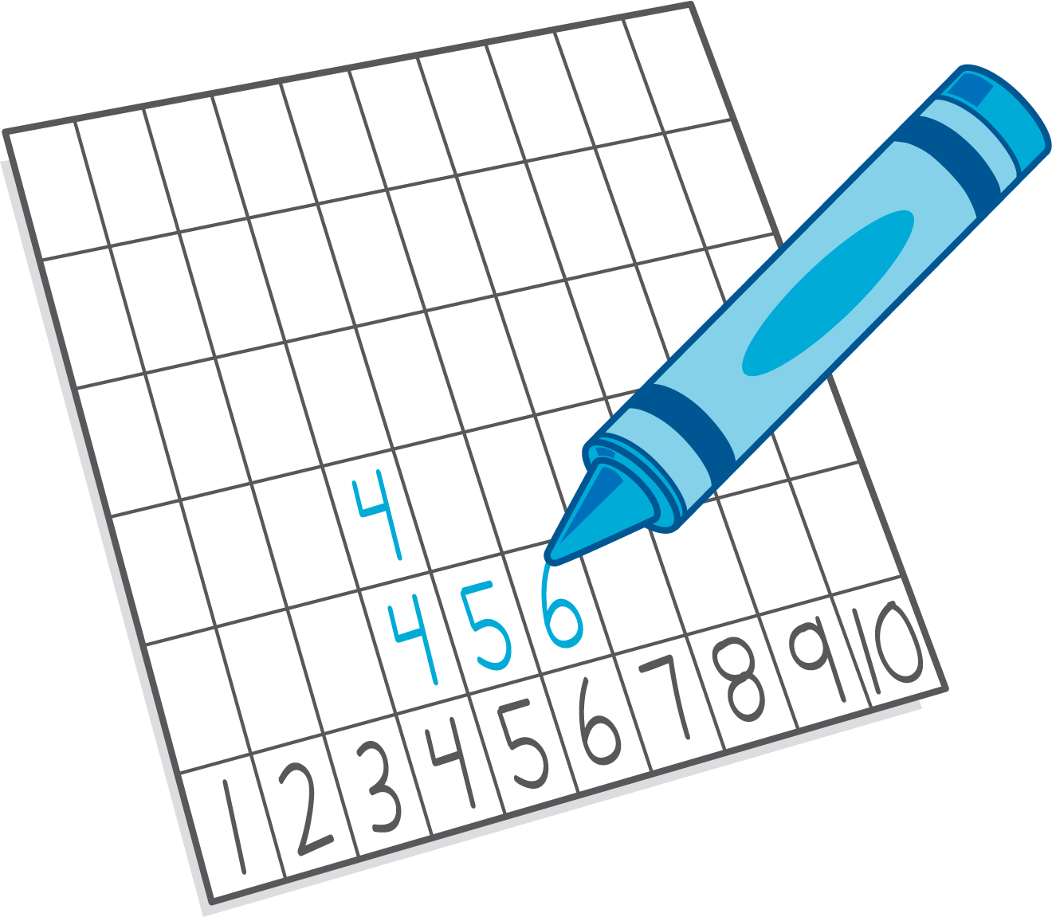
Shake and Spill
Math Fingers
Pattern Blocks
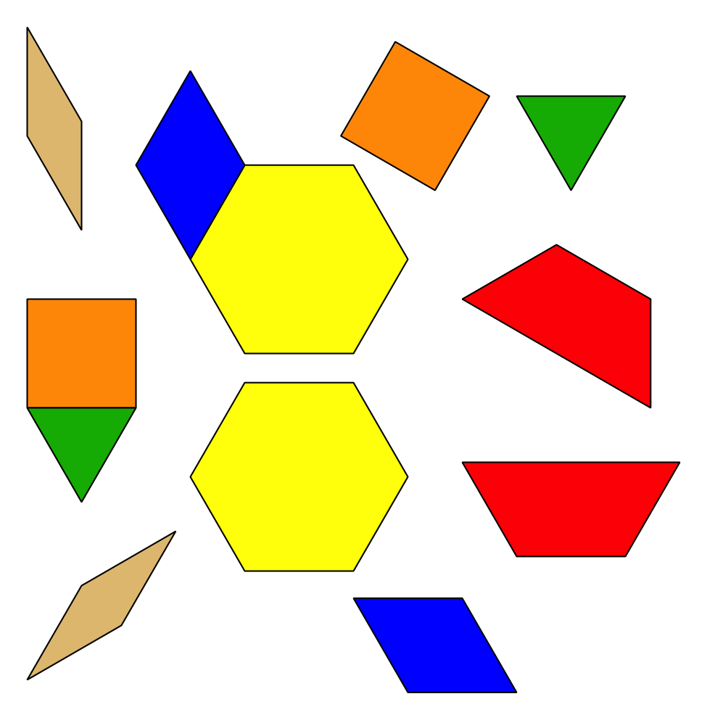
Picture Books
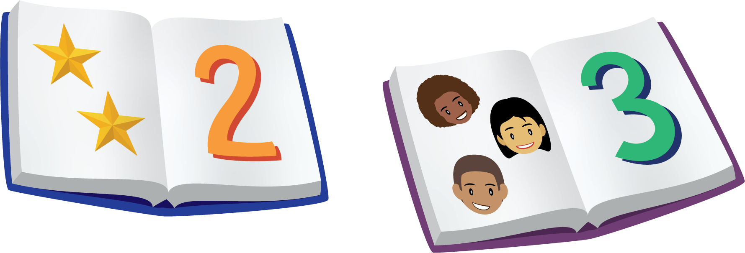
© CC BY 2021 Illustrative Mathematics®

