Lesson 6: Equality Diagrams
Let's use hanger diagrams to understand equivalent equations.

6.1: Notice and Wonder: Solving Equations
What do you notice? What do you wonder?
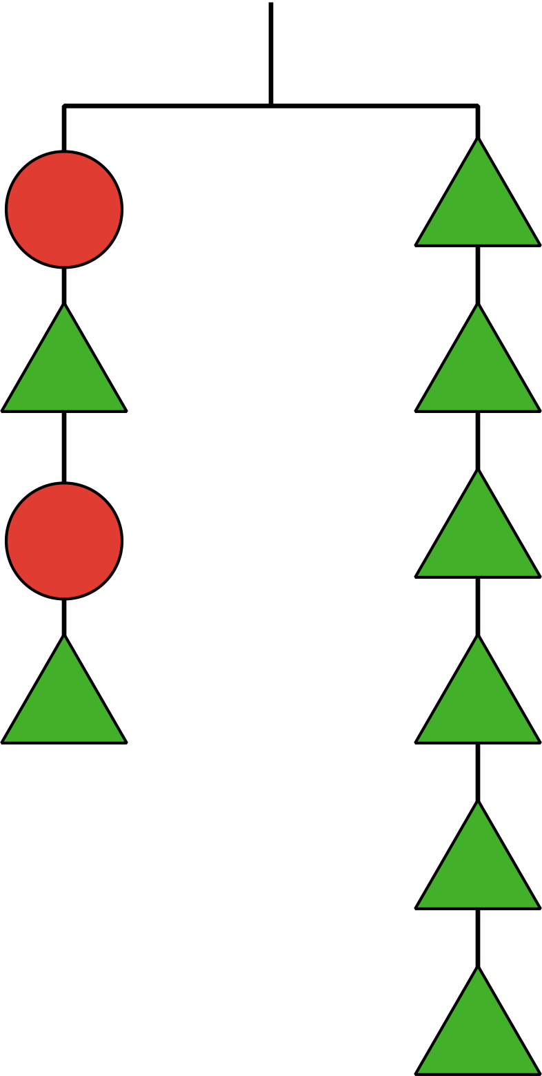
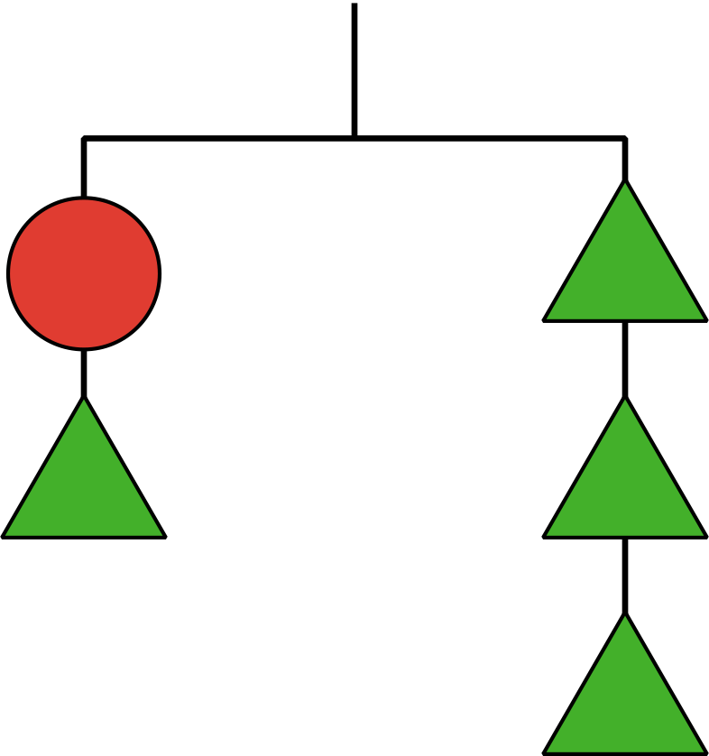
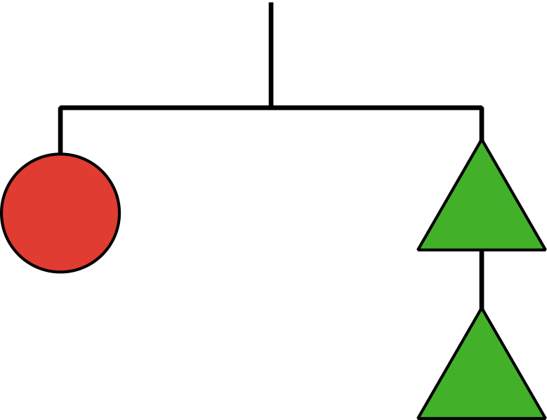

6.2: Hanger Diagrams
- 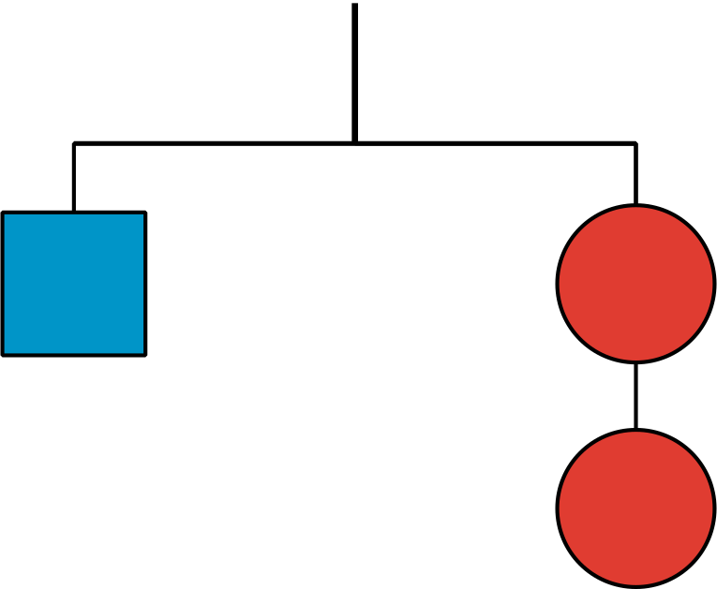
- The hanger with 1 square and 2 circles is in balance.
Which of these should also be in balance? Explain your reasoning.
  - 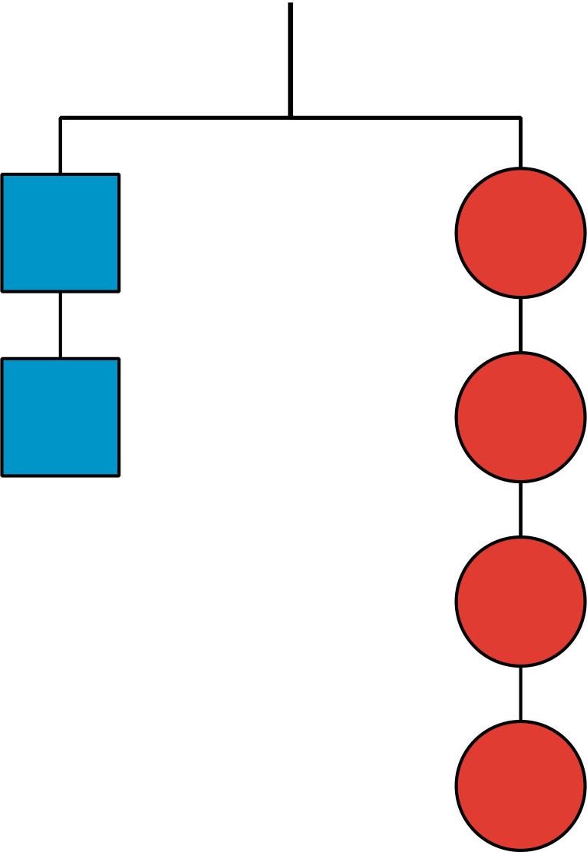
  - 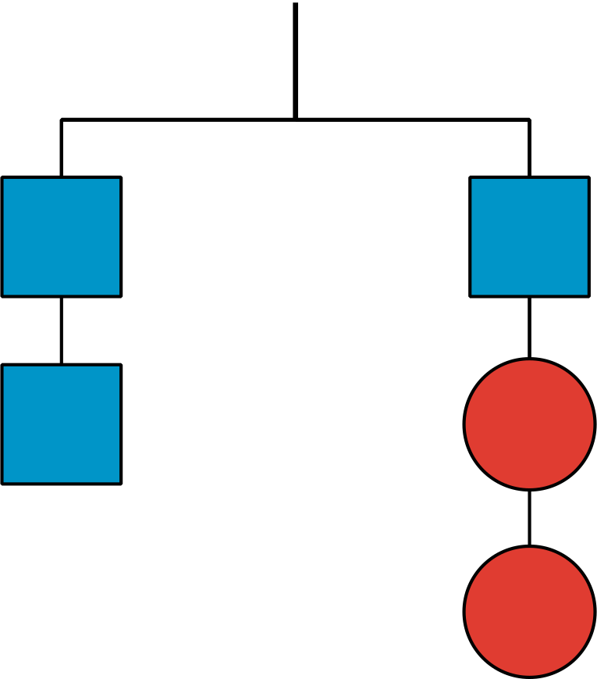
  - 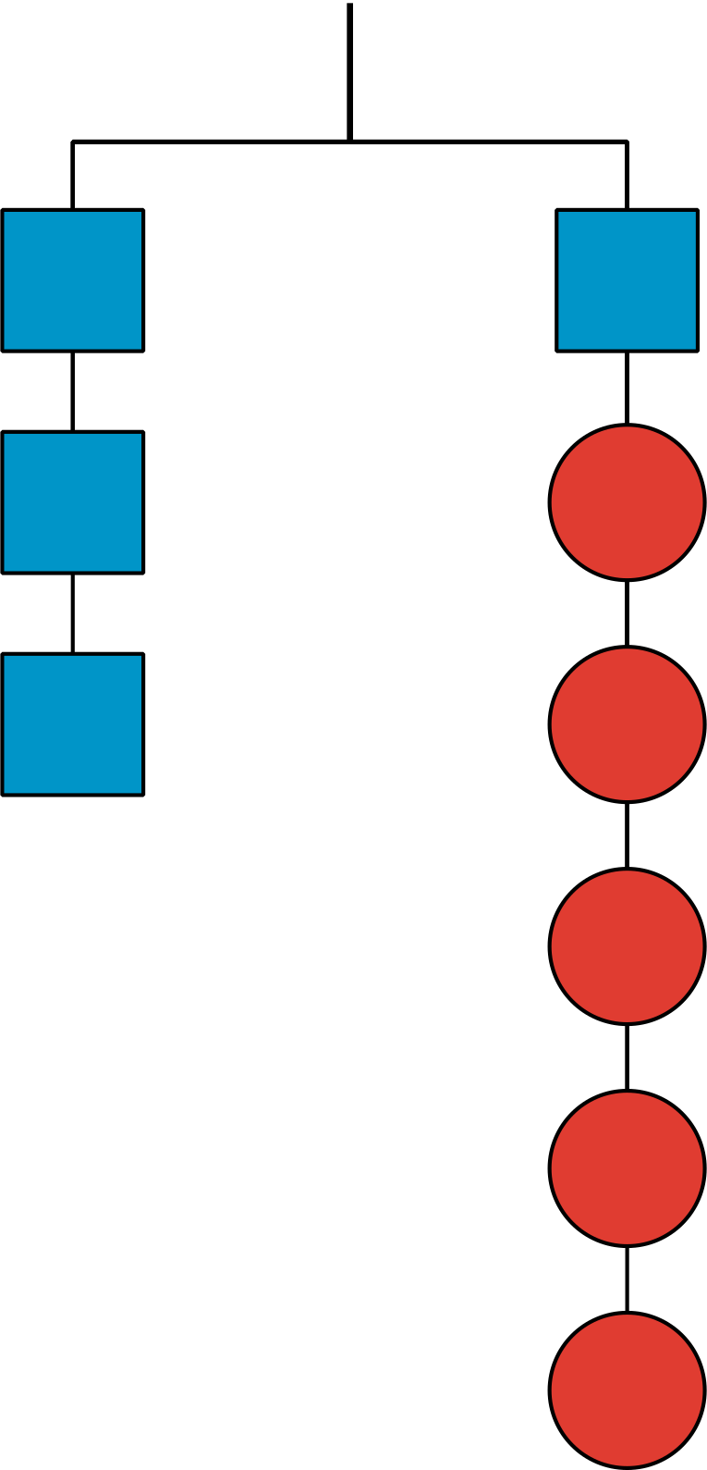
  - 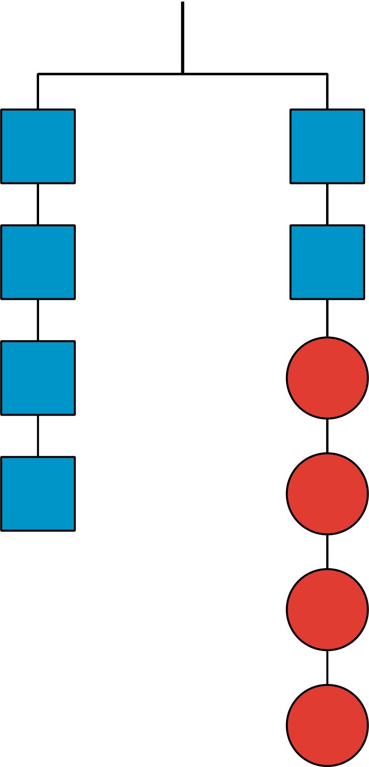
  - 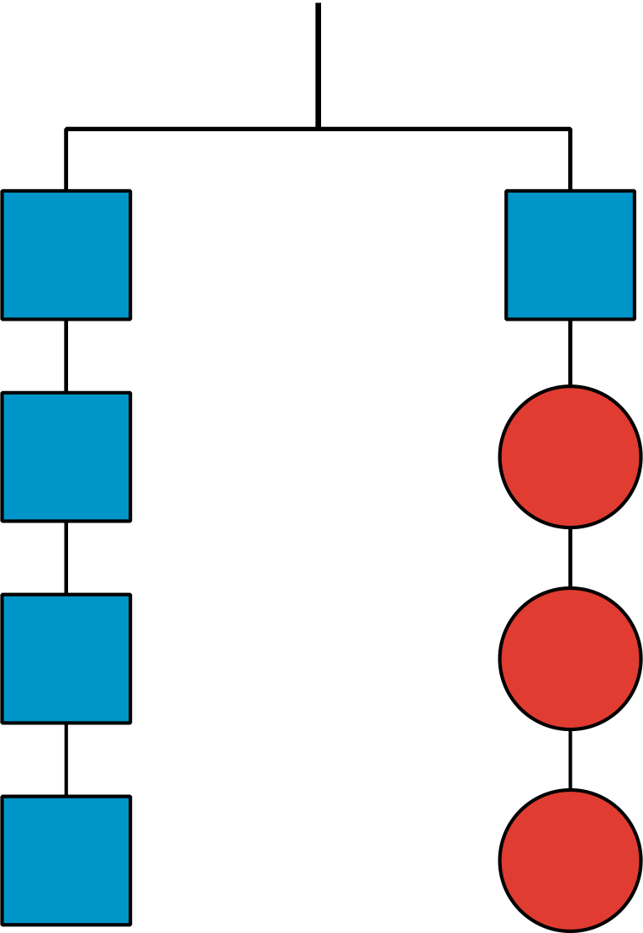
  - 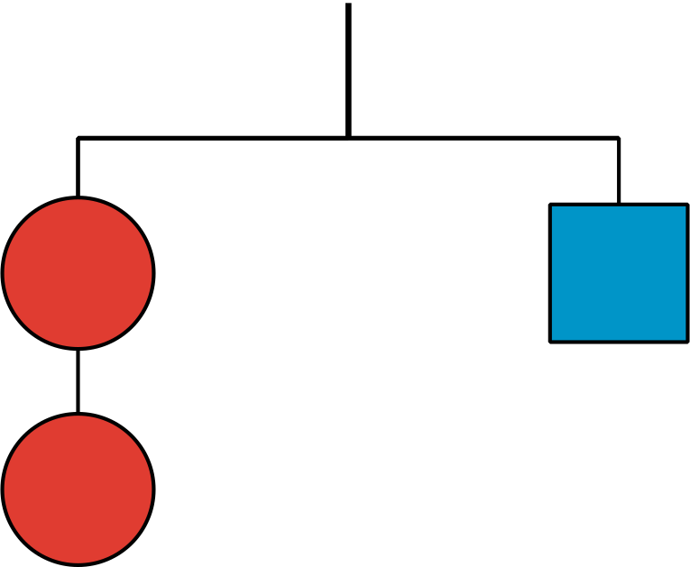
- This hanger containing 2 pentagons and 6 circles is in balance. Use the hanger diagram to create two additional hangers that would be in balance.
- 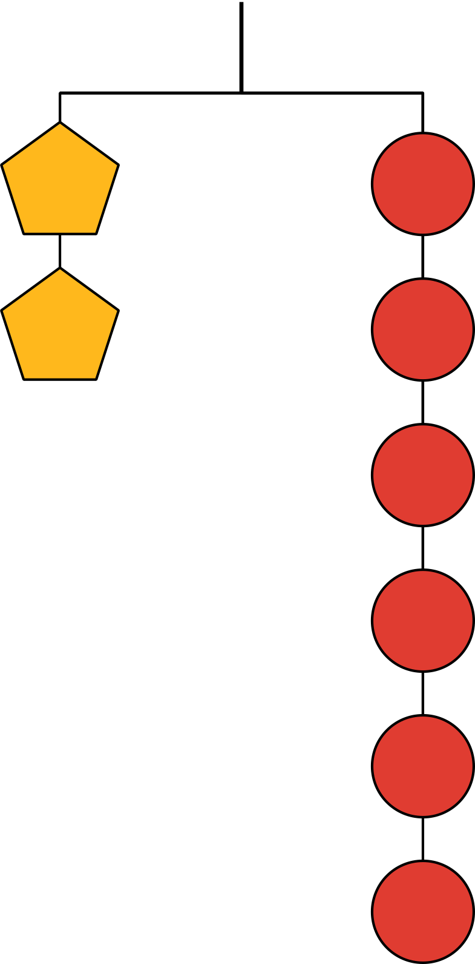

6.3: Diagrams and Equations
In the previous activity, each square weighs 10 pounds and each circle weighs $x$ pounds.
So, this diagram could be represented by the equation $10=2x$.
- Use each of the 6 hanger diagrams containing squares and circles from the previous activity to write an equation that represents the weights on the hanger.
- Solve each equation.
- Compare the solutions to the equations with the answers from the previous activity. What do you notice?
© CC BY 2019 by Illustrative Mathematics®

