Lesson 10: Combining Functions
- Let’s make some new functions using other functions.

10.1: Notice and Wonder: Are Book Sales Improving?
What do you notice? What do you wonder?
$t$ (years since 2010) | number of books sold  in the US (millions) | population of  the US (millions)
0 | 2,530 | 309.35
1 | 2,400 | 311.64
2 | 2,730 | 313.99
3 | 2,720 | 316.23
4 | 2,700 | 318.62
5 | 2,710 | 321.04
6 | 2,700 | 323.41

10.2: How Many Books Can One Person Have?
The table shows the values of two functions, $P$ and $B$, where $P\left(t\right)$ is the population of the US, in millions, $t$ years after 2010, and $B\left(t\right)$ is the number of books sold per year, in millions, $t$ years after 2010.
$t$ (years since 2010) | $B\left(t\right)$ (millions) | $P\left(t\right)$ (millions) | $R\left(t\right)$
0 | 2,530 | 309.35
1 | 2,400 | 311.64
2 | 2,730 | 313.99
3 | 2,720 | 316.23
4 | 2,700 | 318.62
5 | 2,710 | 321.04
6 | 2,700 | 323.41
- Plot the values of $B$ as a function of $t$. What does the plot tell you about book sales?
- 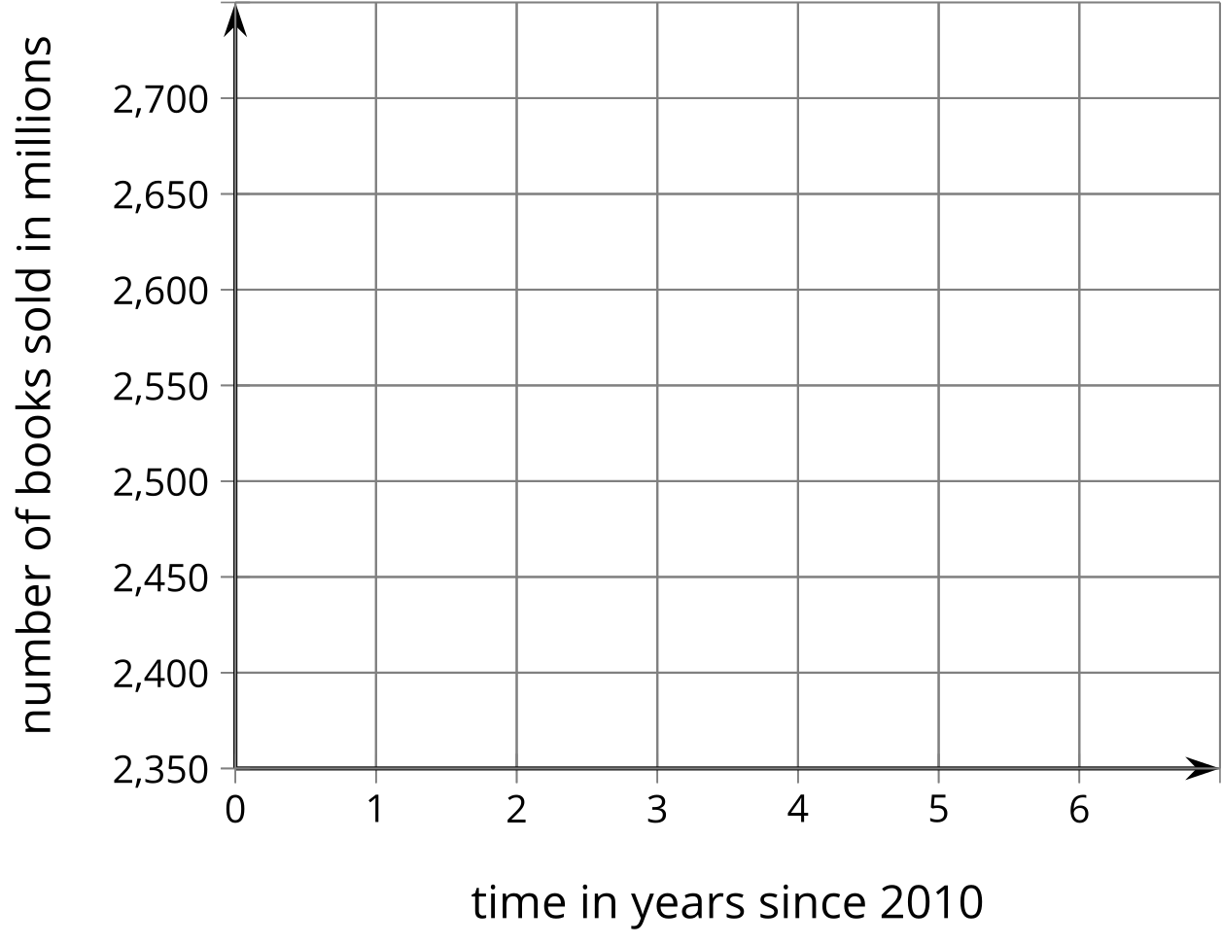
- How many books were sold per person in 2010 and 2016? What do these values tell you about book sales?
- Define a new function $R$ by $R\left(t\right)=\frac{B\left(t\right)}{P\left(t\right)}$. Complete the table and then graph the values of $R\left(t\right)$. What do the values of $R$ tell you?

10.3: Adding Functions
- Here are the graphs of two functions, $E$ and $L$. Define a new function $S$ by adding $E$ and $L$, so $S\left(x\right)=E\left(x\right)+L\left(x\right)$. On the same axes, sketch what you think the graph of $S$ looks like.
- 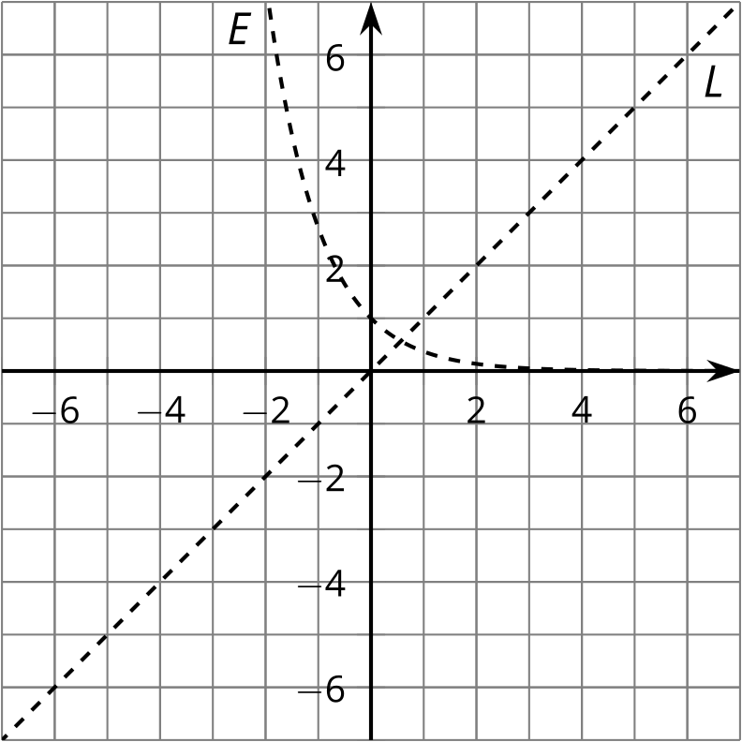
- Sketch the graph of the sum of $E$ and each of the following functions.
- 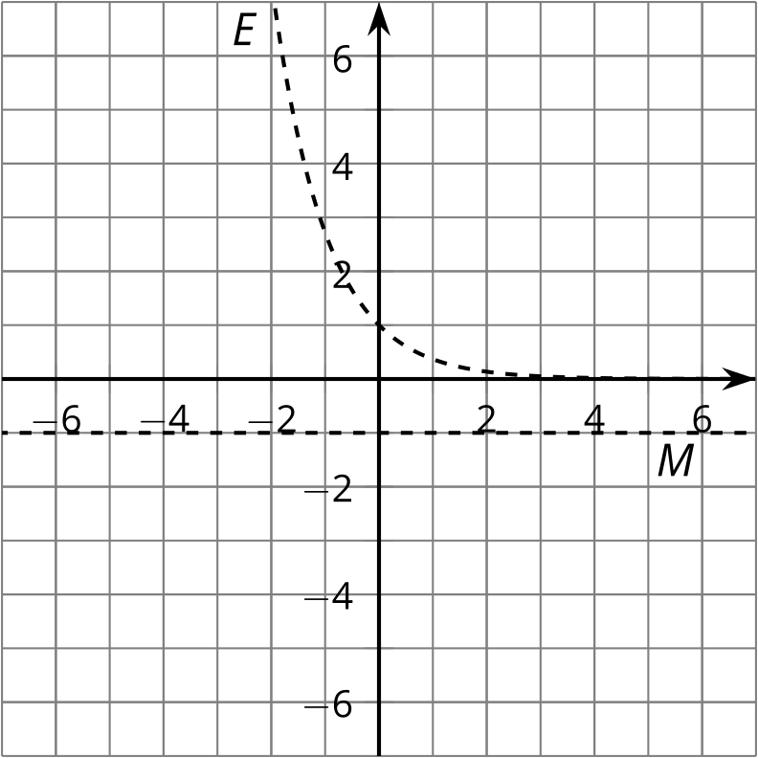
- 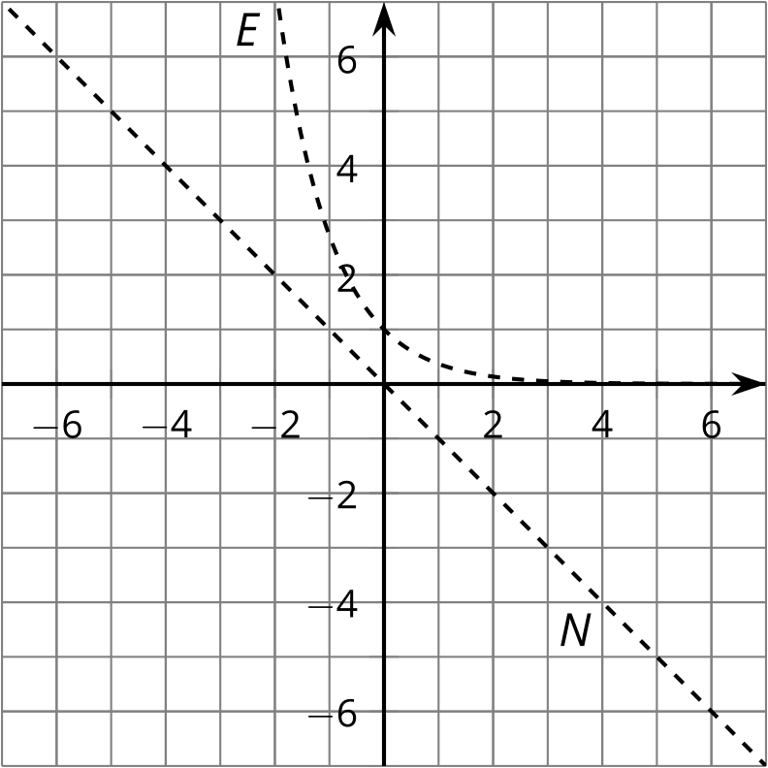
- 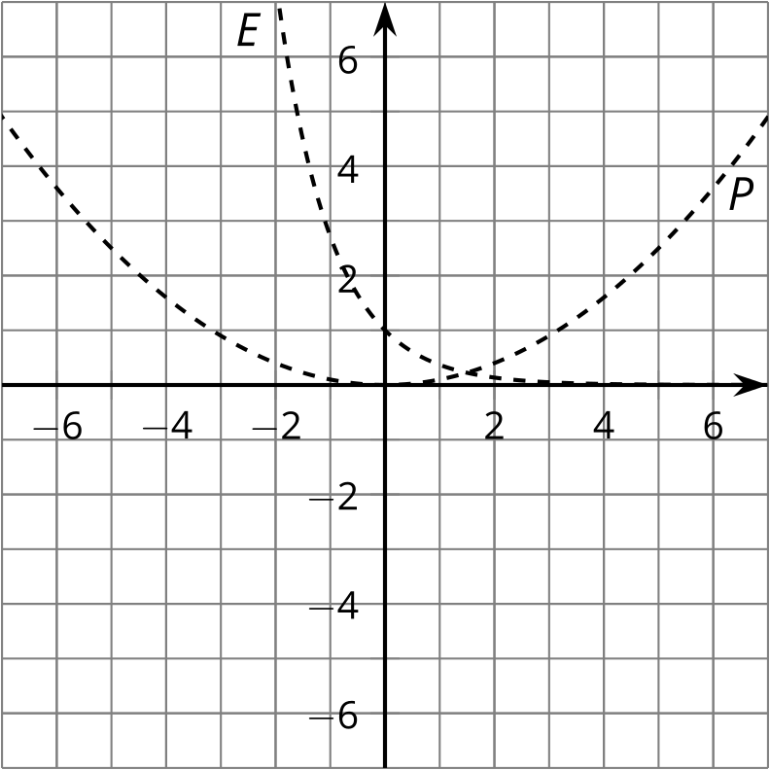
- 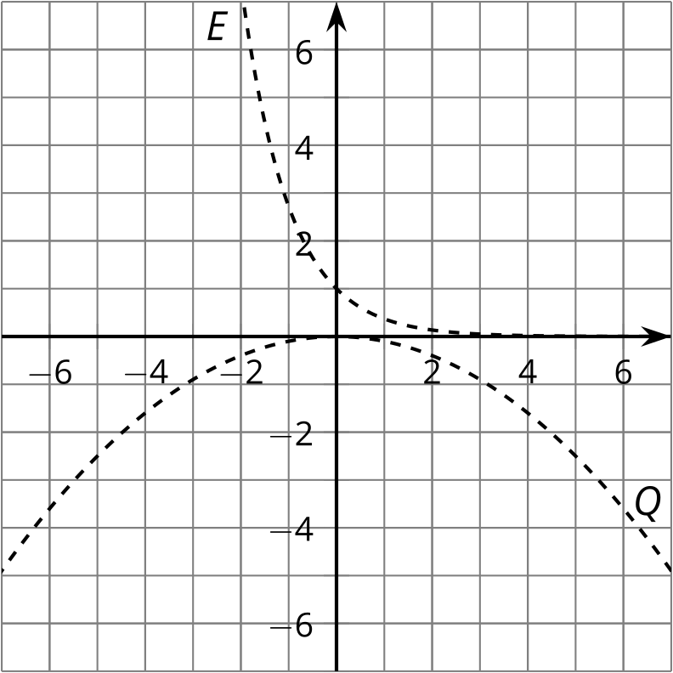

Are you ready for more?
Here are the graphs of two functions, $U$ and $V$. Define a new function $W$ by multiplying $U$ and $V$, so $W\left(x\right)=U\left(x\right)V\left(x\right)$. On the same axes, sketch what you think the graph of $W$ looks like.
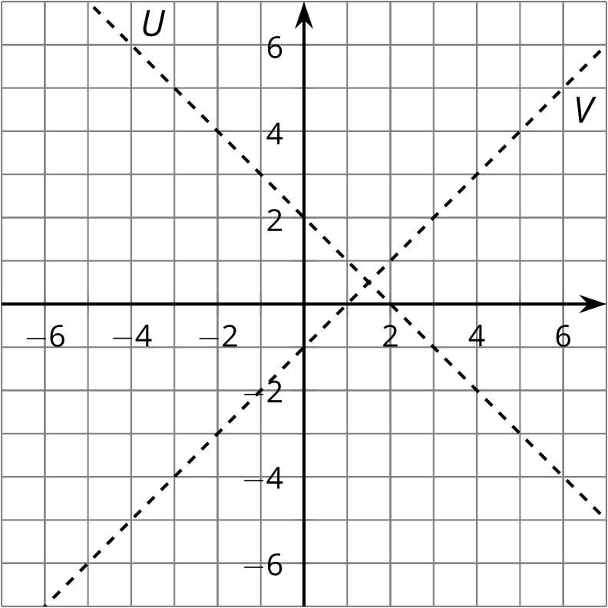

Lesson 10 Summary
We can add, subtract, multiply, and divide functions to get new functions. For example, the cost in dollars of producing $n$ cups of lemonade at a lemonade stand is $C\left(n\right)=5+0.8n$. The revenue (amount of money collected) from selling $n$ cups is $R\left(n\right)=2n$ dollars. The profit $P\left(n\right)$ from selling $n$ cups is the revenue minus the cost, so
$P\left(n\right)=R\left(n\right)−C\left(n\right)=2n−\left(5+0.8n\right)=1.2n−5$
Here are the graphs of $C$, $R$, and $P$. Can you see how each value on $P$ is the result of the difference between the corresponding points on $R$ and $C$?
The average profit per cup, $A\left(n\right)$, from selling $n$ cups, is the quotient of the profit and the number of cups, so
$A\left(n\right)=\frac{P\left(n\right)}{n}=\frac{1.2n−5}{n}=1.2−\frac{5}{n}$
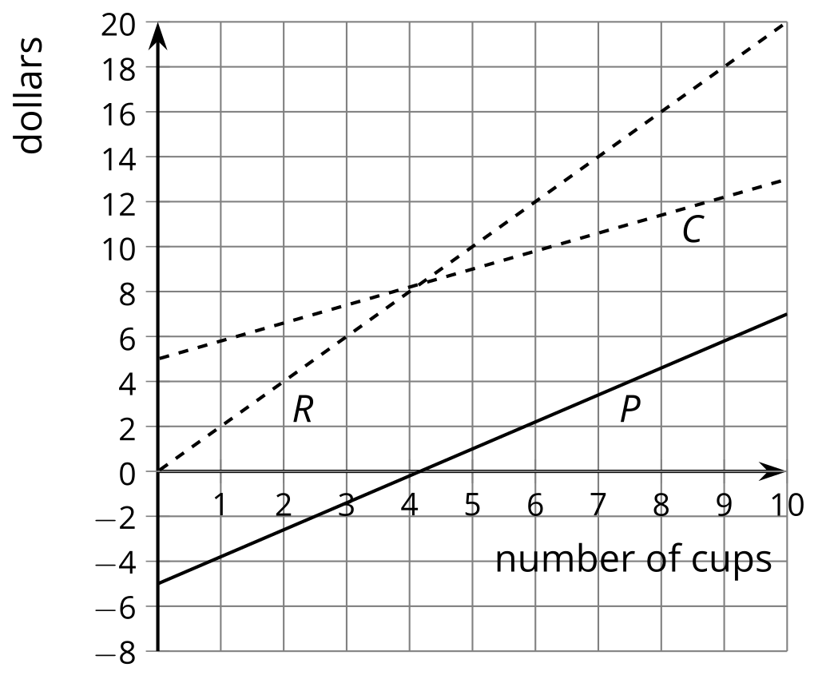
Here are the graphs of $P$ and $A$. Can you see how the value of $A\left(n\right)$ is the result of the quotient of $P\left(n\right)$ and $n$? Why does it make sense that both functions are negative when $n<4\frac{1}{6}$ and positive when $n>4\frac{1}{6}$?
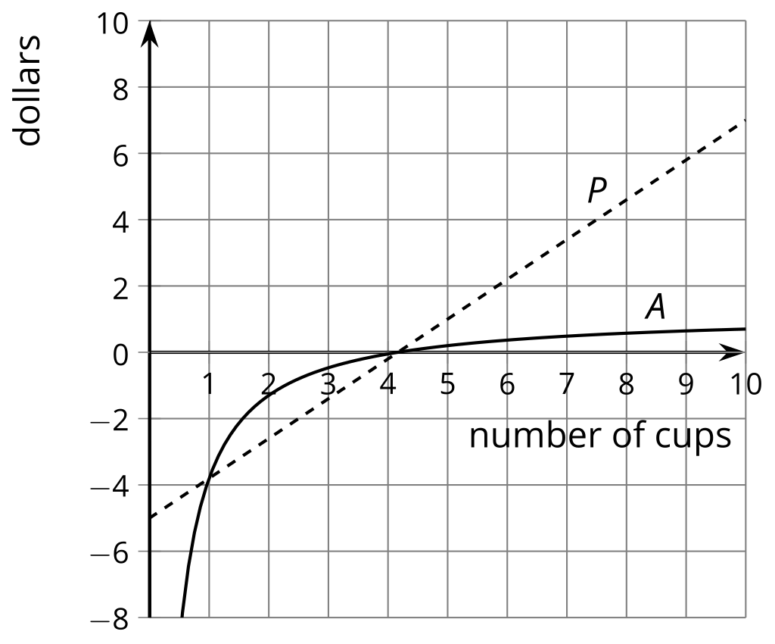
Since $n$ can only be positive, $P\left(n\right)$ and $A\left(n\right)$ always have the same sign for a given $n$ value. Notice that for the average profit to be positive, the seller has to sell at least 5 cups (since $4\frac{1}{6}$ is not in the domain, we must round up). It is also true that for a large number of cups, the average profit is close to $1.20 per cup.
© CC BY 2019 by Illustrative Mathematics®

