Student Task Statements

Lesson 2: Moving Functions

2.1: What Happened to the Equation?
Graph each function using technology. Describe how to transform $f(x)=x^{2}(x−2)$ to get to the functions shown here in terms of both the graph and the equation.
- $h(x)=x^{2}(x−2)−5$
- $g(x)=(x−4)^{2}(x−6)$

2.2: Writing Equations for Vertical Translations
The graph of function $g$ is a vertical translation of the graph of polynomial $f$.
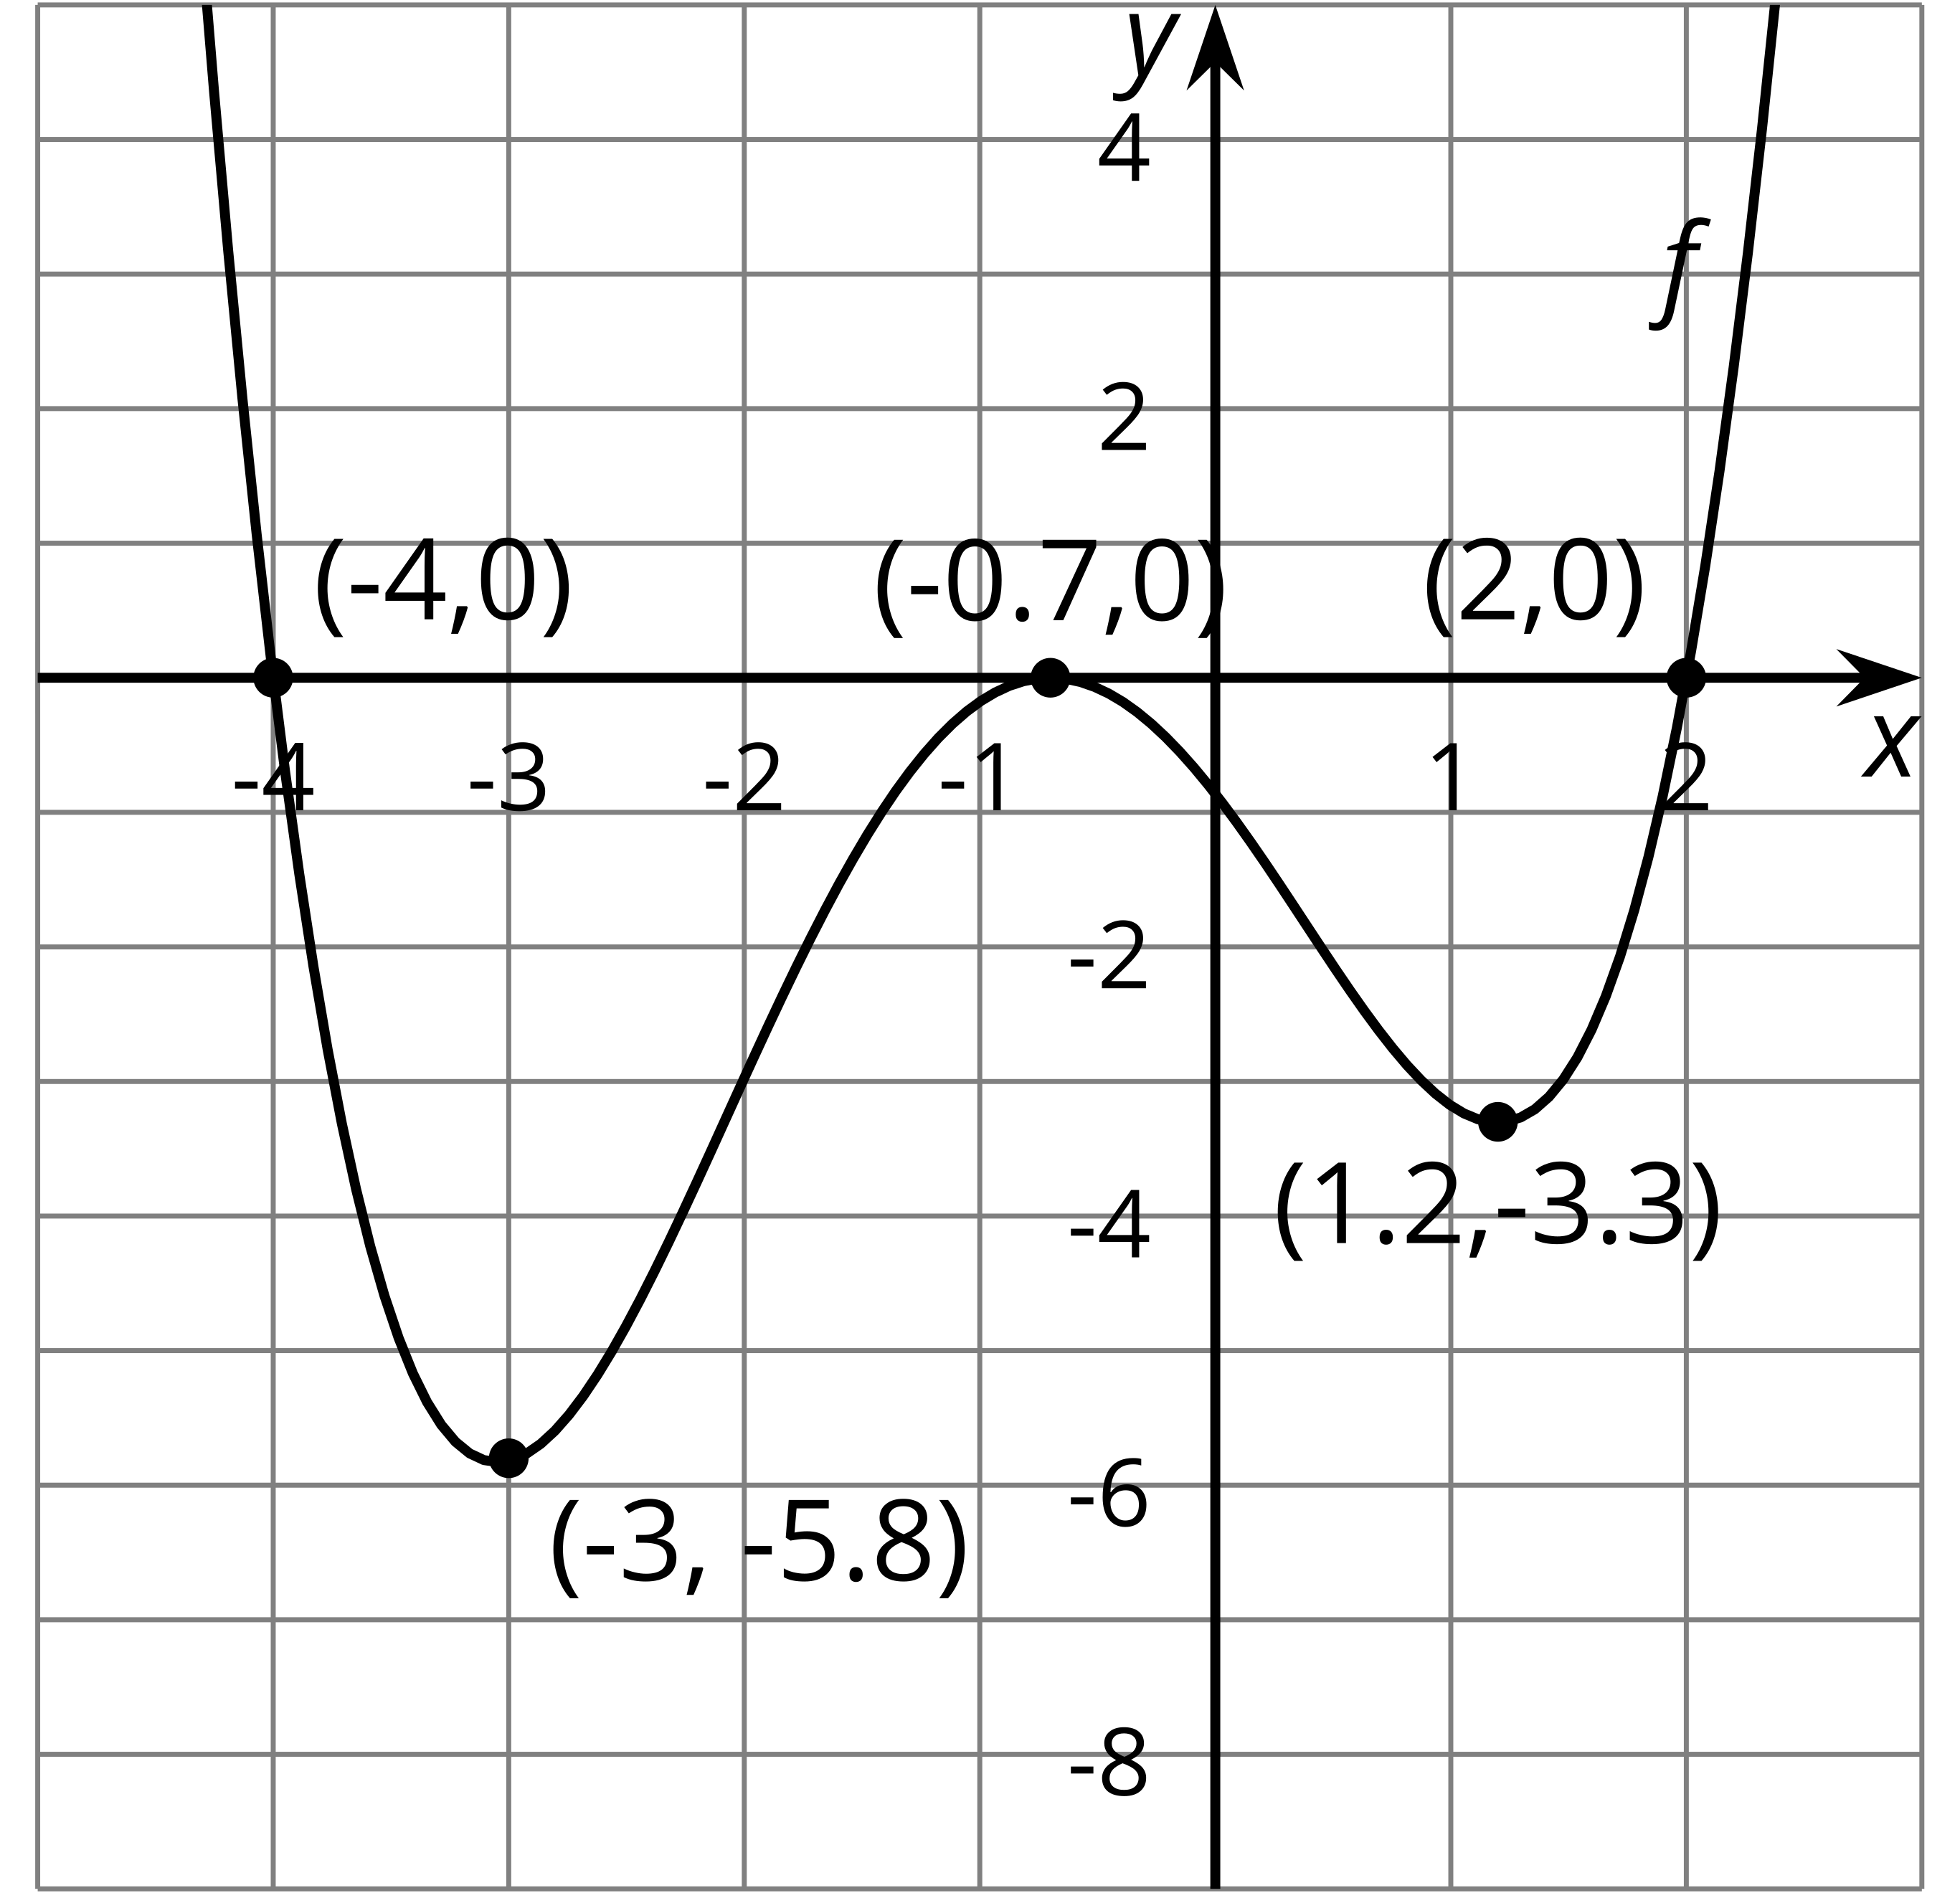
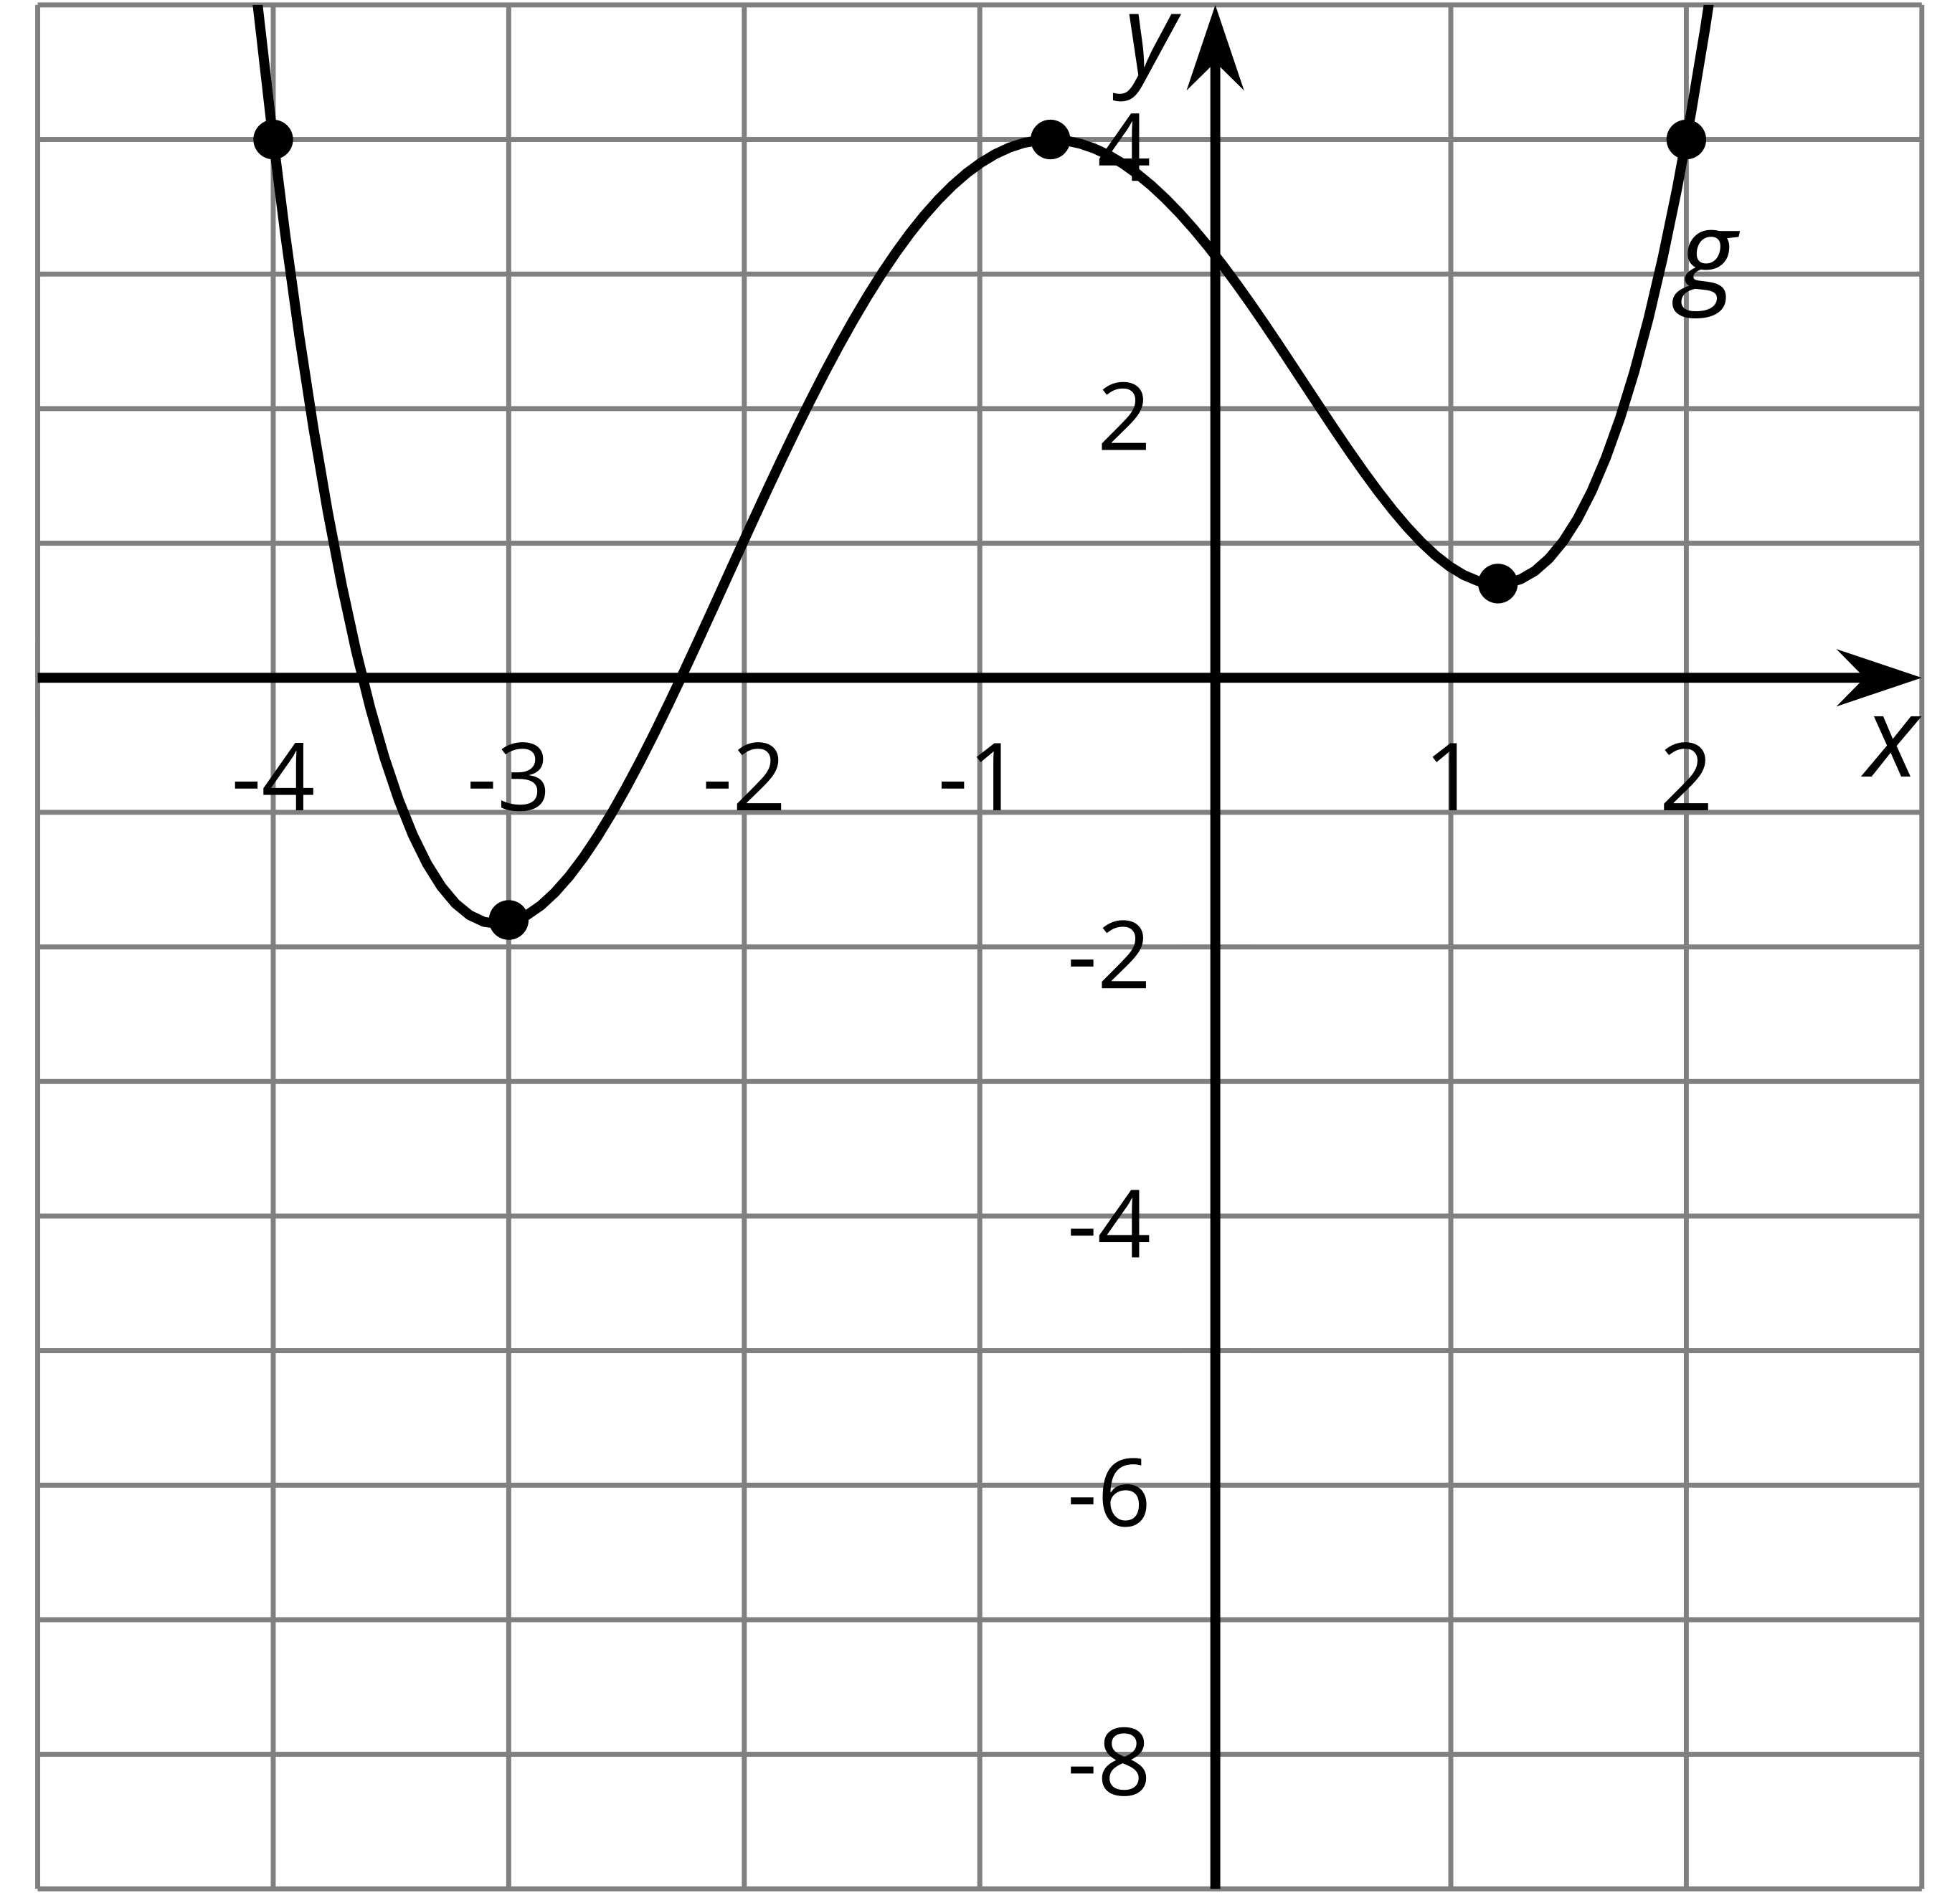
- Complete the $g(x)$ column of the table.
- If $f(0)=\text{-}0.86$, what is $g(0)$? Explain how you know.
- Write an equation for $g(x)$ in terms of $f(x)$ for any input $x$.
- The function $h$ can be written in terms of $f$ as $h(x)=f(x)−2.5$. Complete the $h(x)$ column of the table.
- $x$ | - $f(x)$ | - $g(x)$ | - $h(x)=f(x)−2.5$
- -4 | - 0
- -3 | - -5.8
- -0.7 | - 0
- 1.2 | - -3.3
- 2 | - 0
- Sketch the graph of function $h$.
- 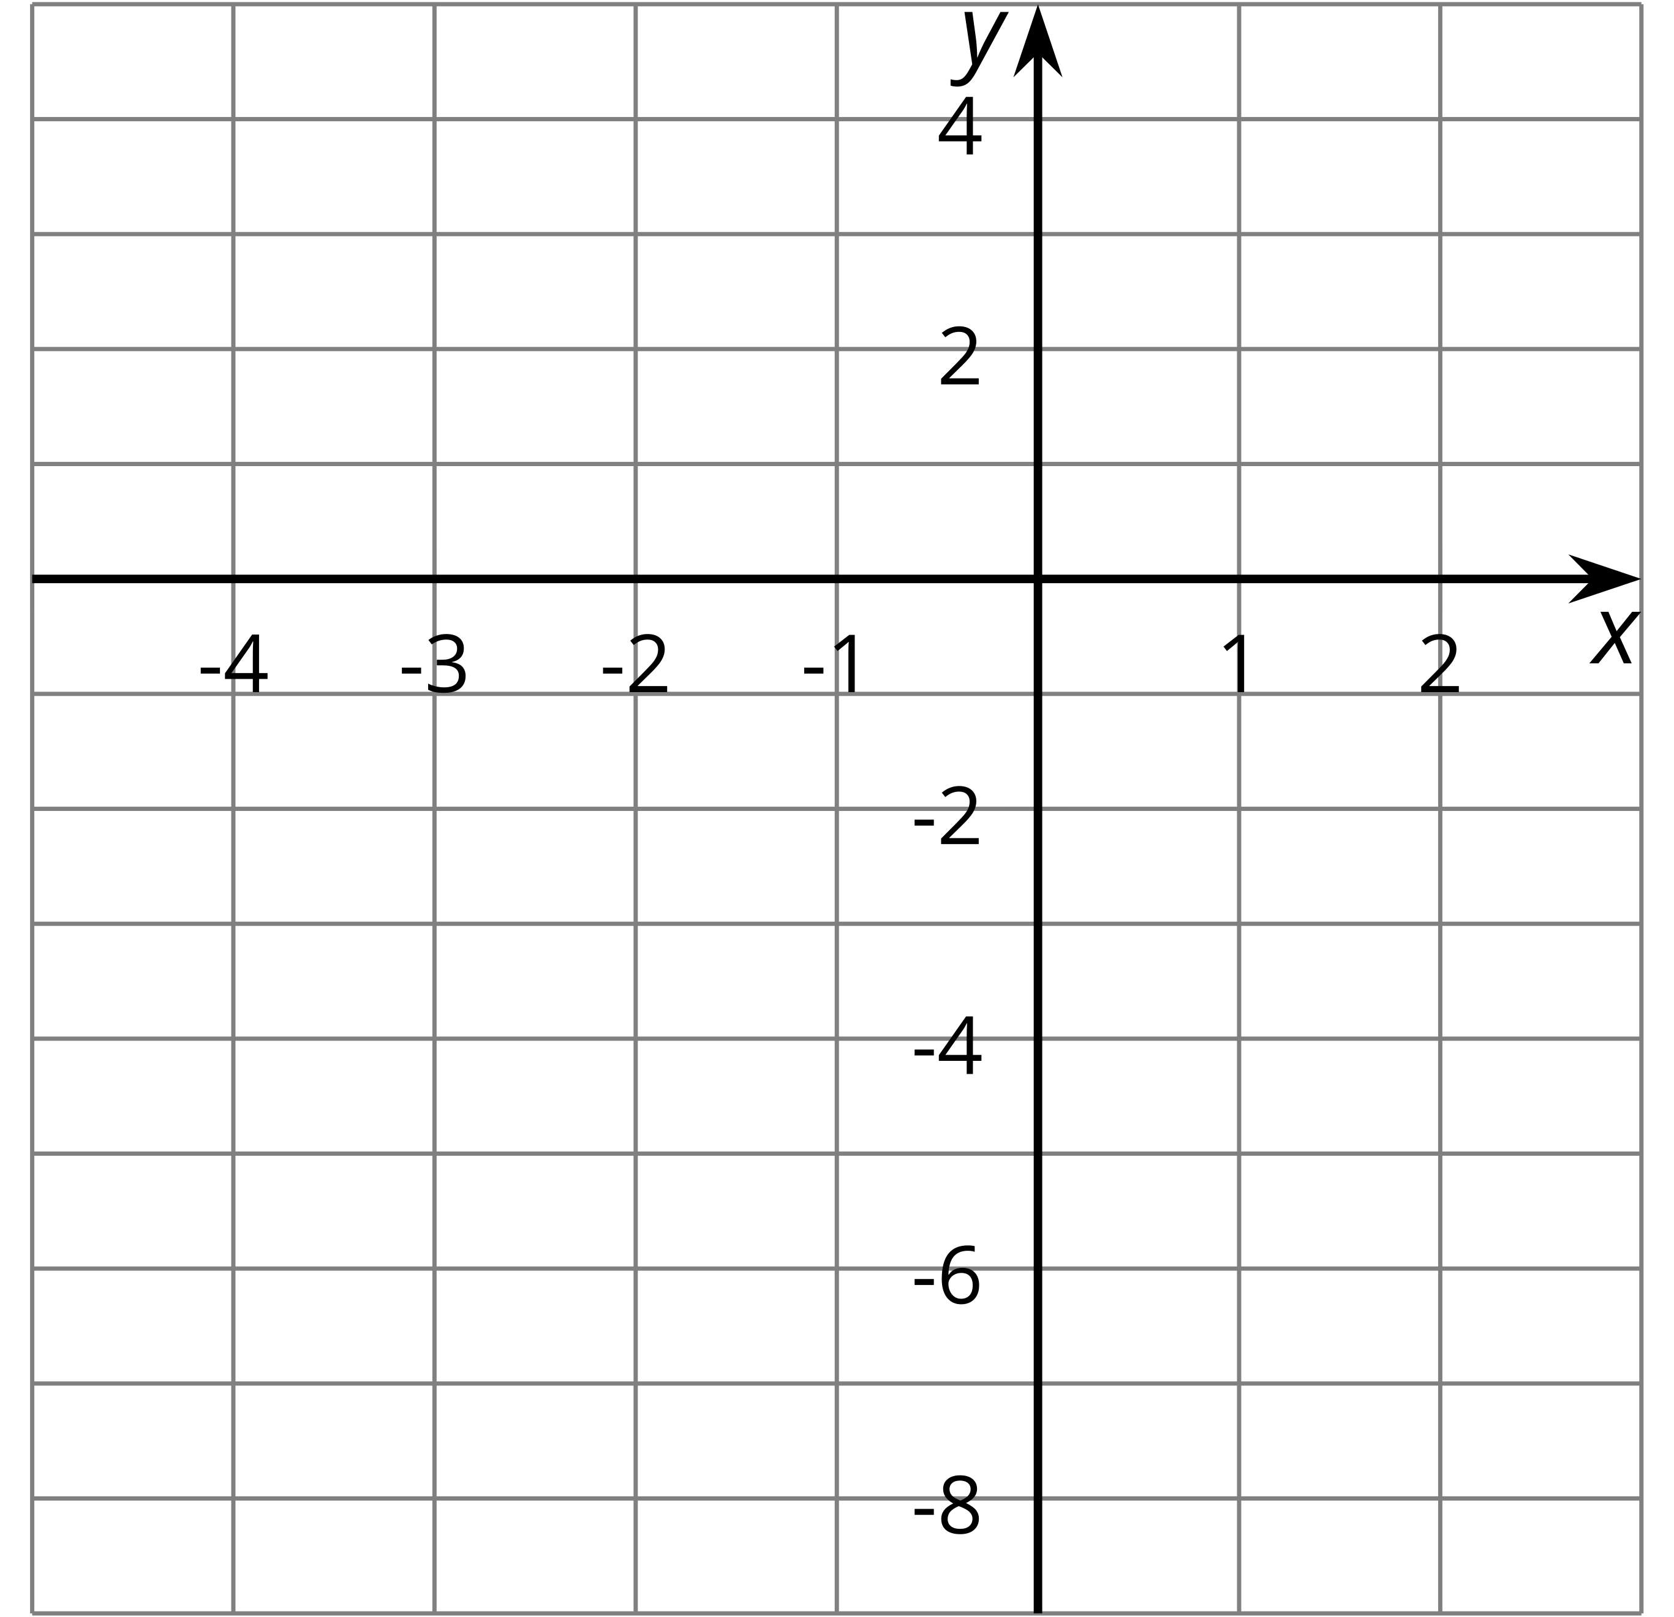
- Write an equation for $g(x)$ in terms of $h(x)$ for any input $x$.

2.3: Heating the Kitchen
A bakery kitchen has a thermostat set to ${65}^{∘}\text{F}$. Starting at 5:00 a.m., the temperature in the kitchen rises to ${85}^{∘}\text{F}$ when the ovens and other kitchen equipment are turned on to bake the daily breads and pastries. The ovens are turned off at 10:00 a.m. when the baking finishes.
- Sketch a graph of the function $H$ that gives the temperature in the kitchen $H(x)$, in degrees Fahrenheit, $x$ hours after midnight.
- 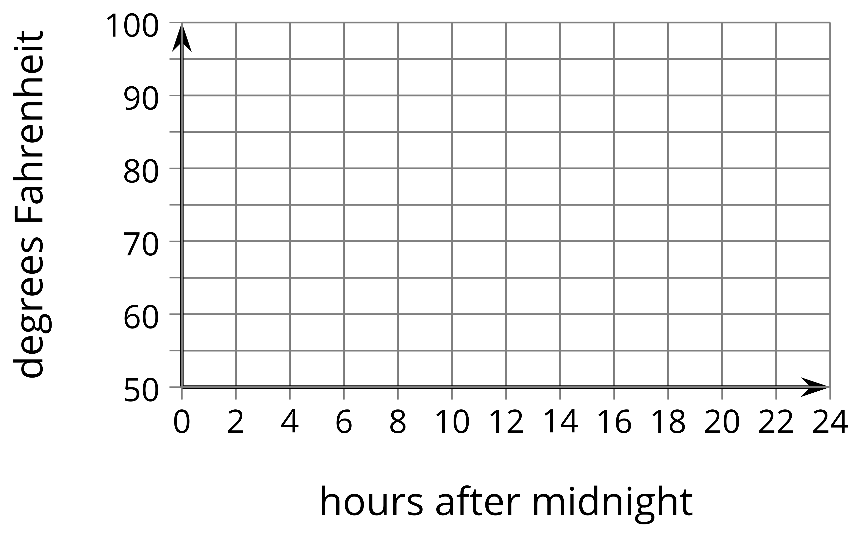
- The bakery owner decides to change the shop hours to start and end 2 hours earlier. This means the daily baking schedule will also start and end two hours earlier. Sketch a graph of the new function $G$, which gives the temperature in the kitchen as a function of time.
- 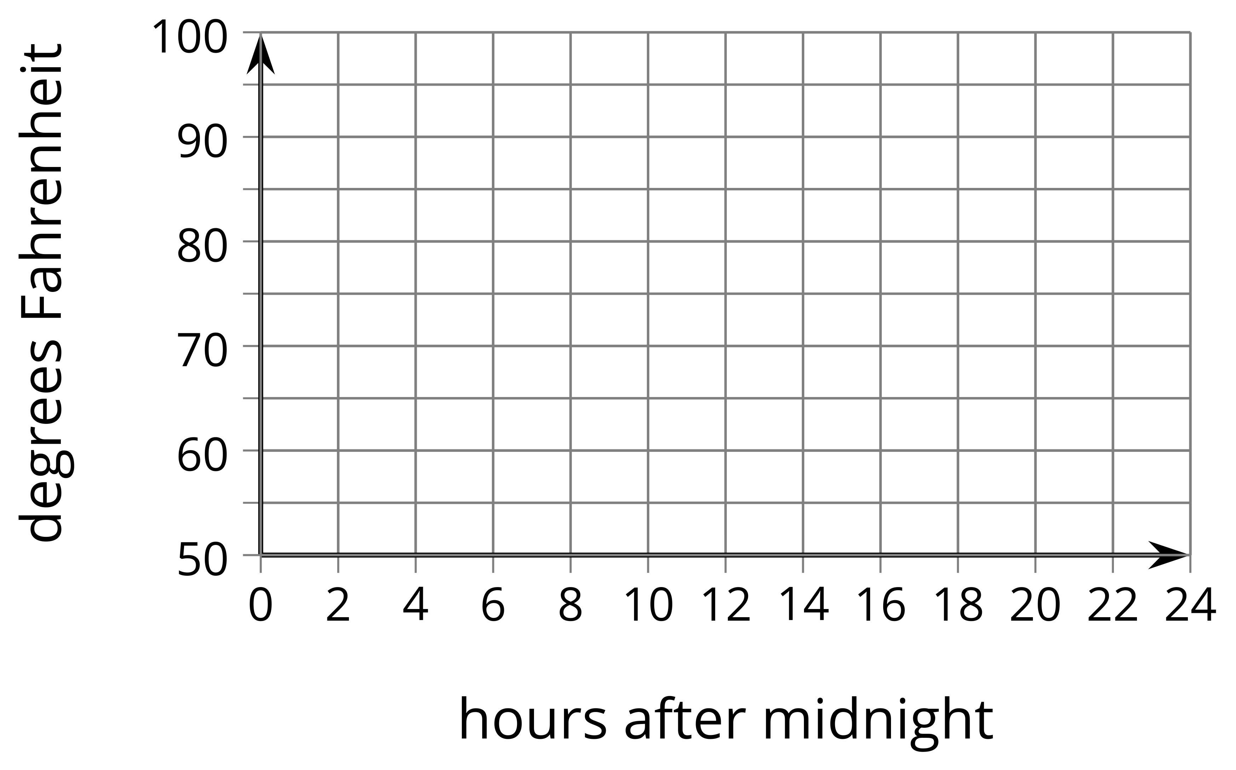
- Explain what $H(10.25)=80$ means in this situation. Why is this reasonable?
- If $H(10.25)=80$, then what would the corresponding point on the graph of $G$ be? Use function notation to describe the point on the graph of $G$.
- Write an equation for $G$ in terms of $H$. Explain why your equation makes sense.

Are you ready for more?
Write an equation that defines your piecewise function, $H$, algebraically.

Lesson 2 Summary
A pumpkin catapult is used to launch a pumpkin vertically into the air. The function $h$ gives the height $h(t)$, in feet, of this pumpkin above the ground $t$ seconds after launch.
Now consider what happens if the pumpkin had been launched at the same time, but from a platform 30 feet above the ground. Let function $g$ represent the height $g(t)$, in feet, of this pumpkin. How would the graphs of $h$ and $g$ compare?
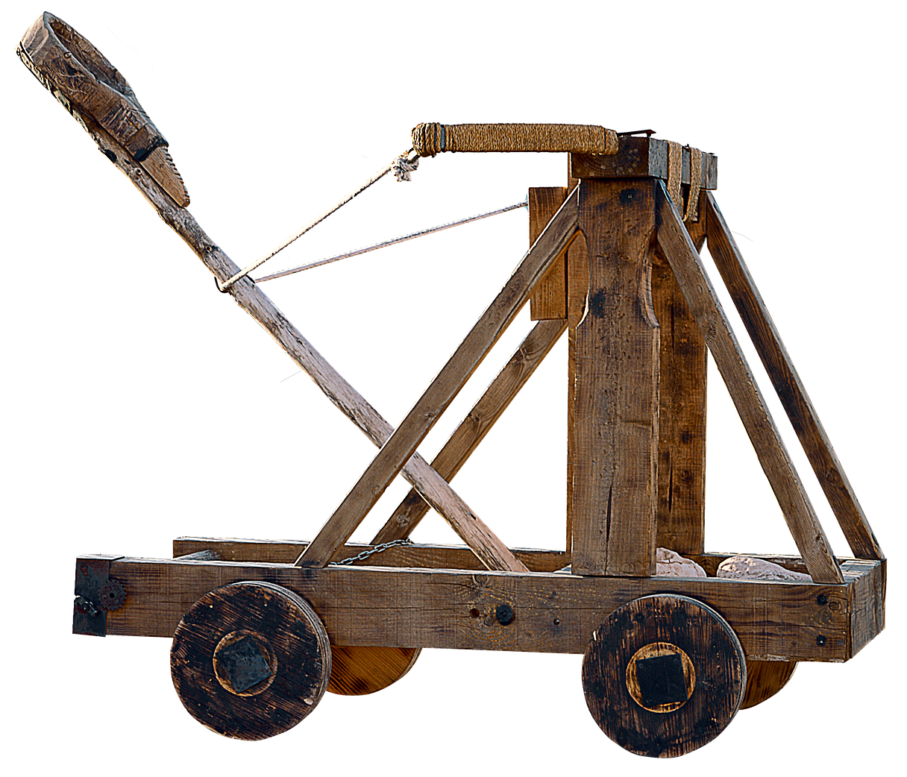
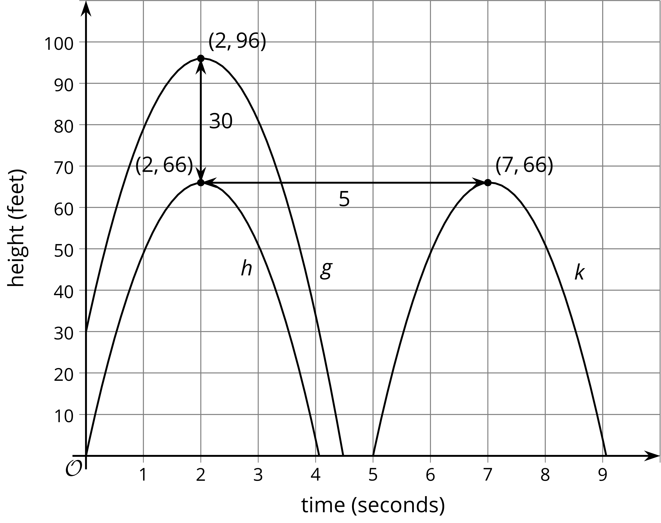
Since the height of the second pumpkin is 30 feet greater than the first pumpkin at all times $t$, the graph of function $g$ is translated up 30 feet from the graph of function $h$. For example, the point $(2,66)$ on the graph of $h$ tells us that $h(2)=66$, so the original pumpkin was 66 feet high after 2 seconds. The new pumpkin would be 30 feet higher than that, so $g(2)=96$. Since all the outputs of $g$ are 30 more than the corresponding outputs of $h$, we can express $g(t)$ in terms of $h(t)$ using function notation as $g(t)=h(t)+30$.
Now suppose instead the pumpkin launched 5 seconds later. Let function $k$ represent the height $k(t)$, in feet of this pumpkin. The graph of $k$ is translated right 5 seconds from the graph of $h$. We can also say that the output values of $k$ are the same as the output values of $h$ 5 seconds earlier. For example, $k(7)=66$ and $h(7−5)=h(2)=66$. This means we can express $k(t)$ in terms of $h(t)$ as $k(t)=h(t−5).$
© CC BY 2019 by Illustrative Mathematics

