Unit 7 Lesson 12: Represent Problems on the Coordinate Grid

WU True or False: Addition and Multiplication (Warm up)

Student Task Statement
Decide if each statement is true or false. Be prepared to explain your reasoning.
- $\left(2×10\right)+\left(3×5\right)=\left(3×10\right)+\left(1×5\right)$
- $\left(3×25\right)+\left(5×5\right)=8×25$
- $\left(4×25\right)+\left(10×5\right)=\left(2×25\right)+\left(10×10\right)$

1 Heads or Tails

Student Task Statement
Han and Jada flipped a penny several times and counted how many times it came up heads and how many times it came up tails. Their results are plotted on the graph.
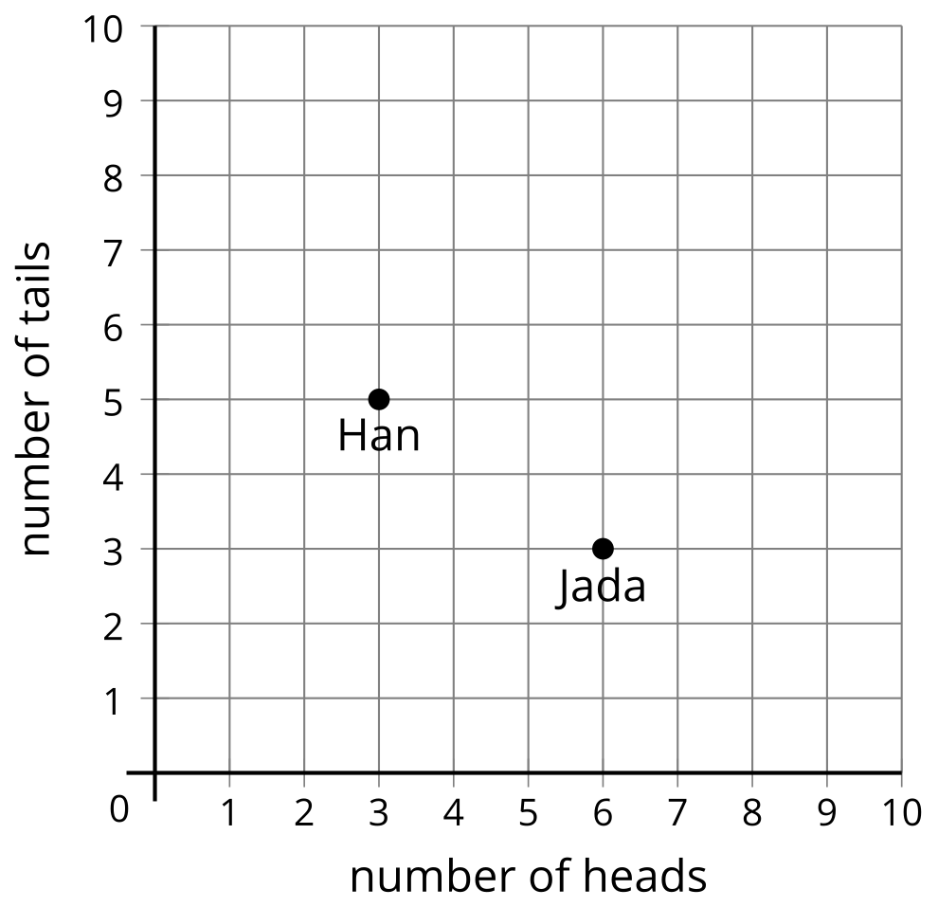
- How many heads did Jada get? How many tails did Jada get? Explain or show how you know.
- How many heads did Han get? How many tails did Han get? Explain or show how you know.
- Flip the coin 10 times and record how many heads and tails you get. Plot the point on the coordinate grid that represents your coin flips.
- Show your partner the point you plotted on the coordinate grid. Look at your partner's coordinate grid. How many heads did your partner flip? How many tails did your partner flip? Explain or show your reasoning.
- Do any of the points you plotted lie on the horizontal axis? What would a point on the horizontal axis mean in this situation?
- If time allows, toss the coin 10 more times and record your results and your partner’s results on the coordinate grid.

2 Coin Values

Student Task Statement
The graph shows the number and value of coins some students had with them.
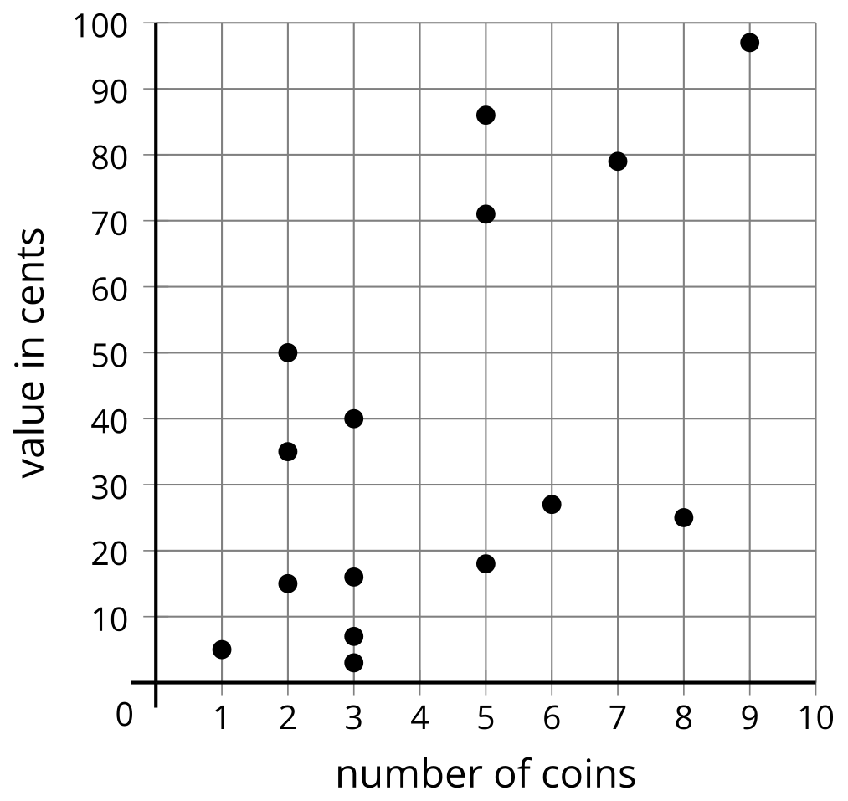
- Tyler has 1 dime, 3 nickels, and 2 pennies. Which point represents Tyler's coins? Label the point.
- Lin has 3 quarters, 1 dime, and 1 penny. Which point represents Lin's coins? Label the point.
- Diego has 1 quarter and 1 dime. Write the coordinates of the point that represents Diego's coins. Explain or show your reasoning.
- Clare has 5 coins and does not have a quarter. Write the coordinates of the point that represents Clare's coins.
- Which coins might Clare have? Explain or show your reasoning.
© CC BY 2021 Illustrative Mathematics®

