Lesson 9: Interpret Bar Graphs

Standards Alignments
Addressing | 2.MD.D.10
Building Towards | 2.MD.D.10

Teacher-facing Learning Goals
- Answer questions based on a bar graph.
- Interpret data represented in a bar graph.

Student-facing Learning Goals
- Let’s interpret data in bar graphs.

Lesson Purpose
The purpose of this lesson is for students to interpret data in a bar graph in order to answer questions.
In previous lessons, students learned how to interpret categorical data represented in picture graphs and other displays. In this lesson, bar graphs are introduced as another way to represent categorical data. Students compare the features of bar graphs to picture graphs and use the unique features of bar graphs to interpret data and answer questions. When students relate the data to the context it represents and carefully interpret the elements of a graph, they reason abstractly and quantitatively and attend to precision (MP2, MP6).

Access for:

Students with Disabilities
- Action and Expression (Activity 1)

Instructional Routines
MLR6 Three Reads (Activity 2), Notice and Wonder (Warm-up)

Lesson Timeline
Warm-up | 10 min
Activity 1 | 15 min
Activity 2 | 20 min
Lesson Synthesis | 10 min
Cool-down | 5 min

Teacher Reflection Question
The scale of the bar graph will be important as students solve problems based on data. How did you see students using the scale on the bar graph today?

Cool-down
(to be completed at the end of the lesson) 5min
Animals at the Zoo

Standards Alignments
Addressing | 2.MD.D.10

Student-facing Task Statement
A zookeeper counted the number of lions, cheetahs, monkeys, and zebras at the zoo. The zookeeper’s data is shown in this bar graph.
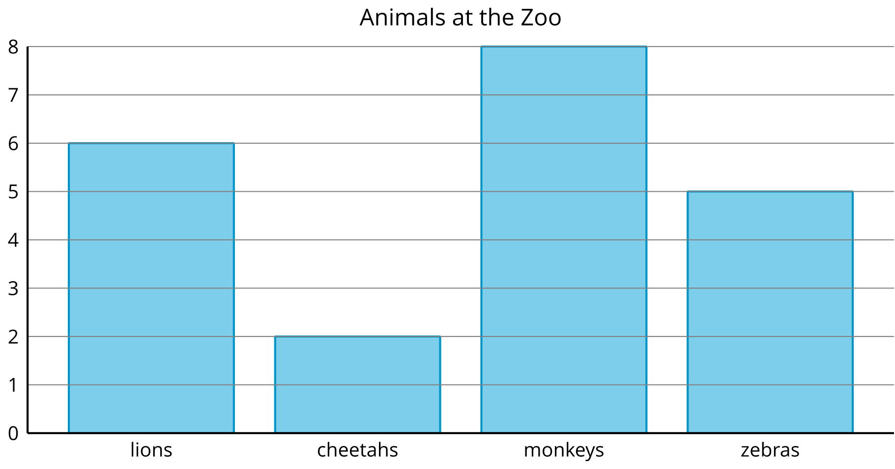
- How many monkeys were at the zoo? __________
- How many lions were at the zoo? ___________
- What is the total number of cheetahs and zebras? __________

Student Responses
- 8
- 6
- 7

