Unit 4 Lesson 19: Make Two-digit Numbers

WU Which One Doesn’t Belong: Different Ways to Show a Number (Warm up)

Student Task Statement
Which one doesn’t belong?
A
B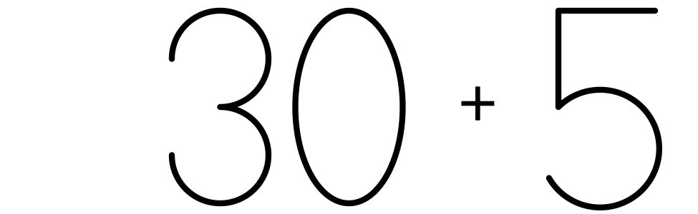
C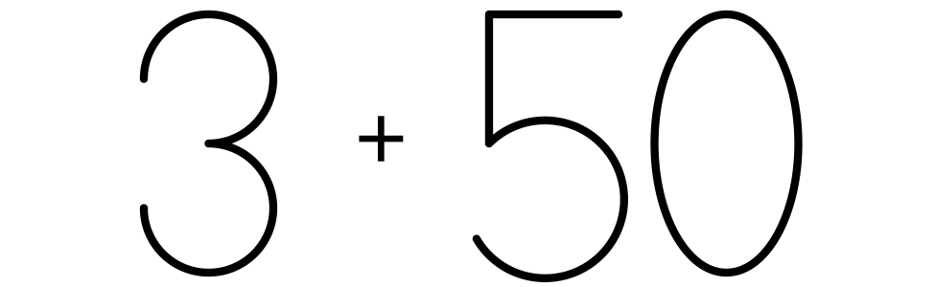
D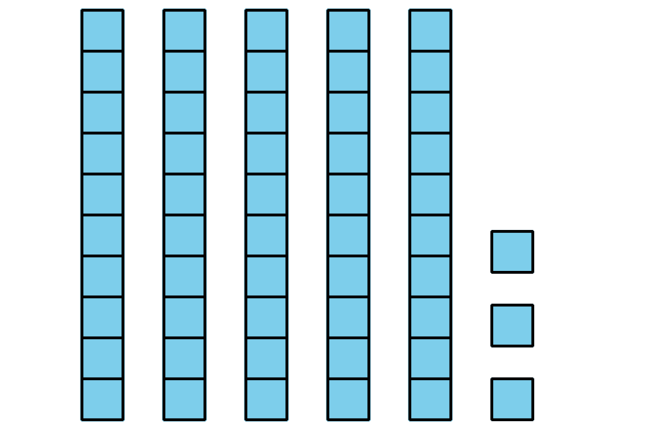

1 Make 65 Using Tens and Ones

Student Task Statement
Create a collection of 65.
You may not break apart any towers.
You may not make any new towers.
Show your collection in a way that others will understand.
If you have time, think of another way to make 65 using the cubes in the bag.

2 Make 37 in Different Ways

Student Task Statement
How many ways can you make 37?
Show your thinking using drawings, numbers, or words.

3 Centers: Choice Time

Student Task Statement
Choose a center.
Greatest of Them All
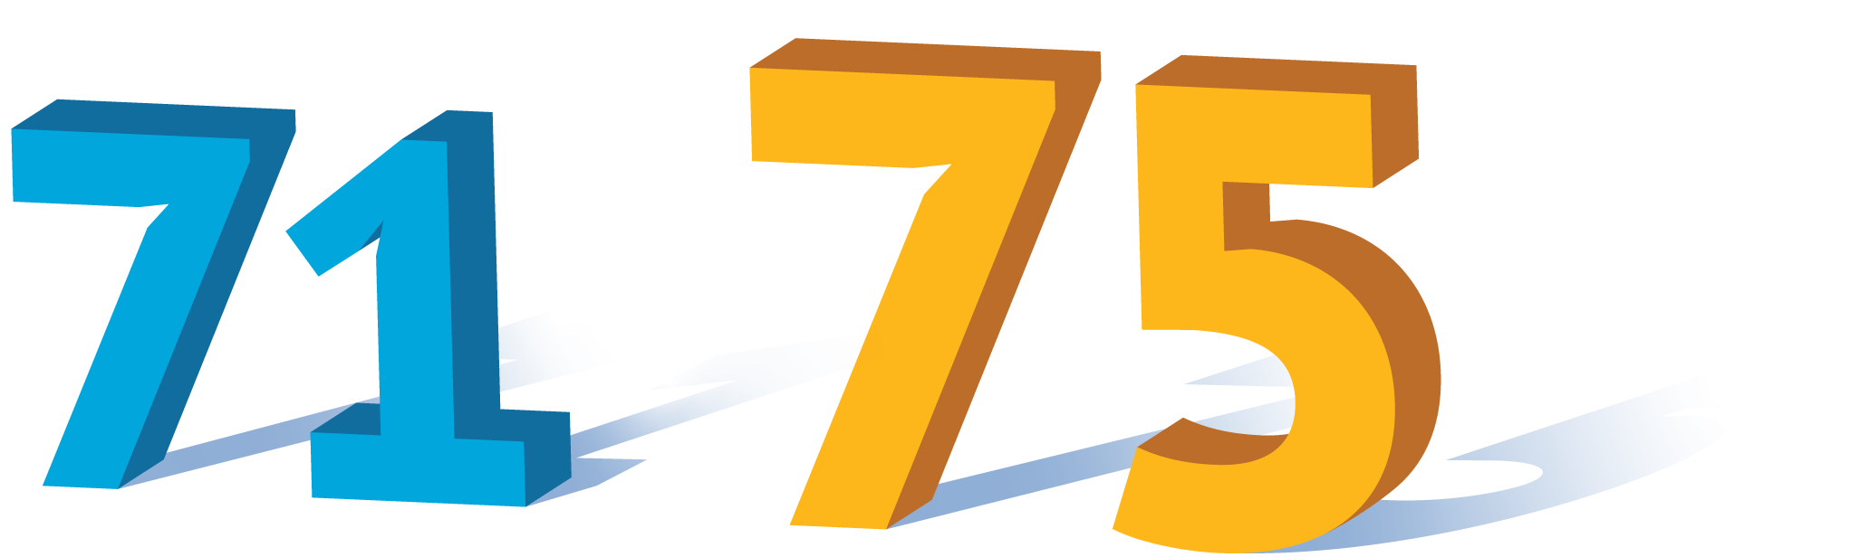
Get Your Numbers in Order
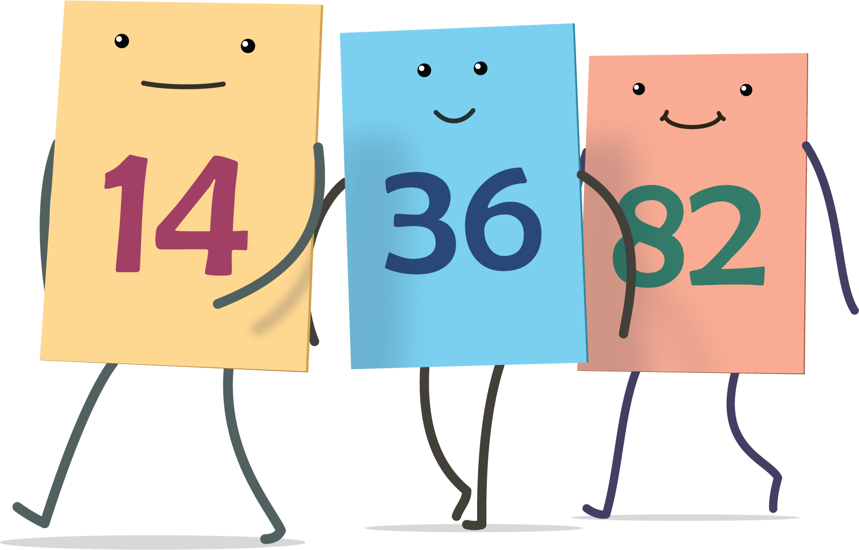
Grab and Count
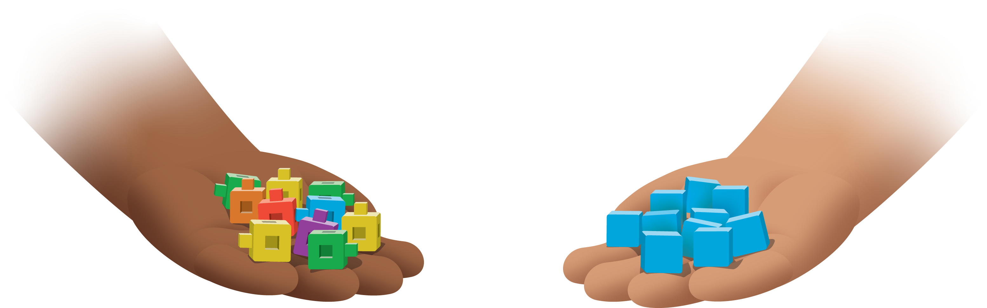
© CC BY 2021 Illustrative Mathematics®

