Lesson 2: Representing Proportional Relationships

2.1: An Unknown Situation
Here is a graph that could represent a variety of different situations.
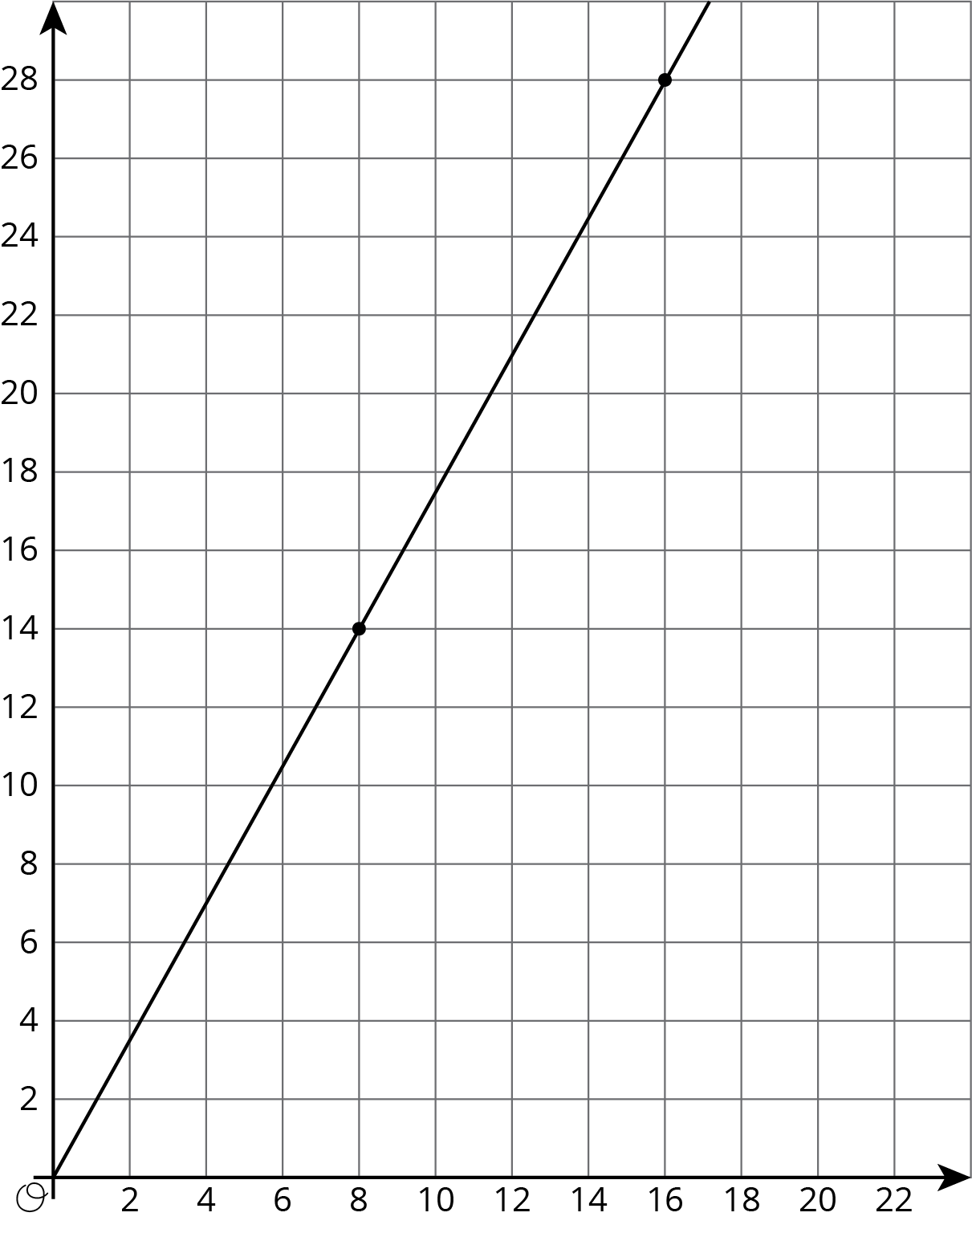
- Write an equation for the graph.
- Sketch a new graph of this relationship.
- 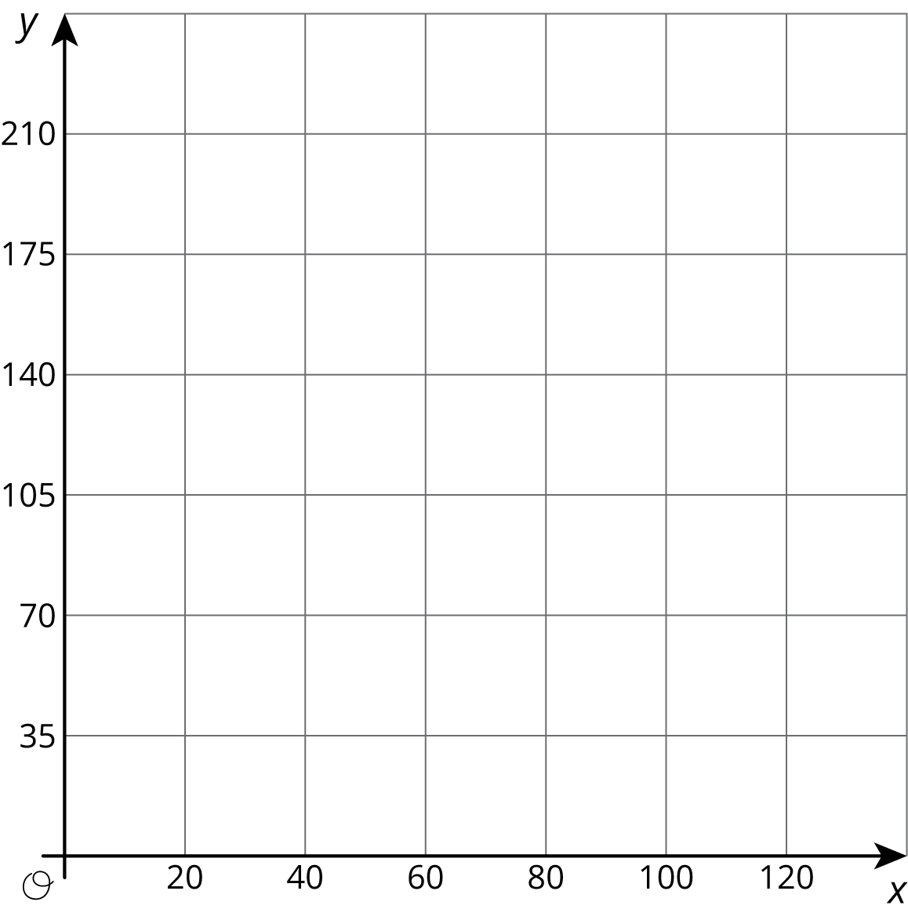

2.2: Card Sort: Proportional Relationships
Your teacher will give you 12 graphs of proportional relationships.
- Sort the graphs into groups based on what proportional relationship they represent.
- Write an equation for each different proportional relationship you find.

2.3: Different Scales
Two large water tanks are filling with water. Tank A is not filled at a constant rate, and the relationship between its volume of water and time is graphed on each set of axes. Tank B is filled at a constant rate of $\frac{1}{2}$ liters per minute. The relationship between its volume of water and time can be described by the equation $v=\frac{1}{2}t$, where $t$ is the time in minutes and $v$ is the total volume in liters of water in the tank.
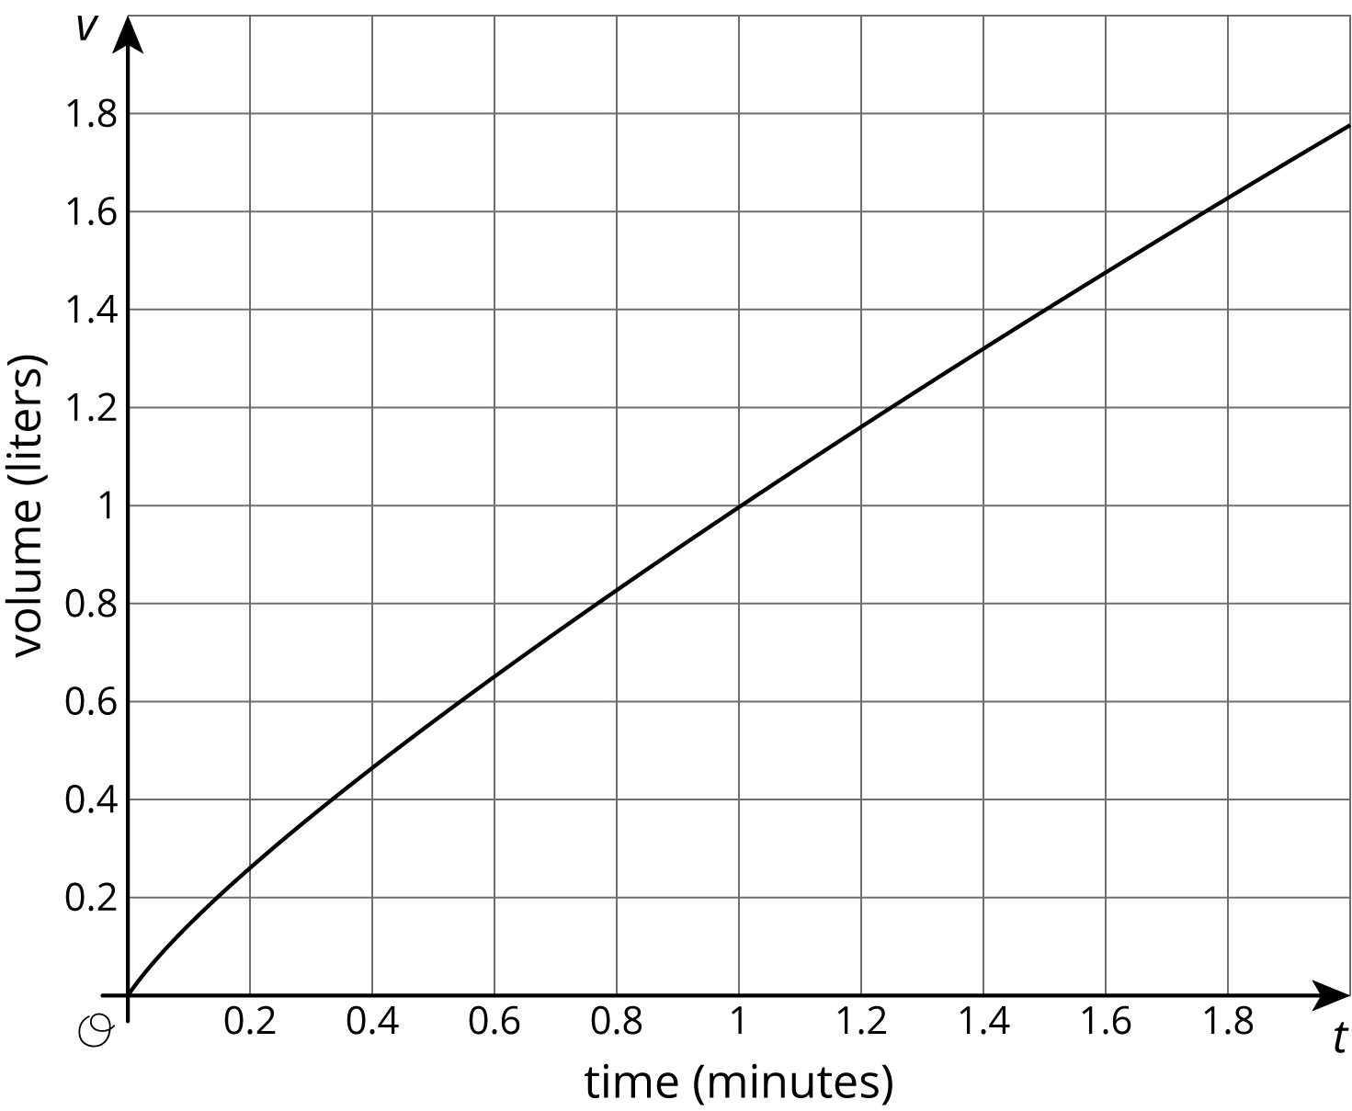
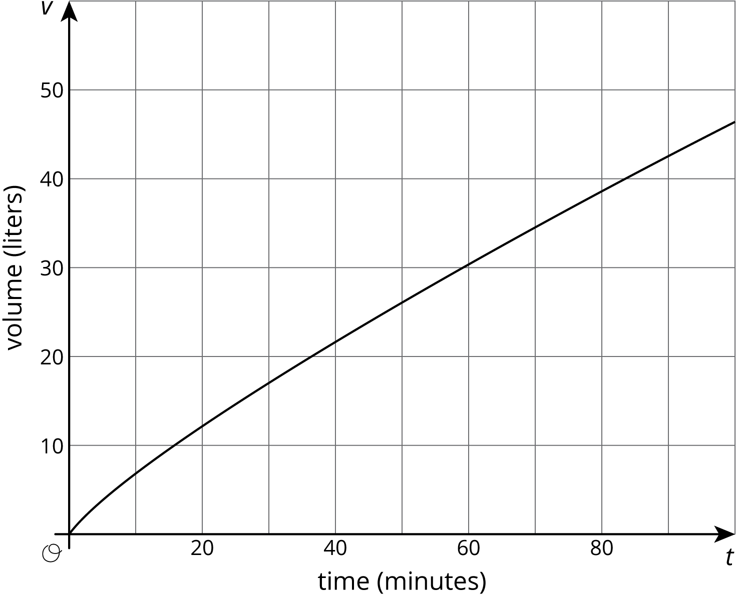
- Sketch and label a graph of the relationship between the volume of water $v$ and time $t$ for Tank B on each of the axes.
- Answer the following questions and say which graph you used to find your answer.
  - After 30 seconds, which tank has the most water?
  - At approximately what times do both tanks have the same amount of water?
  - At approximately what times do both tanks contain 1 liter of water? 20 liters?

Are you ready for more?
A giant tortoise travels at 0.17 miles per hour and an arctic hare travels at 37 miles per hour.
- Draw separate graphs that show the relationship between time elapsed, in hours, and distance traveled, in miles, for both the tortoise and the hare.
- Would it be helpful to try to put both graphs on the same pair of axes? Why or why not?
- The tortoise and the hare start out together and after half an hour the hare stops to take a rest. How long does it take the tortoise to catch up?

2.4: Representations of Proportional Relationships
- Here are two ways to represent a situation.
- Description:
- Jada and Noah counted the number of steps they took to walk a set distance. To walk the same distance, Jada took 8 steps while Noah took 10 steps. Then they found that when Noah took 15 steps, Jada took 12 steps.
- Equation:
- Let $x$ represent the number of steps Jada takes and let $y$ represent the number of steps Noah takes. $y=\frac{5}{4}x$
  - Create a table that represents this situation with at least 3 pairs of values.
  - Graph this relationship and label the axes.
  - How can you see or calculate the constant of proportionality in each representation? What does it mean?
  - Explain how you can tell that the equation, description, graph, and table all represent the same situation.
- Here are two ways to represent a situation.
- Description:
- The Origami Club is doing a car wash fundraiser to raise money for a trip. They charge the same price for every car. After 11 cars, they raised a total of $93.50. After 23 cars, they raised a total of $195.50.
- Table:
- number of  cars | - amount raised  in dollars
- 11 | - 93.50
- 23 | - 195.50
  - Write an equation that represents this situation. (Use $c$ to represent number of cars and use $m$ to represent amount raised in dollars.)
  - Create a graph that represents this situation.
  - How can you see or calculate the constant of proportionality in each representation? What does it mean?
  - Explain how you can tell that the equation, description, graph, and table all represent the same situation.

2.5: Info Gap: Proportional Relationships
Your teacher will give you either a problem card or a data card. Do not show or read your card to your partner.
If your teacher gives you the problem card:
- Silently read your card and think about what information you need to be able to answer the question.
- Ask your partner for the specific information that you need.
- Explain how you are using the information to solve the problem.
- Continue to ask questions until you have enough information to solve the problem.
- Share the problem card and solve the problem independently.
- Read the data card and discuss your reasoning.
If your teacher gives you the data card:
- Silently read your card.
- Ask your partner “What specific information do you need?” and wait for them to ask for information.
- If your partner asks for information that is not on the card, do not do the calculations for them. Tell them you don’t have that information.
- Before sharing the information, ask “Why do you need that information?” Listen to your partner’s reasoning and ask clarifying questions.
- Read the problem card and solve the problem independently.
- Share the data card and discuss your reasoning.
Pause here so your teacher can review your work. Ask your teacher for a new set of cards and repeat the activity, trading roles with your partner.

Are you ready for more?
Ten people can dig five holes in three hours. If $n$ people digging at the same rate dig $m$ holes in $d$ hours:
- Is $n$ proportional to $m$ when $d=3$?
- Is $n$ proportional to $d$ when $m=5$?
- Is $m$ proportional to $d$ when $n=10$?

Lesson 2 Summary
The scales we choose when graphing a relationship often depend on what information we want to know. For example, say two water tanks are filled at different constant rates. The relationship between time in minutes $t$ and volume in liters $v$ of tank A is given by $v=2.2t$.
For tank B the relationship is $v=2.75t$
These equations tell us that tank A is being filled at a constant rate of 2.2 liters per minute and tank B is being filled at a constant rate of 2.75 liters per minute.
If we want to use graphs to see at what times the two tanks will have 110 liters of water, then using an axis scale from 0 to 10, as shown here, isn't very helpful.
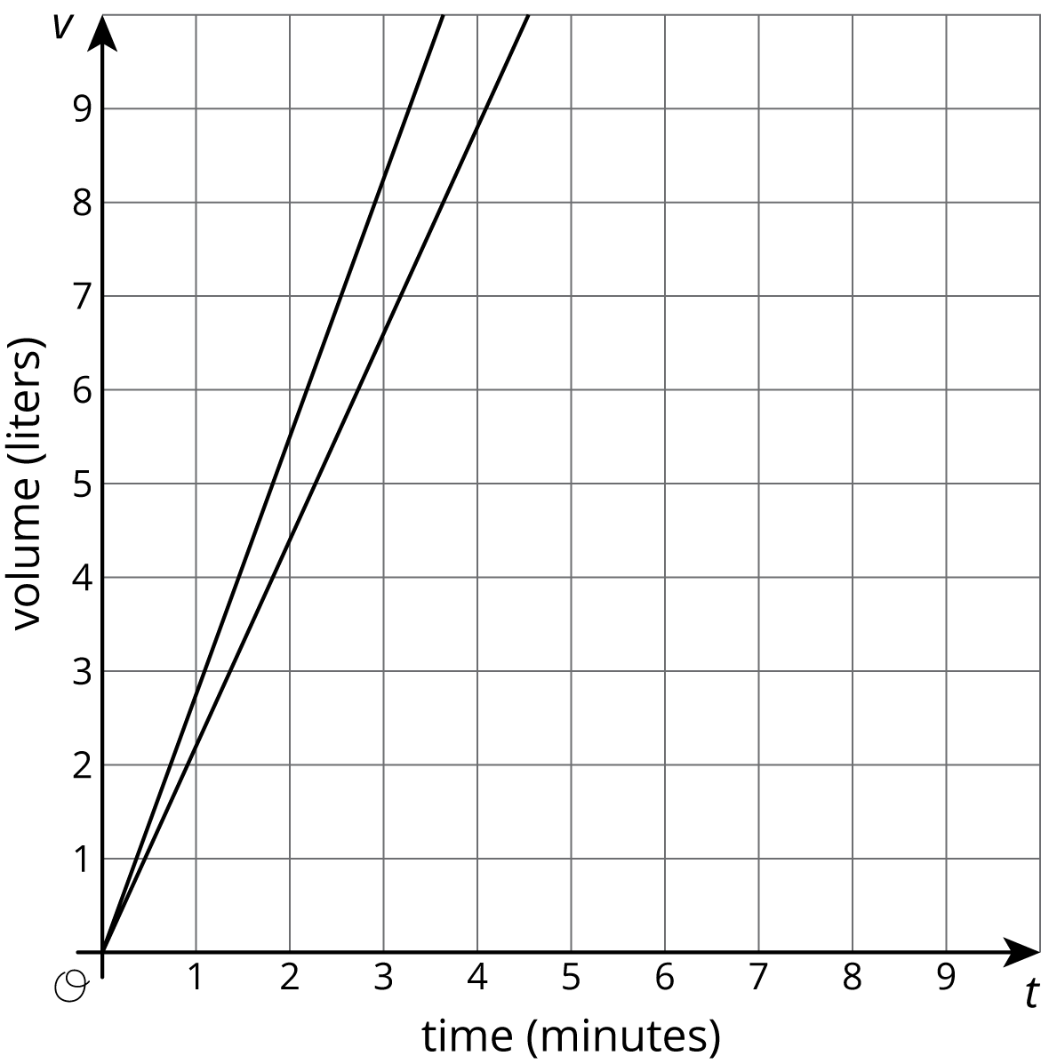
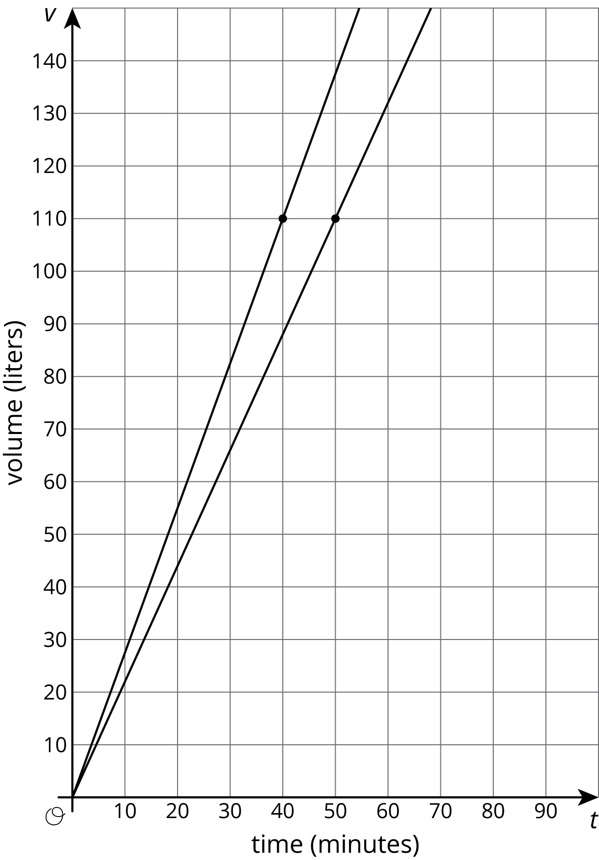
If we use a vertical scale that goes to 150 liters, a bit beyond the 110 we are looking for, and a horizontal scale that goes to 100 minutes, we get a much more useful set of axes for answering our question.
Now we can see that the two tanks will reach 110 liters 10 minutes apart—tank B after 40 minutes of filling and tank A after 50 minutes of filling.
It is important to note that both of these graphs are correct, but one uses a range of values that helps answer the question. In order to always pick a helpful scale, we should consider the situation and the questions asked about it.
What representation we choose for a proportional relationship also depends on our purpose. When we create representations we can choose helpful values by paying attention to the context. For example, if Tank C fills at a constant rate of 2.5 liters per minute, we could write the equation $v=2.5t$. If we want to compare how long it takes Tanks A, B, and C to reach 110 liters, then we could graph them on the same axis. If we want to see the change in volume every 30 minutes, we could use a table:
minutes (t) | liters (v)
0 | 0
30 | 75
60 | 150
90 | 225
No matter the representation or the scale used, the constant of proportionality, 2.5, is evident in each. In the equation it is the number we multiply $t$ by. In the graph it is the slope, and in the table it is the number by which we multiply values in the left column to get numbers in the right column. We can think of the constant of proportionality as a rate of change of $v$ with respect to $t$. In this case the rate of change is 2.5 liters per minute.
© CC BY Open Up Resources. Adaptations CC BY IM.

